Empirical Analysis of Accuracy–Privacy Trade-offs in Federated Learning for Mobile Movie Recommendation Systems
Table of Contents
Introduction 4
Differential Privacy 10
Homomorphic Encryption 11
Secure Multi-Party Computation 12
The Trade-off 14
Challenges and Adaptive Mechanism 16
Related Work 17
Federated Learning in Mobile Environments 20
Privacy-Preserving Mechanisms in Recommender Systems 26
Accuracy-Privacy Trade-offs in Machine Learning 27
Methodology 29
Data Preparation and Partitioning 29
Model Architectures 30
Federated Learning Setup and Training 31
Differential Privacy Implementation 31
Privacy Attack Models 32
Resource Profiling and Metrics 33
Experimental Setup 35
4.1 Overview 35
4.2 Hardware and Software Environment 35
4.2.1 Computation Platform 35
4.2.2 Software Stack 35
4.3 Dataset Preparation 35
4.3.1 Data Loading and Preprocessing 35
4.3.2 Train–Test Split 36
4.3.3 Non-IID Data Partitioning via Dirichlet Distribution 36
4.4 Federated Learning Simulation Environment 37
4.4.1 In-Memory Simulation Architecture 37
4.4.2 Per-Round Execution Flow 37
4.5 Differential Privacy Integration 37
4.5.1 DP-SGD Implementation Details 37
4.5.2 Privacy Budget Calibration 38
4.6 Privacy Attack Setup 38
4.6.1 Membership Inference Attack Configuration 38
4.6.2 Model Inversion Attack Configuration 39
4.7 Experiment Configurations 39
4.7.1 Experiment 1: Centralized Baseline 39
4.7.2 Experiment 2: DP Budget Sweep (RQ1) 39
4.7.3 Experiment 3: Privacy Attack Evaluation (RQ2) 39
4.7.4 Experiment 4: Heterogeneity Sweep (RQ3) 39
4.8 Complete Hyperparameter Summary 40
4.9 Evaluation Protocol 41
4.9.1 Recommendation Metric Computation 41
4.9.2 Regression Metric Computation 42
4.9.3 Privacy Metric Computation 42
4.10 Results Storage and Analysis Pipeline 42
4.10.1 Result Serialization Format 42
4.10.2 Analysis and Visualization 42
4.11 Mobile Client Integration 43
4.11.1 Flutter Application Architecture 43
4.11.2 Server–Client Communication Protocol 43
4.12 Reproducibility Measures 44
4.13 Summary 44
Results and Discussions 44
Accuracy Performance Analysis 46
Privacy Preservation Analysis 47
Accuracy-Privacy Trade-off Evaluation 48
Impact of Privacy Mechanisms on Model Performance 49
Convergence Analysis and Training Dynamics 50
Conclusion 51
Summary of Findings 52
Limitations 53
Future Work 55
Appendix 58
Deep Leakage 58
RSA (Rivest-Shavir-Aldeman) 59
Oblivious Transfer Protocol 59
Shamir’s Secret Sharing 61
Lagrange Interpolation 63
FedSlate 63
Model Inversion 66
Rényi Differential Privacy 67
The Core Object: The Privacy Loss Random Variable 67
The Mathematical Engine: Rényi Divergence 68
The "Click": Why RDP Wins at Composition 69
The Gaussian Mechanism Connection 70
Converting Back to Reality 70
Dirichlet Data Partitioning 71
The Dirichlet Distribution 71
The Partitioning Algorithm 72
Multi-Objective Optimization 74
Solving the MOO Problem in FL+DP 75
Advanced Application: Personalized Differential Privacy 76
Poisson Subsampling 77
Mathematical Definition 77
Properties 77
Matthew Effect 78
The Catalyst: Differential Privacy 78
Mechanism of Matthew Effect 79
Mathematical Formulation of the Disparity 80
Visualizing the Divergence 80
Codebase Structure 81
Table of Contents 81
Code Structure 81
Python Implementation 81
Mobile Implementation 81
Folder Organization 81
Root Directory Structure 81
Key Directories Explained 82
scripts/ - Core Utilities 82
federated_learning_in_mobile/ - Mobile Application 82
results/ - Experiment Outputs 83
Hybrid Experiments 86
Repository Information 86
Key Components 87
Server server.py) 87
Client client.py) 87
RDP Accountant scripts/rdp_accountant.py) 88
Mobile Client federated_learning_in_mobile/lib/) 88
Dependencies 88
Python Dependencies requirements.txt) 88
Flutter Dependencies federated_learning_in_mobile/pubspec.yaml) 89
System Requirements 89
Additional Documentation 89
Code Execution Flow 90
Federated Learning Round 90
Experiment Execution 90
Troubleshooting 90
Common Issues 90
References 91

Introduction
Recommendation systems are the most important components in the world of technology today, especially Social Media, Netflix, Spotify and wherever there is a need to show users what to interact with and reduce their decision-making efforts. Today’s recommendation systems have overgrown from simple filtering systems to showing and recommending users as to what they want and what they will like to interact with so that they don’t or to the very least search for their preferred content. Some examples of platforms that use recommendation systems are: Netflix, Amazon, Spotify, YouTube and many more. The purpose of the recommendation system has also overgrown from just recommending users personalized content to retaining them on the platform for as long as possible and keep them engaged with the platform so that they use the platform more and more. While platforms like Netflix and Spotify use recommendation systems to retain the user into their platform and keep them engaged keep them busy, social media on the other hand use recommendation systems to show users content for maximum likes comments shares Etc. (Bojić et al., 2021, p. 7; Cobbe & Singh, 2019, p. 7; Knott et al., 2024, p. 181; Nadeem & Sivakumar, 2023, p. 1478)
There is something called “paradox of choice”, which says that for user to choose from options it is better to give them more options however if we give them more options they get overwhelmed and that lead to less user interest in the platform which is trying to give user more options (Peters et al., 2013, p. 119). This forms a paradox and it has to be resolved using some algorithm. Every recommendation system out there that is employed or implemented in any kind of Technology is trying to resolve this Paradox of choice. The irony is that while paradox of choice is a paradox, solution is not in solving the paradox. But rather finding a sweet spot between the number of items recommended and the number of items not recommended.
The second purpose of recommendation system is to generate revenue for the platform. Because the more user engages with the platform, the more engagement with the sponsors or the advertisements or the affiliates will happen and that will help the platform to generate even more money. So for example, in platforms like Instagram and Facebook if the user happens to spend time more than previous day then these platforms have a business model of showing ads and sponsored content. So it is more likely that the user will click on some advertisement or some sponsored content which will lead to platform making more money. (Beknazar-Yuzbashev et al., 2024, p. 679; Ronteau et al., 2022, p. 85). We can quote another example of recommendation system in Amazon which is called frequently bought together. This feature recommends related items which user is interested in. so if user buys an item X and the user is being shown item a b and c.It is likely that user may be interested in at least one of the a b and c and may end up buying any of the recommended items which the user did not intend or did not think of buying previously. so that results in the sellers making more money and Amazon making more money. (Adomavičius et al., 2019; Zeng et al., 2015, p. 2)
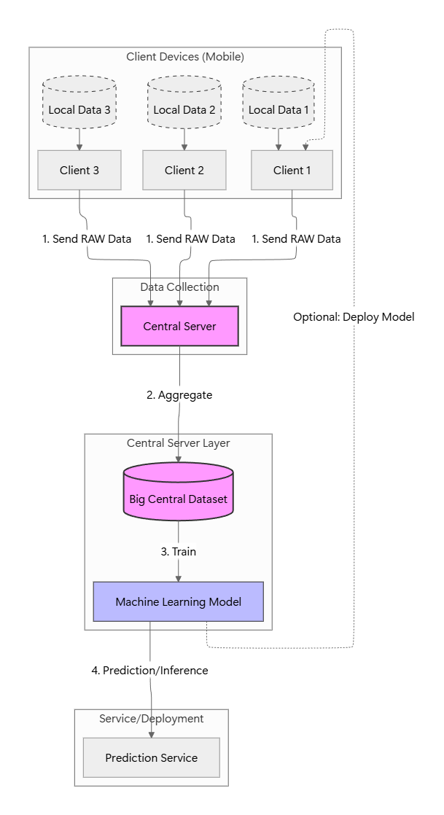
Let’s talk a little bit about how the recommendation system actually works. The conventional way is that the users data the data which is for example users likes, user comments, users favourite things, users preferred bought items ACC. These data has to be taken to a central server where the server processes this data and recommends the user based upon the data that the user generates. The user generates a lot of data depending upon the time and interaction. Even though from user standpoint it is just a simple like or it is just a simple comment which does not do anything to the user but it is a very useful data to the platform that the user is interacting with. So this all data has to be taken to central server in order to recommend more things and more content and more items to the user. This is how most of the company’s work and most of the platforms work. If we name, if we start to name, let’s say Facebook or Instagram, they all collect data and take them to their central servers, which are far away from the place where user is using it or at least far away from the users own device. Tender central servers or central platforms, they process this data, they process all this users likes and comments and shares etc, and they applied algorithm to the data to generate more recommendations that is then brought back to the users device. The user then sees his recommendations and most likely interacts with the recommendations. So for example in the frequently bought items of Amazon user may buy one of the recommended items and the and the bought item is another data which then goes to Amazon central servers and then it adds to the already users data that is present in the central server and the algorithm adapts to the new data that has come and the cycle goes on. The new data then generates a new recommendation content and the cycle goes on and the recommendation improves centrally. (Erdeniz et al., 2019, p. 301; Li et al., 2024, p. 2; Wang et al., 2021, p. 880)
Now this recommendation system which works centrally has a problem. The problem is that all the user data is open to the company and the there is no privacy in the user data. In a sense, the company knows what user likes, the company knows what user favourites, and the company knows what user is going to click next. Privacy is completely jeopardised. And the user has no control over his content and over his data that is being sent to the central server. Not only does the company know the user history, users like history, user watch history, the data since it is open to the company and is and privacy is jeopardised, The data can be easily misused by the company or anybody in between who might be reading the data. Based upon the user’s history and the user’s recommendation lot of wrong Moves can be made by The company itself as well as anybody in between, Which could dramatically harm the user financially, legally and emotionally. (Dawson & Szakonyi, 2020, p. 89; Matz & Kosiński, 2019, p. 23)
One solution to this problem is that we can allow user to have a control over what data has to be sent to the central server and what has not to be. But still this has problem user does not know what data is good and what data is bad. Secondly, the user cannot decide for themselves as to what data has to be sent to the central server not because they do not know the good and bad, but they do not have time to select the data and deselect the data that has to be sent and not sent respectively. For example, if a user is busy listening to songs on Spotify, Then the whole entertainment experience can be ruined by just the fact that user is prompted to select and deselect the data that has to be set to this 45 servers in order to make him recommend more songs. This completely works against the company as well as the user. By this, the user will have bad experience, and they will leave the application or the platform, and the company will lose their users, and they will generate less revenue because of all this selection and deselection of the data. It is therefore not recommended to use this kind of recommendation system. For apps which are slow working, for example, the payment apps or something like that, this system can be employed, and it can work well. For example, user can send what transaction in the payment app has to be sent to the central server. And what transaction has not to be sent to the central server. User can decide what type of bills or payments they are interested in, what types of bills and payment they are not interested in, because these apps are not streaming apps. These apps are not working live or in real time. But however, for fast acting platforms, or for platforms that work in real-time like Spotify or YouTube, this system cannot work and it can backfire. (Ambore, 2023, p. 792; Chikwendu & Asianuba, 2024; Liu et al., 2017, p. 399; Lury et al., 2024, p. 53; Ullah et al., 2022, p. 668)
Now companies come with a loophole that they include a lengthy terms and condition and disclaimers in their applications and platforms that user has to cheque before signing up. Legally this is binding but nobody reads these lengthy terms and conditions and disclaimers. Show in every sense they work against the user in the matter of selection of data that has to be sent to the central server. Clearly this is completely correct but ethically this is not correct because even companies are aware of the fact that users are not going to read the whole terms and conditions and disclaimers of the platform. So if a user happens to suffer some kind of loss because of this data breach or data leak then companies have this upper hand in the legal aspect that they can blame the user themselves as to because they clicked or they checked the box where it says that I agree to terms and conditions or I agree to the disclaimer. Obviously legally user is on the wrong side but ethically the company is on the wrong side. So the loophole is that legally the user consented to the terms and conditions the user consented to the use of the platform despite not knowing what data will be sent and what data will not be sent to the central server. (Creswick et al., 2019, p. 175)
One hack to the central server and the complete database is vulnerable to the hacker. Once that happens imagine the financial fraud imagine the legal fraud that can be done because of this data breach and the vulnerability of the central server. Also it is not just about the ill-intentional use of the data once the central server is hacked. Let us suppose that the central server is not hacked and the company is using the data as they intend, however the way they are using the data may not be favourable to the users and may be ethically wrong when it comes to users point of view. There can also be behavioural manipulation because of the central server data that is collected at one place. For example if the central server knows from reading the data that the user is depressed at a certain period of time in a day the central server can recommend the user things like junk food or maybe items of suicide or items that can be used as suicide etc. So the fact is that they are not just recommending or showing the user content or items they are basically nudging the users behaviour toward a certain consequence which is not right. (Jaycox et al., 2024; Milano et al., 2019, p. 11, 2020, p. 45)
“Denial of services”. For example lets say a bank server knows that a certain user deals with low income people and transacts with people of low income and bank balance. It might then conclude that the user is not reliable to be given any loan. So the system will automatically blacklist the user from taking any loan because of their history because of their transaction history not because of their Credit history but because of the transaction history. This denial of services is against the freedom That we are striving to achieve in modern society Because the blacklisting is being done not on the basis of behavioural history but on the basis of statistical guess. Because companies are financially motivated to exploit data this way, they won't stop voluntarily. This highlights the urgent need for laws (like GDPR in Europe) that force companies to handle data ethically and give users ownership ("a firmer grip") over their own information. (Bojić et al., 2022, p. 16; Hingh, 2018, p. 1290; Oliveira et al., 2025, p. 1; Wachter & Mittelstadt, 2018, p. 16)
In this document we present a solution that is called Federated learning. Federated learning is a distributed learning system in which the data instead of going to a central server is trained on the device of the user itself. One primary thing that is solved because of the federated learning is that the data does not leave the device of the users that way user can have their privacy as much as possible. This consequently makes company blind to what the user likes what the user comments and their history their watch history their buying history etc and consequently the companies cannot behaviourally manipulate the user or misuse their data or sell their data to hackers for ill intentions. The whole idea of Federated learning is that the machine learning which happens at the central server is now happening in the device of the user itself. But since we know that the user’s device is not as powerful and strong as the central server are so there has to be some compensation. However, the good thing is that the compensation is not in the privacy, no privacy is jeopardised. The compensation lies in the model training and the model that the central server receives. This whole document talks about the federated learning in a very deep detail. (Konečný et al., 2016; Saif et al., 2025; Zhou et al., 2022, p. 1)
The FedLearning works within the loop between the client devices and the central server where the raw information about the user is stored in the device (browsing history, purchase history, watchlists or personal preferences) and keeps a privacy (Konecny et al., 2016; Zhou et al., 2022, p. 1). The solution to be proposed will combat the above weaknesses of centralization because the data will not be centralized (Saif et al., 2025). FL has the model being trained on all devices with local data; hence, eliminating the risk of data leakage, breach, or unauthorized access to the information being transferred and eliminates the need to have a central repository of sensitive information as compared to the old systems of machine learning where the data is collected in the central server to train the model.
To help in collective model improvement in case of a large client base, the devices are not transmitting raw data rather sending sparse, anonymized model updates, mathematical descriptions of local training. It is performed in the following manner:
- Model Distribution: It is founded on the current global model which is delivered to a chosen client devices by a central server and is generally a point of refinement(Konecny et al., 2016).
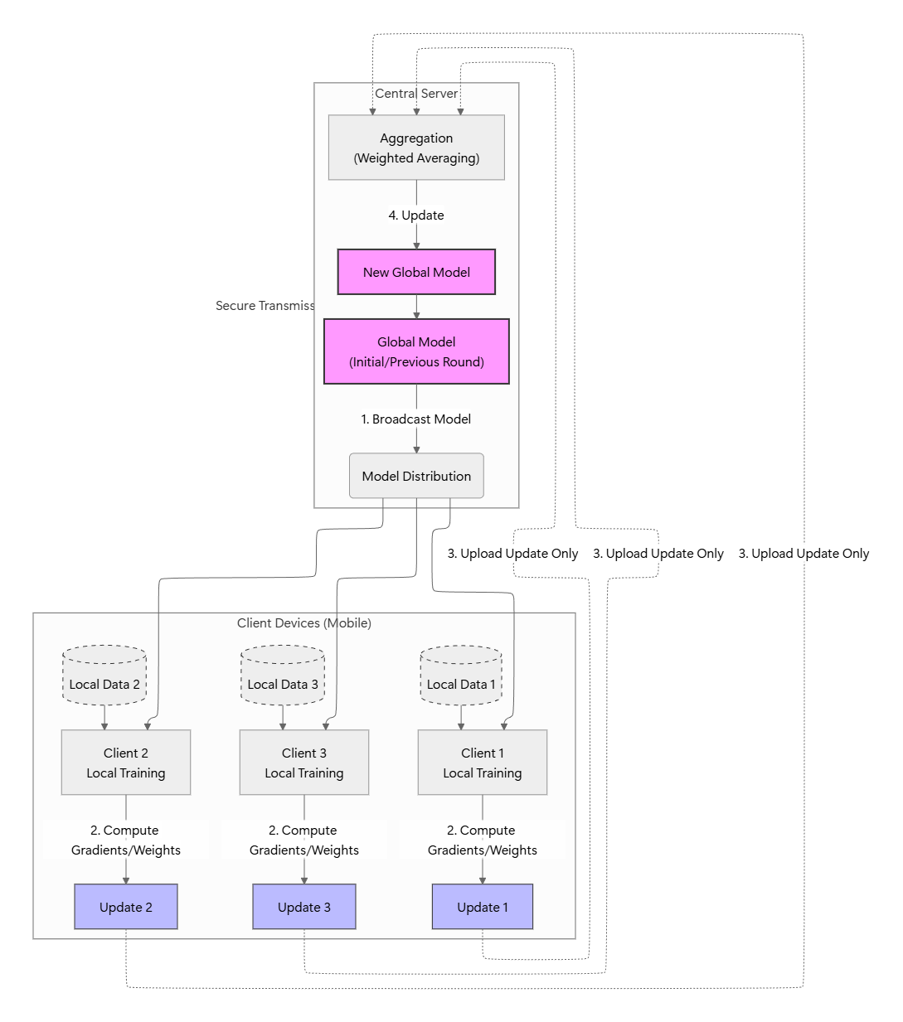
- Local Training: Each of the machines are trained on its own data, in a series of epochs that lead to modifications to the parameters. Despite the fact that the computing power of the client machines is also low in comparison with that of the servers, the privacy is ensured, as the techniques like model compression or by not participating in all instances are used (Zhou et al., 2022, p. 1).
- Secure Update Transmission: Model updates that are encrypted therefore post updates in a secure way and are learned insights without revealing the knowledge on which the insights are founded.
- Aggregation and Global Refinement: The server makes use of the aggregation to produce a superior global model (e.g., averaging) that is resistant to malicious or erroneous updates (Konecny et al., 2016).
- Iteration: This is made to repeat until the convergence in order to be able to come up with models that can be utilized in the processes like customized predictions in mobile keyboards or wearable.
This model utilizes the abundance of client information, and is dependent on the providers of the service despite the profile itself and this reduces the chances of manipulation of behaviour, specific advertisement, or commodification of the information. The efficiency of communication and training processes conducted to attack the resource constraints affecting the client devices also do not affect privacy (Saif et al., 2025). Finally, FL will allow the equitable development of AI by providing privacy-saving material of distributed devices.
However, there is no free lunch. The Federated Learning System also comes with a compensation. This compensation comes as the accuracy level of the models and the recommendation system as compared to the centralised learning systems. In other words, the centralised recommendation systems because they intake raw data from the devices have greater accuracy as compared to the Federated Learning Systems because the federated learning system do not give out raw data to the centralised server and hence centralised server does not know the use and patterns of each user individually. Hence the Federated learning system only averages the aggregated results of models received from individual devices and not the raw data itself. Had they received the raw data themselves the accuracy would be greater but they do not. But on the other hand, the privacy is maintained. This paper tries to establish a sweet spot between accuracy and privacy of Federated learning system in mobile phones. Since as we discussed that there is no free lunch so obviously there is a trade-off between accuracy and privacy when it comes to Federated learning system. So, we have to find a sweet spot where both accuracy and privacy work the best and work in the most optimal way possible. This does not mean that the accuracy will match the accuracy of a centralised learning system or the privacy level will be the maximum this is impossible. Our goal is to find the optimal point where both accuracy and privacy are at their best when it comes to Federated learning system and we are not concerned with comparing the accuracy and privacy with centralised learning system because obviously centralised learning system have far greater accuracy but far lesser privacy so we are not comparing that here. We’re only trying to find the optimal point where Federated learning will work best in terms of both accuracy and privacy. (Cowlishaw et al., 2025, p. 15; Eichner et al., 2024; Lincy & Kowshalya, 2020, p. 265; Tayyeh & AL-Jumaili, 2024)
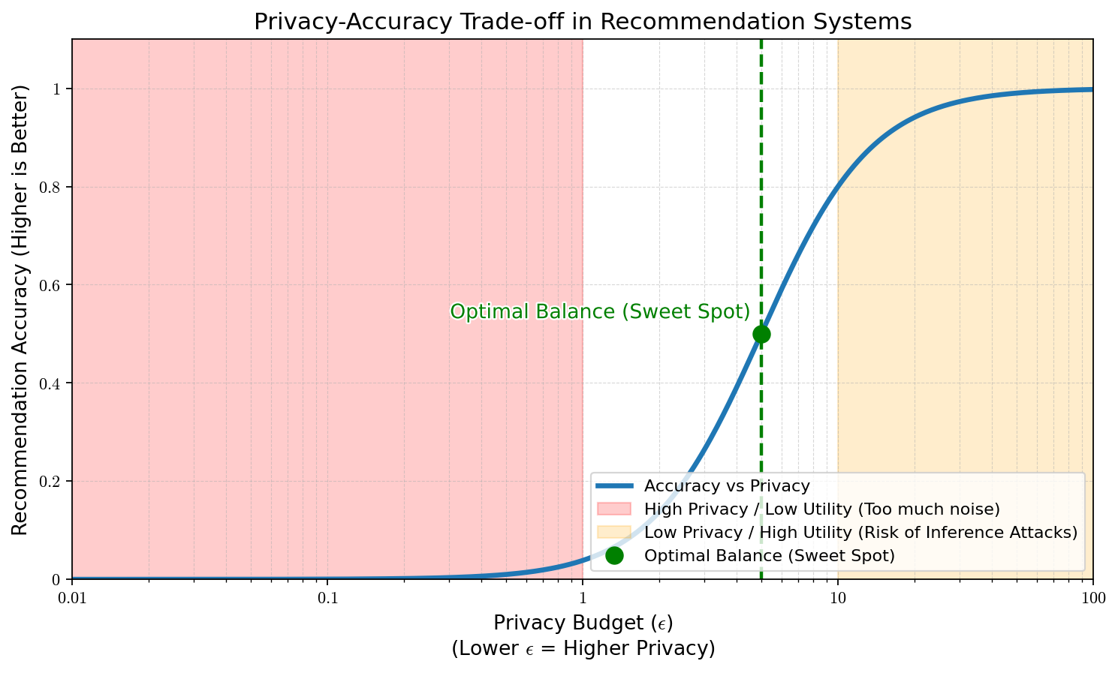
There are three approaches suggested for Federated Learning algorithm:
- Privacy: Privacy is a mathematical framework which makes sure that the output of the trained model is almost same with the user's data included in the dataset or without it (Zhang et al., 2023, p. 997). It is measured by (Jiang et al., 2019, p. 252).
- Homomorphic Encryption: This technique first transfers the user's data into what is called "ciphertexts" and encrypts it (Cheon et al., 2017). Then it executes computations to be done on the cipher texts; instead of the raw data. The results of these computations is another ciphertext which when decrypted is very similar to the results if the computations were performed on raw, unencrypted data (Cheon et al., 2017).
- Secure Multi-Party Computation: This method works in such a way that the central server only sees the aggregated result and never the individual data (Pinkas et al., 2009). This is done through adding noise to the individual data point in such a way that when the aggregation occur in the central server, the noises cancel out and an aggregated result is obtained while at the same time, the central server misses out on what the individual data was (Dwork et al., 2006).

Differential Privacy
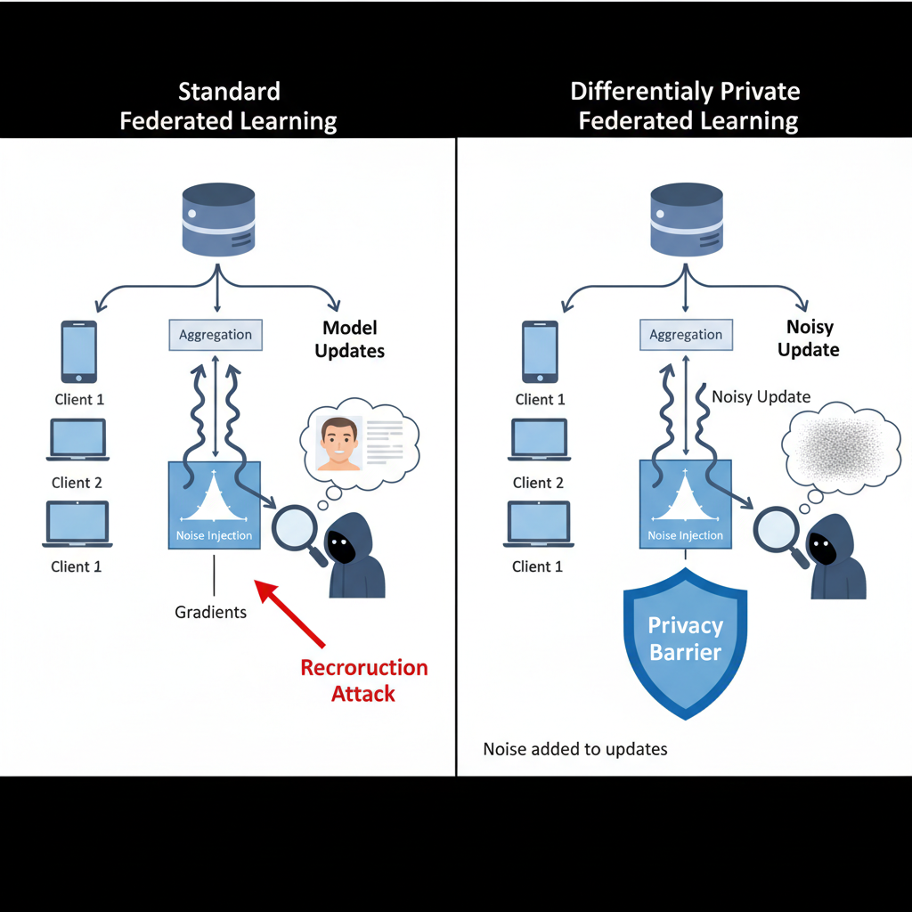
The whole idea of Federated learning is that the data does not leave the device. However, research has shown that when the models are updated either the global models or the local models when they are updated they leak out very crucial information about the device and the pattern the user is dealing with. The model updates which are also called gradients or weights shared by clients can leak sensitive information about the underlying training data. To deal with this kind of problem privacy is integrated into Federated Learning Pipeline. In a sense, privacy is a mathematical framework which actually limits the amount of data or the amount of gradient that an adversary can infer about any single user’s participation in the training process. (Chen et al., 2024, p. 12; Eichner et al., 2024; Kerkouche et al., 2021, p. 5).
In simple word if enough gradients are observed by the attacker, the attacker can reverse engineer the whole process and reach the initial data which created all these lists of gradients. To explain the vulnerability the relationship between the data and the gradient $∇L\left(ω,x\right)$, points in the direction that minimizes loss for the specific data point $x$. This gradient carries fingerprint of the datapoint $x$. In other words, if there are enough gradient, then all the gradient can be reverse engineer to find the original data point. So this is a serious vulnerability. This technique is called deep leakage.
privacy ensures that the output of a randomised algorithm remains roughly the same, even if one or two users data is absent or corrupted in anyway.
Formally, a randomized mechanism $M$ satisfies$\left(ϵ,δ\right)$- Privacy if for all adjacent datasets $D$ and $D'$ (which differ by exactly one user) and for all possible sets of outcomes $S$:
$$P\left(M\left(D\right)∈S\right)≤e^{ϵ}P\left(M\left(D^{'}\right)∈S\right)+δ$$
- $ϵ$ (Epsilon): The Privacy Budget. It controls the maximum distance between the output distributions. A smaller $ϵ$ implies stronger privacy (the distributions are nearly identical) but potentially lower model utility (accuracy).
- $δ$ (Delta): The probability that the privacy guarantee fails. This is usually set to be very small (e.g., less than the inverse of the dataset size).
- $M(D)$ and $M(D^{'})$: They are the outputs of the algorithm in Dataset (Sun et al., 2024, p. 4; Zhao & Liu, 2023, p. 4)
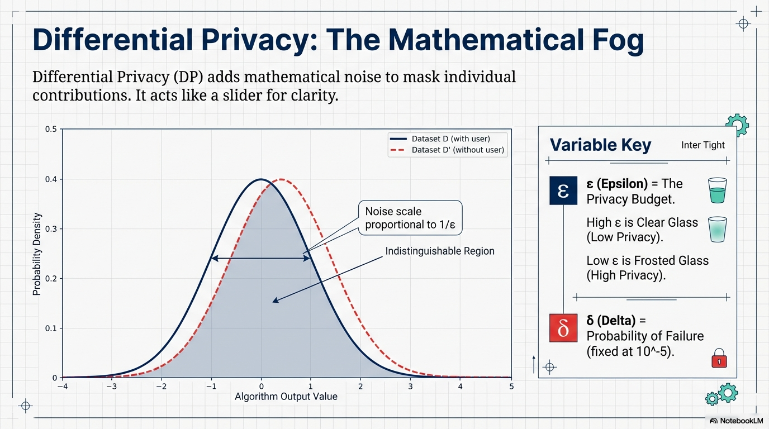
The anonymity of data points (gradient) which can be reverse engineered to arrive back at the original data point is solved by making the data point a probability data point instead of deterministic data point. This kind of adds a layer of mathematical fog so that no single tile in a Mosaic provide enough contrast to identify a specific individual who put the tile there. The tile is basically an analogy, that let’s assume there is a portrait or there is a Mosaic made up of many different tiles and each tile is placed by different individual. Also, assume that each child has a meta data which does not directly name the person who put the tile up there. However, it details the other information about the person like their address, their phone number and the date at which that I was placed up there. An intruder can reverse engineer this information by making sure that particular address, phone number, et cetera Max, their neighbours and that the neighbour was absent in their house on that particular day on which the tile was placed, so this clearly indicate the person was, even though their name was not taken. This is how the gradient cause problem and the attacks and the intruders can benefit out of it. Adding a mathematical fog and a proper fog helps a bit. (Guo et al., 2024, p. 6; Maggi et al., 2011, p. 4; Zheng et al., 2024, p. 5)

Homomorphic Encryption
In standard encryption and decryption, data exists in two forms. First is transit form and the other is rest form. Transit form is also known as Moved data. The REST form is also known as stored data. The purpose of encryption is that it has to effectively store the data in the two states. As long as the data is encrypted, it is faithfully safe. However, when some computation has to be performed, for example some machine learning or some addition, subtraction has to be performed, the data has to be decrypted and exposed to the processor and the operating system. This creates a small window of vulnerability, and this window of vulnerability is known as “Data in use”.
Homomorphic encryption solve this problem by performing calculations and computation on encrypted data instead of exposing the data to the processor and the operating system. The result which is obtained by computing on the encrypted data is also encrypted. However, when decrypted the decrypted data is almost same as the result obtained by performing the same computation on the unencrypted data. So in other words, let’s say we have two cases in which we are performing same competition on two unencrypted data and performing the same using homomorphic encryption. The result obtained from the homomorphic. Encryption computation will be similar to the one which we obtain from the unencrypted data. However, hundred percent accuracy is not achievable. (Abed, 2025, p. 299; Lu et al., 2020, p. 13; Minelli, 2018, p. 85; Shin et al., 2021)
Small example of mathematical definition of homomorphic encryption is as follows.
- Let $M$ be the space of plaintexts (raw data) and $C$ be the space of ciphertexts.
- Let $E$ be an encryption function and $D$ be a decryption function.
- Let $⋆$ be an operation in the plaintext space (e.g., addition or multiplication).
- Let $∘$ be a corresponding operation in the ciphertext space.
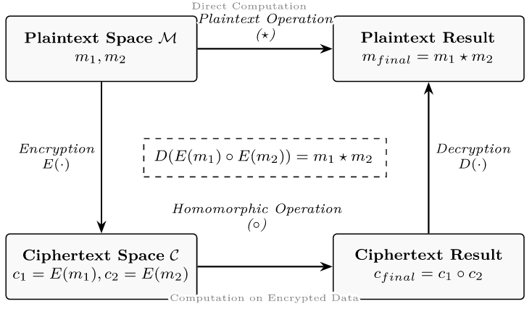
The encryption is Homomorphic if:
$$D\left(E\left(m_{1}\right)∘E\left(m_{2}\right)\right)=m_{1}⋆m_{2}$$
This equation states that performing the operation $∘$ on the ciphertexts and then decrypting is equivalent to performing the operation $⋆$ on the plaintexts.
Note that the operations or the competitions that are performed on encrypted data and unencrypted data are different, this is because the data are different when encrypted and hence to achieve a similar result to different computations are needed. Hence, the equation above presents two different operations instead of one.
One example of Homomorphic encryption is what is called RSA.

Secure Multi-Party Computation
Secure multiparty computation is another cryptography or encryption algorithm in which a set of parties, jointly computer function over their inputs while keeping the inputs Private. Secure multiparty computation also resembles homomorphic encryption any sense that it protects the data at its processing. While traditional encryption protect data at transmission and storage, this protects the data during the time of its use, also known as the data-in-use. (Secure Multiparty Computation, 2011)
The problem was introduced by a person named Andrew Yao in 1982 as millionaires problem. So the problem is that two millionaires want to know who is richer without reviewing their actual net worth or their assets to each other. This problem can be extended to number of millionaires show in a general sense $n$ parties $P_{1}, …P_{n}$ with their private inputs (asset details) $x_{1}…x_{n}$ wish to compute the function $y=f(x_{1},…x_{n})$ with following conditions:
- All parties learn the correct output of the function $y$ which has been calculated.
- No party, learns anything about any other parties, inputs or asset details, except what can be inferred or concluded from $y$ and their own inputs. (Grigoriev et al., 2017, p. 381)

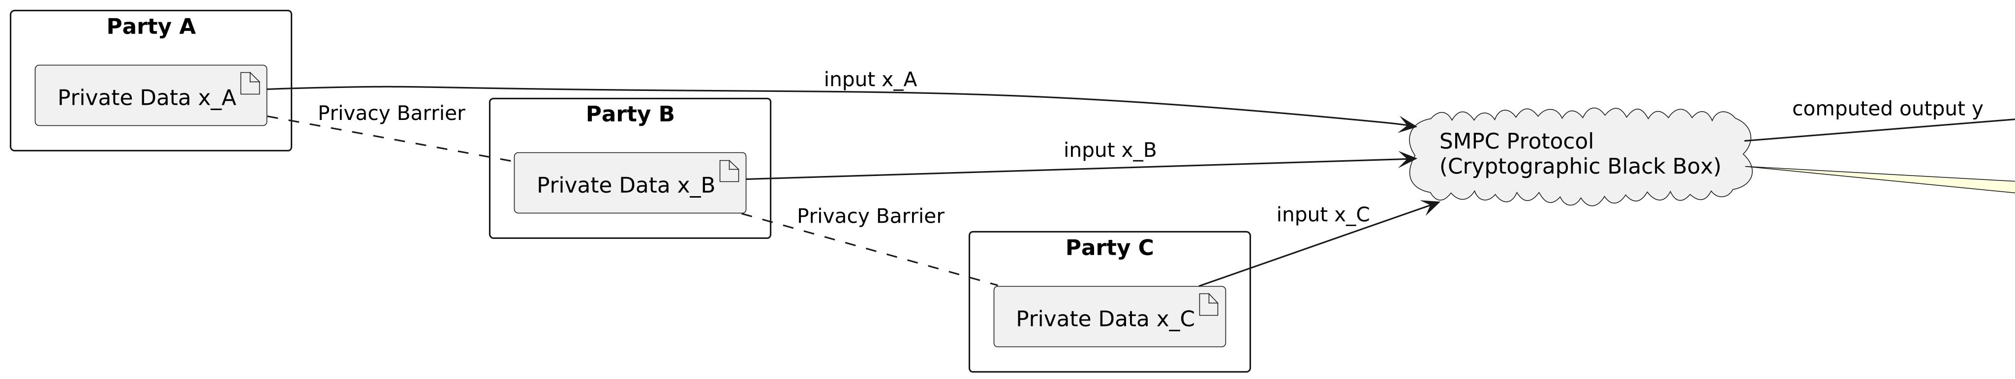
Ideally, there is something called trusted, third-party or TTP. So in an ideal world, this TTP is a trusted party, which computes the function$y=f(x_{1},…x_{n})$ faithfully. All the parties sent their inputs to this TTP to compute the function, the TTP then computes the function without revealing anything to the parties, and then it sends back the output to the parties without reviewing the inputs of any party to any other party. The only input that a party knows their own inputs and nobody else’s, and the other thing that they know is the output that TTP has given to them, that way they come to know who is the richest millionaire among all the $n$ parties. (Agahari et al., 2022, p. 1578; Najarkolaei et al., 2024, p. 7)
However, there is no PTP or trusted third-party in the real world because if we burden any party or any institution to encryptor descriptive the messages, there is always a danger that they will misuse the data and manipulate the parties. In the world, we use what Is called $π$ protocol which involves exchanges of messages. (Hazay & Lindell, 2008, p. 430).
Now this protocol is considered secure if let’s say we have an adversary $A$, in the real world, and a simulation $S$ in ideal world such that what the adversary sees in the real execution is exactly same as what he will see in ideal execution. In other words, For every adversary in the real world, there exists a simulator in the ideal world such that the views of the parties in the real execution is computationally indistinguishable from the view in the ideal execution. That means the adversary should not be able to do anything in the real protocol that they could not have done in their ideal world. This is how secure multiparty computation protects the data in the real world.
Two primitives form the backbone of most MPC protocols: Oblivious Transfer and Secret Sharing.
Irrespective of the above-discussed algorithms and protocols, including the adversarial perturbations, homomorphic encryption, RSA, and secure multiparty computation, the federated recommender systems are still many miles to be completely safe and effective. Such systems that allow mutually training models to be undertaken by the devices that are decentralized, without direct exchange of raw information concerning users are likely to fall victim to sophisticated attacks such as inference attacks. In federated learning, inference attacks make use of the aggregated model changes (gradients) sent by every learning round to decode sensitive user information, e.g. personal preferences or viewing history, which should be regarded as a breach of the privacy principles of the framework itself (Cilloni et al., 2021, p. 156; Zheng et al., 2024, p. 5).
Moreover, the information of the users is not homogenous, and this is a significant threat. In practice user data in any realistic context are usually not expected to be typically independent and identically distributed (non-IID), and the tendency of the distributions of preferences, the distributions of interaction dissipating across a wide spectrum are likely to occur because of the conditions of a circumstance or demographic usage. Such a non-IID character can result in the biased models of the world, a reduced rate and quality of convergence, and such models are local and trained on independently specific data, which should not be aggregated to perform an adequate generalization.
The best compromise between the two i.e. accuracy of the recommendation and preservation of the privacy is therefore of high importance in the resource constrained resources such as mobile phones where the models keeps on being updated to follow the changing pattern among the users. The privacy which is unreasonably high, utility will be driven to a minimum and more than liberal privacy will result in the exposure of the data.
The problems of trade-offs between accuracy and privacy in the federated learning are referred to in the provided paper using the case of the movie recommender systems in mobile devices. In evaluating the effectiveness of federated movie recommenders using varying privacy settings we do also consider their effectiveness in terms of local training epochs and also client sampling plan and aggregation plan on data. Specifically, we examine implications of such a privacy-related trade-offs as lossless noise multipliers to privacy budget and privacy level indicator (e.g., specifies privacy level 5) does affect such valuable indicators as recommendation precision, recall, NDCG and user experience indicators (e.g., rate of session satisfaction). The ancillary costs we also measure (in terms of CPU or GPU cycles used to perform an encryption or noise addition, network overheads (also called secure aggregations), battery overheads, and latency spurts) are then tested in actual mobile hardware (Android phones).

The Trade-off
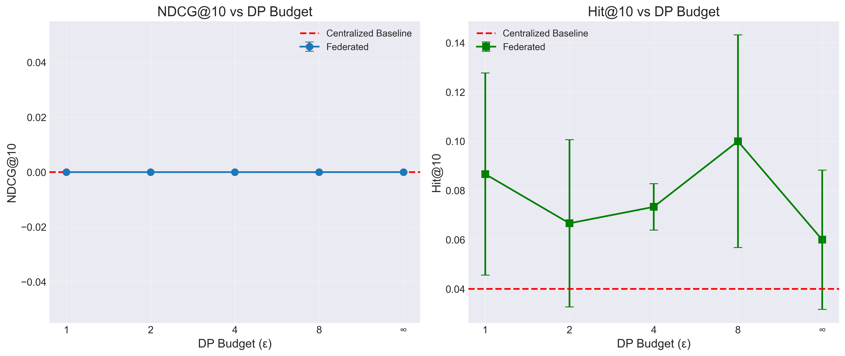
The main question these graphs answer is: "How much does the model's performance suffer when we add privacy protections?"
The horizontal axis represents the Privacy (DP) Budget, denoted by the Greek letter epsilon $(ϵ)$.
- Privacy is a mathematical definition of privacy. It works by adding "noise" (randomness) to the data so no single individual can be identified.
- $ϵ$ (Epsilon): Think of this as a "clarity" slider. The lesser the value of $ϵ$, the greater the privacy. This means, that the system adds more noise (randomness) to the data so that backpropagation to the original data points is difficult.
- Low $ϵ$ (e.g. 1): means High Privacy. The system adds lots of noise to the data to mask individual identities. It is like looking at a photograph through frosted glass. Very hard to decipher and learn from.
- High $ϵ$ (e.g. 8): means low privacy. Less noise is added. The photo is now clearer.
- $∞$ $ϵ$: No privacy noise at all. This represents the standard Federated Learning performance without the specific constraints of Privacy.
In order to perform our experiments, we have used a comparably well-known database in the context of the recommender systems research: it is also called MovieLens 1M. The fact that it had a solid basis on a justifiable analysis because it had a million movie ratings with thousands of its users. In order to make it realistic we just simply divide the data set into two data sets i.e. training data set and testing data set. This way we would clearly see the performance of federated learning model in different privacy settings - as they do on actual human beings whereby privacy of the person is a primary issue. Splitting the data and attentively We have made sure that we had numerous users in our models so that we can study with a range of user tastes and movies choice. This assisted us in getting into the literarily the mode that privacy trade-offs can possibly cause on the quality of suggestions.
After we had fiddled with the privacy settings of our federated learning space there were a few interesting trends emerging. An illustration of this is provided by the fact that as we worsened the privacy budget (epsilon) system inverted the privacy defence - or it induced less noise in the data. This contributed towards the model learning in a much more explicit manner since one of the most significant cause of better suggestions will be that the model was later able to concentrate on trends with simplicity. This is however with a spin to it; Less privacy actually means more risk among the users. Pushing this too far will result in the loss of the main benefit of utilization of federated learning (inability to inflict harm to information of the user). The whole plan was then more or less, to make sure that we do not deprive anybody of his or her privacy, in the name of attempting to make a little addition of accuracy.
In order to put this trade off into a slightly greater perspective we will speak of one of the figures of HR@10 ( Hit rate at 10 ). This is hence the solution to the posed question of the number of times that the system will get the right movie that will be in the list of the top 10 recommendations. Once we go above 0.5 that is mostly held as pretty good, i.e in doing so it implies that there is the useful system that has not lost its privacy. Our results, supported in prior research (Minto et al., 2021) indicated that even with a very high privacy guarantee (which here was in the form of a privacy) we could target the values of the HR to a level of 0.68 when given on a big data (in this case, on 50,000 users and 5,000 movies) with a big data. That's quite encouraging! It is shown that the federated learning will be able to help in the provision of smart suggestions without revealing the privacy of the participants due to the streamlined privacy settings.
On the whole, the results can do a lot to ensure that the importance of further expanding the points of intersection between privacy and accuracy is made acceptable. The discussion of the boundaries of privacy protection has taught us much of how federated learning may be implemented in practice even in the situation with the mobile devices that do not need the space to be so extensive. These results are not merely an affixation of the fact that privacy friendly recommendation systems can exist; however, the outcomes also give some useful insights to the users of the recommendation system a hint at the developers that would perhaps seek to find out the optimal balance between utility and privacy. Concisely, our subsequent study of this area indicates that when judiciously selected through suitable privacy options, federated learning will be the right choice of provision of safe and efficient personalised suggestion in everyday scenarios.

Challenges and Adaptive Mechanism
In a collaborative machine learning innovation, federated systems such as FedSlate develop these recommendations systems to be designed in such a way that more than two parties collaboratively learn a model without the agencies having to share user information (although eventually they might share it indirectly). However, the advantages of such approaches are potentially negative impacts on uneven distribution of benefits among parties involved. More specifically, organisations or sites with fewer users (probably due to limited numbers or reduced analysability) are more likely to see increased accuracy of the recommendation than the ones with stronger sources of feedback. The rationale of this relationship is that privacy-saving techniques and, in particular, privacy introduce noise to user data to the extent of blurring personal identities. With less information entities, it can be used to have a positive mask to fill the gaps of information and more or less equalises the playing field. Conversely, the user feedback is abundant and high quality on participants making them, it may easily become diluted by the same noise and reduces the accuracy of the recommendations thereby causing a lowered user satisfaction. (Cunningham et al., 2024; Deldjoo et al., 2023; Jabr & Rahman, 2022, p. 1520)
This is an imperative fact that draws one of the most important issues of federated recommendation system, namely, the trade-off of privacy and utility itself. The reason why privacy is used is to safeguard individual users to ensure that they cannot be distinguished individually even in an aggregate analysis. However, by employing these privacy safeguarding strategies one willingly introduces imbalance in the performance of the federated players. A case in point would be the organizations that are less engaged by users since with diminished noise the entities will be less impacted and similarly, their functioning will compare to bigger entities. It is also probable that all organisations that have exposure to heavy amounts of user feedback are likely to experience a decrease in recommendation accuracy, as the amount of noise introduced to the system to guarantee privacy will deteriorate, and will hide valuable behavioural predictors within the datasets the organisation is provided. (Cummings et al., 2024; Müllner et al., 2023, p. 4; Puglisi et al., 2016, p. 3; Yu & Jaakkola, 2014)
Privacy and utility: this is tricky contact which requires application of a multidimensional observation of federated recommendation systems. The privacy mechanisms cannot be simply judged in terms of their efficiency because it is as well crucial to deeply examine them in the area of fairness. It has to target the assurance that privacy protecting practices are favourable to all the categories of user, regardless of the extent of their involvement, and the depth of information they consume no matter how minimal. This is essential in making sure that no cases of over-benefits or wrongful harming of some groups of users or organisations are present. In other words, the challenge lies in ensuring that the privacy assurance is provided, and at the same time, the utility and equity of recommendations are not undermined to the stakeholders of the federated ecosystem. (Cai et al., 2024, p. 1; Sun et al., 2024, p. 1)
To successfully go through such challenges, adaptive privacy mechanism must be used. Unlike with the application of the static technique where privacy budget is equally applied to everyone participating in the system, the adaptive mechanisms are developed or modelled similarly, in that they are able to dynamically adjust privacy settings in response to real-time system feedback and learned performance deviations. Such processes are constantly monitoring the privacy and utility trade-offs, which are evolving, to enable the system to maximize the privacy settings of individual players or groups. An example of this is that, in case one particular entity turns out to be particularly affected by the noise of privacy, then the adaptive mechanism can be used to ensure that they have a lower appropriate privacy budget so that their accuracy of recommendations are not impaired unintentionally. Conversely, the participants possessing a more abundant data can be calibrated through the mechanism of noise with a lower likelihood of increasing the privacy paranoia that will unreasonably reduce utility. (Cai et al., 2024, p. 9; Tinsley, 2011)
It is shown through empirical literature that adaptive privacy approaches result in a huge loss in utility and simultaneously, they result in targeted privacy. They are able to be significantly smarter than the traditional privacy settings in the manner in which they allocate privacy resources in those areas where they are most needed, which would ensure a maintenance of a privacy at minimal compromise and trade-off of the accuracy and fairness. However, there are still difficulties that occur despite the developments. Even federated networks like FedSlate will yield disproportionate returns unless privacy budgets are provided to fit local demands and requirements of each of the participants. With this, adaptive privacy budgeting must be built and communicated to activate fair results and to make the system not favour the ones that receive the least of users and penalize the ones that belong to the stronger dataset. (Hiniduma et al., 2025, p. 8; Wang et al., 2024, p. 12; Wasif et al., 2025, p. 10)
Recommendation algorithms ought to be reviewed too so as to ensure relevance and applicability of algorithm in real life. It implies that it is tried on various platforms, demographics, data structure, and devices that have varying resources. Such harsh examination is required not only to comprehend the efficacy but also to verify equity and inclusiveness since the two elements directly affect client satisfaction and engagement. One major limitation that the existing federated recommendations styles are trying to resolve is that they are not seeking to determine more intensive semantic and behavioural links among the users during the model update aggregation. This weakness could restrict the overall power to prescribe or some non-conscious patterns of user behaviour may be lost in this step of generalisation. (Abdel‐Hafez & Xu, 2013, p. 10; Gandon, 2002, p. 47; Gu et al., 2021, p. 4070)
To address these gaps, there is a need to do it in an intricate manner. Equity enhancement, adoption of dissimilar data formats, and trade-offs between privacy and utility satisfaction, as well as creation of adaptive controls, are all eminent fronts and frontiers of research and development in the future. One of the potential avenues is the development of the user-acceptable federated recommendation systems whereby people are freely allowed to modify their privacy parameters. Such an individualised approach may be applied to rectify preventable inaccuracy in the case of over-protection as well as avoiding leakages of information. Systems can be better risk-specific and expectation-specific in that users make their privacy settings informed to aid in guaranteeing the level of privacy protection. (De & Métayer, 2018, p. 118; Zheng et al., 2025, p. 17)
A research direction that is aimed at improving dynamic privacy systems, which maximize the trade-off which exists between privacy, utility, and fairness should be one of the research directions in the future. It is noteworthy especially in heterogeneous user population and complex data environment where a one-size-fits-all approach is most likely to fail. In addition, in federated learning systems where the interaction information between the users is sparse it is dire to apply data augmentation, as well as skilled spreading of information across richer datasets in federated learning. Such strategies will have the capability of enhancing both strength and effectiveness of models of recommendations which will be capable of operating in a dependable manner even during data paucity. Last but not the least, federated recommendation system development requires the ability to balance between the maintenance of privacy and high utility and equity such that every one of the users experiences safe, efficient and personalised recommendation in their everyday lives online. (Ammad-ud-din et al., 2019; Roy et al., 2024, p. 29; Sun et al., 2024, p. 1)

Related Work
The section under consideration evaluates the literature content related to federated learning in reference to recommendation systems with particular focus on privacy-preserving tools and their impact on the model results. It reviews as well a number of strategies of how to solve the challenges of data heterogeneity, communication efficiency and equity in federated recommender systems and how the rating bias is effectively handled by the models. The latest innovations in federated learning as a recommendation system, such as FedRec and FCF, have primarily focused on matrix-factorization-based collaborative filtering, and FedMF also has a homomorphic encryption transmission of the gradients. Regardless of such developments, the majority of the existing literature is inclined to disapprove of the multifacetedness of the challenges of fairness, prejudice, and the threat to the integrity of the systems that play a fundamental role in generating effective and robust recommender systems. Even though some of the literature attempts to enhance effectiveness of federated recommender system by suggesting mechanisms through which convergence can be expedited or lightweight communication based on lightweight communication is offered, a holistic understanding of veracity and faithfulness of federated recommender system with various model of attacks is yet to be accomplished as a research. Moreover, one of the opportunities of higher performance and privacy facilitated by the adoption of foundation models in federated recommendation systems is the fact that the technology is still in its infancy. More specifically, they apply their massive pre-training knowledge in the models to improve the quality of the recommendations and federated learning is used to make the sensitive user interaction data fed to fine-tune the models local. However, to fully incorporate the opportunities suggested by the foundation models in federated recommendation systems, a novel area of research is required to explore the phenomenon of how their pre-training, and capabilities can be used to mitigate the problem of heterogeneity in data and improve the effectiveness of model aggregation. Paradigm shift in this federated environment suggested in the recent literature using large language model will entail simplicity of data integration and complete utilization of large language model to attain better results, but, at the expense of augmented communication due to large parameter sizes. (Chen et al., 2023; Faiyaz & Salman, 2025, p. 1; Jiang et al., 2025, p. 28; Moreno et al., 2025, p. 2; Sani, Iacob, Cao, Lee, et al., 2024; Sani, Iacob, Cao, Marino, et al., 2024, p. 3; Yao et al., 2024, p. 1)
In this part, the available literature on the topic of federated learning mechanism in recommendation systems is presented and, in particular, the privacy-saving mechanisms and their impact on the performance of the model are discussed. It also dwells into various mechanisms of coping with such problems as heterogeneity of data, efficiency of communication and equity of federated recommender systems and how the models can be utilized to effectively deal with the problem of rating bias. Recent trends in federated learning as a recommendation system which include FedRec and FCF, has largely focused on collaborative filtering and matrix factorization of the matrices FedMF also incorporates a homomorphic encoding aspect to transmit gradients in a secure manner. In spite of such developments, many of the existing studies are inclined to dwell on the primitive aspects of equity, bigotry, and risks to system integrity, which play a vital role in the formulation of effective and trustworthy recommender systems. However, the research of fairness, integrity in the circumstances of various attacks is an active research question in spite of the particularity of other studies aimed at enhancing the efficiency of federated recommender systems by accelerating convergence or by using light-weight communication schemes. In addition to that, the foundation models supported by federated recommendation systems represent a shining light to high-performance and privacy despite the fact that the sphere is still at its initial developmental phases. Precisely, the models, on the one hand, take advantages of their widely computerised pre-training knowledge in order to better the quality of the recommendations in which also federated learning maintains the sensitive user interaction data utilised in a fine-tuning process localised. However, the complete capacity of foundation models to the federated recommendation system is achieved with the perception of how their pre-training capabilities can be applied to address the problem of data heterogeneity and serve to optimize the effectiveness of model aggregation. Whereas the recent literature suggests as an application of large language models, the idea of large language models in such a federated structure suggests rather a change in the thinking of data integration, which is not necessitating a complete utilization of the large language models but suggests that it will be driven by a paradigm shift to the complete utilization of the large parameters in data integration at an increased communication cost. (Arnold et al., 2024, p. 1; Guran et al., 2024, p. 1; Halevy & Dwivedi-Yu, 2023; Javaid et al., 2024, p. 19; Qu et al., 2025, p. 18)
Other issues, raised with this integration, include unfamiliar issues regarding privacy-security trade-offs as well as non-IID data distribution management issues that are situation in federated settings. Furthermore, in spite of the fact that federated learning has privacy-friendly properties, nowadays the federated recommendation systems are scarcer in their abilities, such as the impossibility of working with non-IID data distributions, and reduced the performance of the models under the influence of privacy-saving processes. As a way of managing those problems, the necessity to shift to more developed federated learning models and secure a high rank of dealing with different data characteristics and high-quality recommendations and high privacy policies. Development of frameworks that can ensure the impartiality and fairness of the recommendations, privacy of the users and disclosure of the outcomes is significant in improving the future recommender systems. In particular, the introduction of large language models and foundation models to federated recommendation systems introduces the new paradigm in an attempt to increase the scope of the generalization of such systems, as well as the quality of its recommendations, which are limited by the classical approaches to collaborative filtering. It is through this integration that the foundation models possess vast pre-trained knowledge that allows it to be capable of solving data sources sparsity and cold-start problems and federated learning provides privacy reassuring form of personalized recommendations. (S. Li et al., 2024, p. 11; Z. Li et al., 2025, p. 1; Zhang, Long, Guo, Liu, et al., 2024, p. 2; Zhang, Long, Guo, Xiao, et al., 2024)
Indicatively, with an example, federated adaptation mechanisms can be employed to permit desire -shift variations amidst a user in an agreeable and privacy conscious means with featherweight customized adjustment on client devices. One significant benefit of the approach is that the communication overhead of exchanging large-sized model parameters is reduced and, therefore, improves resource-limited mobile environments. Moreover, another potential solution to the suggested system enhancement suggests implementing large language models into the federated learning systems because large language models have an opportunity to leverage their large pre-trainings and generalization capabilities to address the issue of data scarcity and increase personalization. This remedy however comes at a cost in that new techniques are necessary to interdiscipline the computational demands of large-scale models with privacy guarantees provided by the federated learning in the situation of resource-limited environments. The decrease of the data sparsity and heterogeneity of the client devices which typically leads to diminished model performance in classical federated systems of recommendation is another issue of the field importance. More research on the ability of such models to be effectively tuned to decentralized data and the fact that their privacy processes do not attract the attention of the quality of recommendations and fairness can also be conducted. The Federation Foundation Models development presupposes these issues with the help of collaborative learning in federated structures toward the improved model performance and data privacy as well as the possibility to develop more personalized and context-sensitive models. It has the possibility of increasing data and has a smaller computational requirement, with the pre-training and data augmentation techniques, and serves as an option to the problem, such as the shortage of data, variability in computation, etc. More so, federated foundation models offer a robust privacy-preserving scheme to collaboratively fine-tune models with varying disparate and decentralized and non-IID data, combining parameter-efficient and personalization models to decrease the communication and computation expenses. (Ren et al., 2024, p. 2; Woisetschläger et al., 2024, p. 8317; M. Yang et al., 2024, p. 13; Y. Yang et al., 2024; Yu et al., 2023, p. 3)
Ultimately, the core insight that makes everything click is that Federated Learning is not just a privacy feature; it is a distributed optimization problem under constraints. We are attempting to minimize a global loss function $L(θ)$ (representing recommendation error) without direct access to the dataset $D$ over which $L$ is defined.
$$\min_{θ} ∑_{k=1}^{K} \frac{n_{k}}{n}L_{k}(θ)$$

Federated Learning in Mobile Environments
This unification whilst seemingly highly promising presents a number of challenges in specific ways and in peculiar details in specifically mobile settings where devices are frequently constrained by low computational ability, battery life, storage capacity as well as on and off network, inconsistent connections. All these constraints necessitate the development and deployment of highly optimised communication protocols that can be run under variable bandwidth conditions and parameter-efficient fine-tuning controls (minimise memory footprint and computational overhead) during trainings and inference on devices, One of the key elements in this respect is the requirements of memory-efficient recommender systems that can be executed on the leveraged mobile devices of high-end smartphones to less advanced handsets. To that end, novel techniques of compressing the models such as quantisation and pruning are required, which are beneficial in terms of minimizing the size and complexity of the recommendation models without compromising with their predictive capability. Other problems that make lightweight neural architecture, adaptive offloading schemes and the use of modular model components with selective model updating are the problem of cold start in which new users or items have little or no history of interactions information to produce high-value recommendations. (Gangadharan et al., 2024, p. 11; Luo et al., 2024, p. 1)
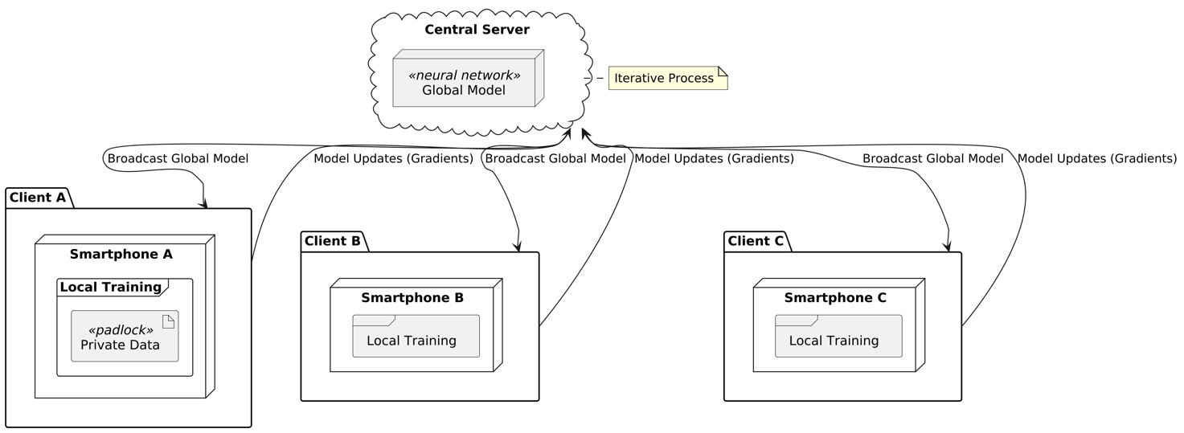
This is more so when it comes to federated environments in which data is spread and there are privacy concerns involving the sharing of the data of users. Getting over with this implies that they employ complex techniques, like meta-learning and data enhancement. By modifying models with adaptability to new users or items based on prior knowledge learnt during the execution of a myriad of tasks, meta-learning can help new users or items achieve better generalisation on limited data. The other is data augmentation which artificially creates additional data to be used in training or the effect of current data to be augmented to enhance the learning process to counter the sparsity and augment the robustness of the model. A combination of these methods can allow this system to produce valuable recommendations even in data sparse environments. Moreover, testing of federated recommendation systems in the mobile environment should move beyond the conventional metrics of accuracy to include testing of privacy leakage, communication cost and system utility as a whole. This is composed in the formulation of successful methods of measurement to the extent to which privacy preserving methods including privacy and secure aggregation, safeguard the privacy of individual user data to the cost of subtracting the performance of suggestions obtained. In practice, this is typically a very fine balancing act because on one hand, the provision of increased privacy by the means of noise, cryptographic or other tools may compromise the quality or expressiveness of the model and on the other end, greater respect towards the utility might also increase the cost of privacy of the systems - the architectural design of federated learning systems in mobile recommendation systems is therefore a matter of significant concern to balance these trade-offs. The main points are provision of combination of adaptive privacy budgets, dynamic aggregation techniques by considering device heterogeneity and incentives to produce client sustained participation. More importantly, the system must uphold the abilities of the effectiveness personalisation where the desirability of recommendations is not subdivided when the constraints of the occurrence of local computation and privacy regulations are incorporated within consideration. The trade-offs involved and ensuring that this balance is paramount to real-world implementation because this has a direct effect to user trust, engagement and overall adoption of federated learning based mobile recommendation services. in short, even though the combination of federated learning and recommender systems in mobile setting has a lot of a potential in preserving privacy of the user personalisation, it also demands the radical solutions to the problem of resource limitation, cold starting and the interrelation between privacy and utility. To deal with these problems, highly developed model design, optimisation strategies and integrated evaluation structures are necessary in order to make the most out of potential of this beneficial paradigm and to reveal its full potential in practical scenarios. (Bailie & Gong, 2024, p. 109273; Cummings et al., 2024; Lefkovitz et al., 2024; Schlegel et al., 2025; Wu et al., 2024, p. 10)
This is a twofold purpose of this regularization name as far as fine tuning in the federal process is concerned. The first is that it offers a guard measure to ensure that the revised model parameters do not drift too far to hold back broad based generalised knowledge that has been acquired by the model through the enormous pre-training step on a myriad of datasets. And this is particularly true to the extent that the clients used are highly heterogeneous and small local data, which might be the case in federated learning, and lead to poor performance as well as poor generalisation, as a byproduct of the overfitting of the adapted models to the respective user preferences or other peculiarities of the local domain. (Jiang et al., 2025, p. 13; Yu et al., 2023, p. 322)
Second, regularization term enhances a successful knowledge transfer through ensuring that the difference between the fine-tuned parameters and the foundation model is controlled. It enables the model to take advantage of abundant semantic representations and inductive biases held in the foundation model and also learn to make recommendations to every user individually. Such a tradeoff is so important in federated recommendation systems, where one can suit very well to the needs of a specific user, without the overall intelligences that the foundation model represents. (Zhang et al., 2024)
Such regularization is often carried out by more practical algorithms based on such norms which are called L2 norm penalties, or other constraint based, algorithms that measure and limit the number of fine-tuning deviations that take place. This is so as to ensure that the customizations carried out during the personalisation are effective and reliable so as to have somehow alleviated the possibility of catastrophic forgetting of the powers of the foundation model. The federated system may thus make the up to the most personalised, yet accuracy preserving and privacy preserving as well, recommendations which is a combination of global and local knowledge, which may be put into the specific use cases which are mobile, resource constrained. (Yu et al., 2023, p. 3; Zhang, Long, Guo, Liu, et al., 2024, p. 2; Zhang, Long, Guo, Xiao, et al., 2024)
The way out of this is an interesting solution introduced by the highly learned foundation models with high-level semantic knowledge that can be utilized to generate good representations of users and items and thus allows zero-shot and few-shot learning to simplify the process. The capacity is accompanied by the necessity of providing an adequate transfer of knowledge within the framework of a basis model, which are being loaded into the federated learning environment without subjecting it to a heavy consumption of computationally intensive load. The foundation of web adapt on mobile federated learning is also elaborated to incorporate a balancing of the model structure and training algorithms to be executed using hardcore budgets of resources. It will involve the creation of new solutions in order to quantize and prune optimized to execute on-device inference and federated learning approaches that are able to assist the capabilities of different hardware settings and network circumstances. Such a complicated interaction implies that both the architectural aspects of the foundation models and the limitations of communication of federated mobile environments should be shared broadly to achieve the right accuracy privacy trade-offs. Further bonus plans to attract clients and effective deployment strategies are great in the environmentally friendly platform of the federated foundation model on the wireless field. Speaking more specifically, by using the foundation models and the system of federated learning, we will be capable of performing a more personalized approach and an efficient system of recommendations, by dealing with such concerns as the data sparsity and non-IID distributions of data among the consumers. However, with the integration, new complexities are attached including an effective personalization modelling because of the variety of preferences of the separated clients and effective fusion between collective knowledge of previously trained foundation models and personalization of the users. These complexities lead to issues, and these issues are best addressed by a complex resolution, which is normally a trade-off between the computation problems of large models and privacy protecting on-device learning and efficient knowledge transfer relations in a federated scheme. These methods are usually parameter efficient fine-tuning methods, which can be adapted to the specifics of the individual user, without necessarily doing considerable customization to the large ground model itself. It is a paradigm of teacher-student learning that can be effectively deployed to small devices that belong to clients to utilize the amount of knowledge about the domain of the enormous foundation model. It is a method that is often supported with methods such as knowledge distillation applied in the student model in order to realize causally similar performance with reduced computation costs as opposed to a larger teacher model. It also can be potentially useful in a mobile environment when the computing resources present is minimal; in this case one can have a recommendation system that possesses high capability at levels that do not necessarily overload the available capacity of the device. Besides, parameter-efficient fine-tuning approaches, which can be suggested to supplement quantization approaches like AWQ, can also become a potential solution to running and training these large models on federated networks, which can tackle the technicalities related to the on-device execution. The mechanism is additionally effective as it reduces communication overheads in terms of reducing the amount of data that is transmitted between clients and central server which in turn increases the practicability of executing more compilated recommender systems in the background of mobile that has bandwidth limitation. The federated learning models could be enhanced by adding the foundation models to help improve collaborative filtering through exploiting the immense inductive biases and external knowledge exemplified in FMs and that has been acquired by examining many massive datasets to provide guidance to more common adaptable components of the recommendation system. Not only in making good initial recommendation is it addressing the problem of cold-start, but also in addressing the problem of data sparsity and heterogeneity of distributed mobile dataset. (Gupta et al., 2017, p. 991; Jafri et al., 2022, p. 2; Kannout et al., 2022, p. 218; Pozo, 2016, p. 5; Ralph et al., 2020; Wu et al., 2024; Yuan et al., 2016, p. 1901)
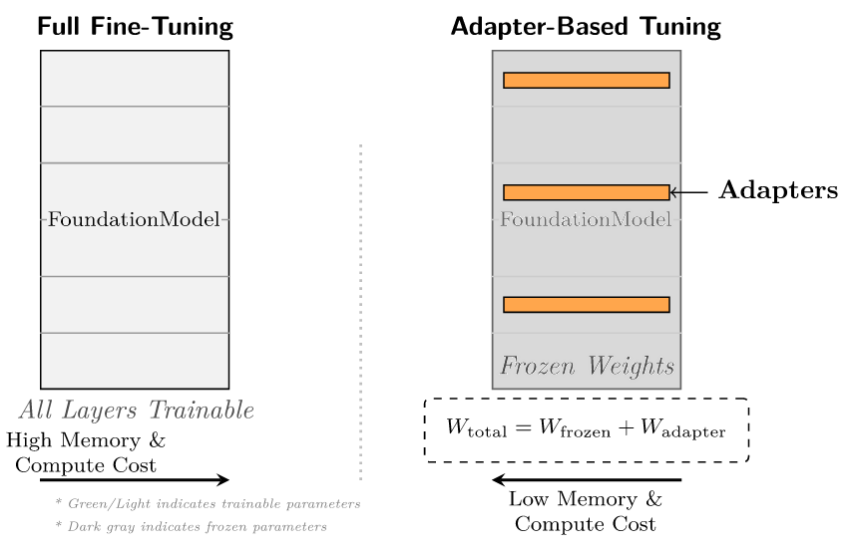
This way, the federated recommendation systems will be able to increase their learning capacity in the sense that they are able to enjoy a much larger range of domain knowledge and language sense of the underlying background models. Through this common ground, it must be able to maneuver through the obstacles of the heterogeneous Doctoral users cohorts and the quirks of heterogeneous client devices which is typical of the real setting of mobile surroundings. Importantly, the strategy helps to bridge the difference between the general and individual user requirements since such the system might give better or contextually based recommendations which occur during the incidents of limited or extensively disaggregated data of the users in the devices. (Otebolaku & Andrade, 2016, p. 1600; Yao et al., 2019, p. 51)
Nevertheless, the federated adaptation is only successful in hybrid approach the art of biological continuous updating and amalgamating the already obtained user embeddings. They are commonly constructed when the information that is being used is an inhomogeneous set of users, and when exploited irresponsibly can be known to produce misguided suggestions, or even cause a performance decline because behaviour or interests of a user in various aspects are not matched. To mitigate such risks, new federated systems are based on high parameter-efficient ahead of time tuning, including adapter-based tuning and prompt-based tuning. In this specific instance, these special techniques are designed to only scale the smaller percentage of parameter model (e.g. lightweight adapters, or prompt vectors), and thus cause an enormous decrease in both the costs of communication and computation. It is specifically applicable in privacy-sensitive federated solutions whereby, it minimizes the number of information that is exchanged among client-specific devices and central servers, as well, it also renders the user information more secure on an individual basis. (Bonawitz et al., 2016; Bozorgasl & Chen, 2024, p. 2; Eichner et al., 2024)
As an example we can say about prompt tuning methods, which can be described as communication and effective adaptation-to-new tasks or to new conditions of users through the transmission and update of small prompt vectors rather than all the model parameters. Adapters based methods are rather integrated together with a model architecture and additional (modular) parts, which could be trained on a user or a device. The advantages of the adapters are that they have low memory footprint and can be easily updated hence making it possible to utilize with limited resources on a mobile device. The two strategies do not deny the legacy underlying foundation model any type of flexibility or localised personalisation. (Chua et al., 2023, p. 4)
More to the point the use of the massive Foundation Models in federated by recommendation systems is also a means of reconfiguring the traditional issues with the recommendation system like no data, heterogeneousness of data and cold start issue. The models lead to effective cross-task knowledge transfers that can be used to build powerful user representations that are generalisable even without local data or IID (not independently and identically distributed). This provides a greater effectiveness of recommendation and personalization on a large organization of users that had little previous history of interaction, or users that had less computational resources that was to be accessible on their devices. (Khan et al., 2024, p. 1; Wang et al., 2024)
Better still, we will be in a position to create good user interests and intricate user interaction designs as time goes on using the state-of-the-art slave architectural components such as specialised Transformer layers and group gating networks. It is more valuable, particularly in environments where there exists a federation of which the user behaviour can very easily be extremely multifaceted as well as stipulated. These types of architectural innovations are used in the creation of custom recommendation structures, which can be configured to suit the capabilities of specific client hardware, in order to make sure that a wide range of hardware can be used to provide high-quality recommendations. (Gupta et al., 2021, p. 870; Razak et al., 2021, p. 733; Zhaoxia et al., 2022, p. 11)
On another attempt to achieve the balance between the foundation models strength and the practicability of mobile federated learning is a trend of development of more and more personalised adapters. They are tiny modules which ought to have the capability of learning and encoding preferences in individual users without putting much strain on the computing and memory. The customisation adapters allow offering finer-grained and adaptive suggestion services to trade-offs between mixed and universal knowledge and consider the presence of user-specific personalisation. Better still, they do so without invading the privacy of the users either as sensitive information about individual aspects of behaviour is not sent anywhere because it is stored in one of the local storage of the user to the device itself and is never transmitted to the servers out there. (Gao et al., 2023, p. 6; Ji et al., 2025)
Summing it up, all these methodologies may be used within the development of the federated recommendation systems, that will not only be scalable and efficient, but also highly adaptive and Privacy sensitive. Application The federation of the foundation models and parameter-efficient personalisation plans could be utilised to implement meaningful and context-sensitive modifications considering the privacy of each individual user and executed in the multi-dimensional multi-adept mobile setting. It will be a giant leap in making the reality out of what may be termed the vision of the personalised, and secure, scale recommendation services, a reality, and will also meet the technical as well as the ethical demands of the contemporary data-driven applications.
Moreover, with the ability to optimize the resources by tuning the fine details of the resource based devices, several methods like heterogeneous Low-Rank Adaptation will arrive at the optimal solution of operation only by consuming the minimum communication resources without overfitting simultaneously. Besides this, further research on federated prompt tuning and continuous learning in these models can also be an efficient direction, to make them more personal and offer context-sensitivity, by allowing them to spend more computational power on optimizing the models with new information generated privately. More specific attention needs to be paid to the architectural design and privacy mechanisms of the said federated recommender systems since they are the most important elements to influence the say-off between the accuracy of the recommendation model and privacy of user information. This incorporates a subtle understanding of the dissimilarly secretive protocol and secure summation algorithms which can effortlessly blend so as to result in the forecasting capability of elevated foundation models being eroded to an unreasonable scope. Thus a subsequent study should be aimed at optimization of these privacy enhancing technologies such that it can be in a position to ensure high recommendability, as much as can be, and absolute safety of the sensitive information knowledge of the user with the distributed learning paradigm. This optimisation refers to the search of other ways to compress gradient and asynchronous updating protocols that can bring the cost of communication and ability to cover heterogeneity of clients to a bearable threshold, and will be fundamental in the future expansion of federated learning to large user bases and multifaceted foundation architecture. In addition, the adaptive regularization policies and the client-adapted federated learning algorithms also can be examined to enhance the performance further in the model and alleviate client drift in conditions where the data distribution is highly non-IID, which is characteristic to mobile feedback recommendation under realistic settings. (Casado et al., 2021, p. 3417; Haller et al., 2023, p. 770; Seo et al., 2025; Vedadi et al., 2024; Xu et al., 2025)
The second element of federated learning that would evolve in the future is the creation of more advanced aggregation techniques, which will be grounded on the differences between the value the respective clients provide and the quality of data they propose. Malicious or unreliable parties post updates of clients of applicable weight wilfully to the system with reliable and relevant updates that can be quite useful in strengthening and validating the system. This makes the weight of outliers or bad data have no such strong influence to the global model that will additionally enhance the soundness of a system of general recommendation. Additionally, the research on the inclusion of federated learning to other more potential innovations, specifically, the Internet of Things and edge computing, is prospective, in particular, the work of a mobile movie recommendation system. These systems provide the highest personalisation and user privacy through localised data processing in the edge device and provide low-latency through decentralising computation. This combination of technologies introduces an opportunity to create a scalable and versatile infrastructure that can meet the demanding computational capabilities of federated learning, the efficient utilization of resources, and enhancing the efficiency of a system and the quality of the model. (Eichner et al., 2024; Feng et al., 2024, p. 32)
Nevertheless, the problem with ensuring that the federated foundation models have brought out the best in the models needed to recommend the mobile movies systems is the necessity to acknowledge intricate architectural, aggregation and privacy issues. Also added will be the promises of the encouragement of efficient decentralised, peer-to-peer communication mechanisms, the adoption of better and safer aggregation algorithms, which will also increase the efficiency of the system, the reduction of the dependency on the centralised servers, and the server side computational burdens. These solutions help to scale up further to make it real time recommendations and fault tolerance in the large scale systems. Irrespective of these changes, it remains evident that there are still some harsh hardware and algorithmic constraints that must be overcome. Trade-off This trade-off is typically accomplished via efficiency constraints, particularly when placed on model complexity-reduction, which certainly might affect the training rate and the overall machine efficiency. Overcoming these challenges, new model architectures tailored to federated environment would be necessary the architectures that incur minimum communication costs and minimum computational requirements on single devices, and which are very predictable. (Ferdaus et al., 2024, p. 3; Rane et al., 2024, p. 38; Saif et al., 2025, p. 19; Shrivastava, 2024, p. 361)
Higher security and fault tolerance: Decentralised federated learning is a peer-to-peer communication framework that can be enhanced with regard to superior security and fault tolerance. Meanwhile, the cross-device federated learning structure will unlock the bottlenecks of calculating and transferring data that, specifically, on the basis of massive foundation models will demand the new mechanisms of resource management and offloading of tasks. These techniques play a very important role in the trade-off between cost of communication, and the cost of computation locally, which turns crucial in the instance of fine-tuning at scale of large models when prediction is required to predict applications such as movie recommender. To address these issues, we need to develop lean and mobile optimised versions of neural networks, which can successfully be implemented on portable devices, and which can attract fewer energy, and less resources. Further reduction of the model footprint and the computing needs could also be accomplished by pruning and adaptive quantisation - federated learning can be made available even on a broader range of mobile devices. It is also hectic that engineers and designers face in the implementation of the foundation models of these such systems especially the real-time performance and scalability in the industrial applications. The computation amounts to and communication efficiency maximisation in federated learning systems, in more detail of complex multi-modal models such as GPT-4o is an excellent problem, and often involves distributed strategies of computation to manage the colossal resource consumption, intrinsic in training and fine-tuning such models over time with massive compute clusters. (Das, 2024, p. 2; Jin, 2025, p. 17; Rane et al., 2024, p. 24)

Privacy-Preserving Mechanisms in Recommender Systems
Personalisation, in the event of federated learning, particularly by the recommender systems, must be done in a manner that will not jeopardize privacy of the users. This is not simply encryption procedure of the data, and aims at sophisticated mechanisms. One of the techniques studied nowadays is called an advanced privacy or secure multiparty computation, to make sure that the data of the user remain secure, not only during the training of the models, but also during inference. Homomorphic encryption and zero-knowledge overwhelming, e.g., are schemes of ensuring that there exist efficient structures of maintaining privacy without exposing the utility of aggregated updates in a model. Providing personalised federated learning methods would allow creating strong and understandable user representations and ensuring that privacy remains the priority. It is especially relevant since it views the issues in relation to sparse data and statistical difference between the various individuals on which it is hard to conclusively ascertain about the finesse of the users in the proper sense. Also, since user preferences may shift with time, there is always the necessity of models changing with of a changing data distribution. What cannot be defined as being thus deemed to fall under the category of “personality leakage” and what can be done to be held to proper measures on the categorizing of becoming less important is one of the greatest problems that remain unresolved fully, yet (sec. 4). So, it is extremely important to develop improved objective functions and optimisation of strategies with the stated goal of preserving personality during the federation of foundation models refinement. It is also vital to generate mechanisms of the adequate quantification of such trade-offs between the accuracy of personalisation, and the risk of leakage of personality, especially of multidimensional and intricate representations of a consumer. Another issue that is of the particular importance is that advanced models will extract sensitive user traits like personality off of seemingly innocent user-interactions and that is the ethical issue of the misuse of the data and bias of algorithms. To meet these considerations, it is necessary that there exist mechanisms that allow transparent auditing, personal governance such that inferred user features are treated in an irresponsible manner. Moreover, federated foundation models would have to overcome current distribution jumps to achieve an ongoing execution, as traditional risks might lack the ability to address distribution changes, as it must being able to educate all of the parameters and is delicate to variations in the user information. (Abikoye et al., 2024, p. 471; Geimer et al., 2024, p. 7; Jin, 2024, p. 12; Kong et al., 2025; Li et al., 2025, p. 4; Yang et al., 2025; Zhao et al., 2025, p. 2)
This infuses the relevance of adapting inventive and privacy-enhancing strategies to implement personalisation in federated learning environments that can be flexible in addressing the issue of a growing user preferences whilst creation of hard rules on privacy. Furthermore, the future area of research should be centred in combination of both advanced debiasing and advanced model optimisation approaches, to trade off a high quality explainability with a high computational efficiency. This also involves construction of explainable solutions to AI in the federated environment to ensure that users can get to know the logic upon which the personalisation is emanating out of – without compromising their privacy. The solution of ethical issues, including loss of privacy data and algorithm prejudice, in the instance of the federated foundation models will require new interpretability techniques.
    - Application of advanced privacy methods whereby ability to apply varying amount of noise can be used to optimize on data utility loss.
    - Assimilating safe multiparty computer with prototype compressions to be effective.
    - Federation which involves removing a particular data only after the model is trained is used. (Balbierer et al., 2024, p. 7; Padmanaban, 2024, p. 241; Roy et al., 2023, p. 14; Tang et al., 2022, p. 321)
More so, the current study of federated unlearning methods also can potentially promise the existence of dynamic elimination of sensitive data of shared models after training and, therefore, provide upper-notch and versatile protection of privacy. These innovations are also needed to make certain that federated learning systems that act as recommendation engines are adaptive to evolving user requirements, not simply, but also engaged in averting rendering sensitive personality characteristics to which exposing sensitive personality characteristics have increasingly been of a growing concern as foundation models have become increasingly prolific. It is a multi-layered and dynamic issue, and interdisciplinary solutions that encompass advances in machine learning, cyber security and responsible AI are necessary to develop certified and compliant systems that are ready to adapt to new regulations. (Baradwaj et al., 2024, p. 26; Chen et al., 2022, p. 1)
These complexities can only be overcome by having a combination of technical protections, such as the use of differentiated privacy, homomorphic encryption and effective governance structures and ongoing auditing. Moreover, federated recommendation systems in the fight against new threats include aggregation techniques, which is resilient and post-training adversarial detection.
It is significant that the models are supposed to be resilient to the data poisoning and privacy threats, and ensure that, in case some individuals do obtain to upgrading the client, the final model integrity is not compromised. This multi-layered solution goes to the extent of implementing privacy-conscious aggregation technology that retains an ability to detect anomalies and layer-wise defence privacy mechanism admitting transparent examination of anomalies. The opportunity to make dynamic inferences on the parameters of the model based on the specific features and capabilities of the client devices opens up a variety of opportunities to optimize the efficiency of the learning process and also consider the heterogeneity of the customers.
A specific relevance of this adaptive approach is specifically considering the fact that representatives of the opposite side may capitalize on weaknesses in order to make an esoteric set of attacks, such as membership inference and gradient leaks, and in the process, to provoke the shortcomings of the currently available privacy-enhancing technologies. It is thus essential that in future studies, efforts be made to strictly test federated foundation models concerning the emerging threats, such as evasion methods that have the capability of specifically targeting large language models, to ensure that federated foundation models are secure and resilient in practical applications. (Jiang et al., 2025, p. 28; Li et al., 2023, p. 6; Ren et al., 2024, p. 32; Yao et al., 2024, p. 3; Yu et al., 2023, p. 8)

Accuracy-Privacy Trade-offs in Machine Learning
The most essential problem when developing the effective federated learning system in order to suggest the movies during mobile devices use is to find the right balance between privacy to the users and the model under question. Although federated learning offers the protection of privacy inherent in that the method does not store the raw data in a remote location, this does not mean that the approach is not vulnerable to newer attacks, including model inversion and data poisoning. There is the need as such to incorporate more privacy-saving techniques. However, these solutions have the propensity of introducing their own form of trade-offs such as worsened performance of the models or increased computer hardware requirements and thereby compounding the trade-offs of the accuracy and privacy even more. An example is differentiational privacy, which provides quantifiable privacy guarantees but with converse benefits of accuracy particularly in low-data and complex models. On the same note, the privacy offered with such technologies as secure multiparty computation and homomorphic encryption is excellent and yet they are computationally intensive to an extent of not being applicable to real-time mobile recommendation systems. (Harasic et al., 2023, p. 345; Roy et al., 2024, p. 28)
One major field where the challenge is enormous is the clinical AI. In the clinical AI, It is highly Essential to hide the data And secure the data by adding noise An insured that privacy is intact as as high as possible. However, because of the trade off When too much noise is added to hide the data, the inaccuracy in the recommendations increases rapidly. Sometimes the inaccuracy goes over the roof, so much so that the recommendations become useless. Now, second problem is that if the clinical data and the recommendations of the clinical data are to be displayed on mobile system, because the mobile system are computationally weaker than any other system for example Laptop or desktop, decoding of the hidden data becomes even difficult. Devices like mobile phones prove almost useless in decoding the hidden data for the clinical AI Due to their computationally weak nature. It has to be thought about the fact that any privacy mechanism we employ, especially on mobile recommendation systems along with other platforms like your hosting server etc. has to be created dynamic in nature. Which means that if a recommendation system is being recommended on mobile phone, it is different from the one that is being recommended on a hosting website. This is because the nature of threats and attacks keep changing from time to time. Similar is the case with data distribution. For example, in the field of medical science, new diseases keep coming in. New devices are launched that may have completely different hardware and computational power, so that the privacy mechanism that worked on previous versions of the device may prove null and void in its purpose when employed in this newly launched device. This situation may put us into a situation where we are fighting with old disease with old technologies and privacy mechanism, while the new more powerful disease comes up and does damage even more rapidly than any disease we previously encountered with our older privacy protection mechanisms. Then again, the problem that comes is to find a balance between protecting the data using privacy mechanism and the accuracy which the recommendation system as a consequence shows to the users in their device. The problem gets bigger and severe in more complex machine learning models like speech recognition and medical image analysis, where this balance between privacy and accuracy, if biased towards privacy, will result in even severely inaccurate recommended contents. For example, in speech recognition, if we add more noise to train the system with strong privacy, this extra noise when sent out to work in real environment where user will speak words and sentences for the machine to listen to and interpret will result in wrong words being interpreted by the system. This will make the system useless for daily communication and usage. Similarly, if we apply a similar noisy machine learning model (i.e. A model trend on too much noisy data for privacy protection), The final result when employee to real life medical applications may cause the model to miss critical features in X ray or CT scan or completely false positive reports. And even worse is that missing out on features in the images which point towards underlying disease may result in false negatives and the patient may be advised to not take any serious action.
Apart from the noise accuracy trade-off in privacy, there is one more problem known as “poor gets poorer”. This means that if privacy mechanisms are not designed with proper balance and buyers and equity, the model may end up discriminating between different user groups or users data. In other words, the noise which is added to the data may be proportional to the magnitude of the data point. So if this kind of noise is propagated into the model the data set may start collecting into groups of small sub data (as in unsupervised learning) and the whole data set may end up looking like a collection of lumps of data at many different places on the graph. Here lies another problem. User who contribute rare type of data, for example some users may like very rare genre of movies. If we apply equitable noise to the data set of all the users these rare contributions may for sure will get clocked in too much of noise and the system may not learn much about these rare data set types and hence perform poorly. Because the whole point of Federated learning is to hide the raw data of the user, it is therefore almost impossible to tell whether the system is recommending content in all fairness to all users or not. Privacy and fairness cannot go hand in hand at some instances. The simple fact that if privacy mechanisms and measures are not designed with fairness in mind, they can lead to harming minority group of users. Especially though group of users who contribute rare genre of data set. To resolve this dilemma, we can deploy what is called “personalised privacy”. In this what happens is that the privacy protection is tailored to each user according to the data the user generates. This helps in keeping sensitive information of each user safe while at the same time system works efficiently and reliably from for each user. A new strategy is proposed known as “multi objective optimization” to handle fairness and privacy tag of work and create a balance between all the groups so that no group of users is left behind with useless recommendations on their devices. This strategy has a goal to find an optimal point among accuracy, privacy and fairness, all at the same time. There are also some technical challenges like a privacy technique named Poisson subsampling which can put too much load on the low end mobile phones or hardware and their CPU. This will exclude users who possess older phones and hence will collect correct data from only users that have high end specifications mobile phones and devices especially when they are new. Consequently the unfairness. This leads us to a warning named Matthew effect warning. It says that privacy if focused on while creating a privacy system without bringing into the game fairness, then the resulting model of Federated learning will reinforce or amplify already existing inequalities making the “poor even poorer”. (Balbierer et al., 2024, p. 12; Chen et al., 2023; Kairouz et al., 2021, p. 78; Ren et al., 2024, p. 8; Wang et al., 2024, p. 28; Zhao et al., 2025, p. 2)

Methodology
In this part, we will discuss about how we did the experiment and the methodology we used to perform the experiment to find the optimal point of trade-off between Accuracy and privacy in mobile recommendation system of movies. We will discuss about the approaches, methods tools that we utilised and procedures to investigate and research about or core research questions. The methodology that we are employing addresses and inquires accuracy-privacy-fairness, its trade-offs which is found and is quite prevalent in federated systems employed in mobile devices for recommendation of movies to the users. What we are most interested is to enquire the selection and processing of datasets to simulate various mobile environments in different types of devices. The devices are especially geared up to simulate resource-constrained real and physical devices; including the configuration of FL protocols which account for non-IID data distributions. Then we also discuss and employ privacy preservation mechanisms such as privacy and secure aggregation to compute the metrics.

Data Preparation and Partitioning
In this part, we explain how we selected the dataset, what the dataset actually contains, and also what kind of preprocessing and data partitioning strategies we used so that we can simulate a real federated learning (FL) setting for a mobile movie recommendation system. For this work we mainly use the MovieLens-1M dataset, which contains around 1,000,209 explicit ratings, and we use it because it helps us to realistically simulate personalization and user heterogeneity. This dataset is also very commonly used in FL recommender system research because it is quite sparse (around ~95%), it has diverse user behaviour patterns, and it is closely related to the mobile streaming domain, where ratings can be treated similar to watch-history, likes, or content requests. For the preprocessing step, what we do first is we filter the data a bit. Basically, we remove users and movies that have less than 5 interactions, because this way we can reduce the sparsity of the dataset and also handle the cold-start issue to some extent, while still keeping the interactions that are actually meaningful for our experiment. After that, we convert the explicit 1–5 ratings into implicit feedback by doing binarization, where any rating that is ≥ 4 is treated as a positive interaction as 1 and the rest is treated as 0. We do this mainly because in real mobile app cases we usually don’t have full rating values all the time, but more like simple signals such as “watched”, “liked”, or “clicked”, and the missing ratings are treated like unobserved interactions. We also use the timestamp information to do a chronological train-test split (80/20), since it is more realistic for sequential recommendation where the model learns from past behaviour and then predicts future behaviour. On top of this, we apply per-user normalization to standardize the ratings, so that differences caused by users rating in different ways (like some users always rate high and some rate low) is reduced. To simulate federated learning (FL) in a realistic way across different types of mobile clients, we split the data horizontally (so, user-based partitioning). What we do is randomly assign users to K = 100 clients, and then each client only keeps the interactions that belong to the users assigned to it. This setup naturally creates a non-IID data distribution, because users behave differently (different preferences, different activity levels, and also different amounts of data, which often follows a power-law type pattern). We also make sure the client dataset sizes are not all the same (for example, roughly around 10–200 users per client) so that it better reflects the heterogeneity we usually see in real mobile settings, and even after processing there is still around ~45–80% sparsity left. With this overall setup, we can preserve privacy (since the raw user data never leaves the client), keep things scalable for edge/mobile devices, and more properly evaluate the accuracy–privacy trade-off under realistic non-IID federated learning conditions.

Model Architectures
Describes the models of machine learning implemented (matrix factorization) and their mathematical formulation and implementation decisions in order to make them amenable to mobile deployment. This entails adaptations to exceed the resource constrained environments by means of quantization and model pruning by taking into consideration efficient inference in a variety of mobile hardware. Furthermore, in this section, we'll talk on how these models can be particularly designed for recommender systems, like collaborative filtering and the matrix factorization approaches to guarantee high relevant and high performance to the recommender system in the federated learning paradigm. This also includes combination of novel architectures dedicated for the federated scenarios such as federated collaborative filtering or federated matrix factorizational decentralized training and privacy preservation. The mathematical formulations of such models will be presented which hereby underline the role that crucial models play in enabling privacy-preserving mechanisms, e.g. secure aggregation or privacy that do not come at cost for model utility. The choices and the adaptation of such models are important for ensuring that the proposed federated learning framework is computationally feasible on mobile devices, and can capture complex user-item interactions for purposes of accurately recommending movies. These architectural decisions are done carefully under consideration of strength against dictionaries that isn't meet IID data distribution assumption and ability to maintain their performance under different communication constraint which is natural to mobile FL environments. In addition, the methodologies include the accommodation on the client side whereby individual devices can optimize global models using their own local data and this can be made to allow the personalization to better accuracy and privacy boundaries. The rationale of the multi-global model strategy that is embedded in a hierarchical framework to work with heterogeneous in device and data distributions will also be discussed, and will improve the scalability and personalization from end to end across the network. This approach makes personalized and efficient learning for diversity devices and data distributions possible where the approach means time departing from traditional FL paradigms also by the realization of multi-global model approach in hierarchical framework. This multi-global model strategy is in contrast to conventional federated learning strategies that usually maintain a single global model, in which instead of depending on different client characteristics and preferences, they have more nuanced approach to take care of the diversity of the data. This enables a more adaptive and resilient system which is useful in context where there is huge heterogeneity between users, and between different device capabilities.

Federated Learning Setup and Training
Describes the federated learning protocol (FedAvg) and the communication mechanism and training procedures and the way the clients are involved in the distributed training procedure. This section will describe the FedAvg algorithm as base algorithm and dedicated algorithms to deal with the non-IID data using multi-global algorithms in a 3-tier federated learning architecture. This hierarchical framework has attained better data privacy, computation efficiency and scalability, compared with the traditional client-server FL models. In particular, there are three layered architecture to include clients, edge layer and federated edge layer, which make efficient aggregation and personalized management of models. This architecture allows for a solid and robust approach to handle the non-IID data characteristics by aggregation across multiple layer and supports for multiple global models leading to a significant increase in the efficacy of the model and addressing the data & computation heterogeneity. As the significant coordinator the edge layer explores the metadata of the results obtained from training sessions of clients to give information on model states and requirements as well as to query the federated edge layer in case a suitable model can not be found locally. This multi-tiered approach is more granular in terms of aggregation and distribution of models and more adaptive to the fluid and varied nature of distribution of movie recommendations to the mobile medium. The fedge layer in turn is in charge of the storing and assuring of currency and representativness of these different global models with respect to various data landscape. This kind of structural orchestration allows well selected model and distribution strategy which is especially beneficial for case scenarios using different mobile clients with different data distributions and different computational capacities in movie recommendation system. This holistic solution provides for both the global awareness and individual preferences to be well represented and user privacy and efficiency to be kept. The information exchange between the clients and the server is based on well-known algorithms (e.g. FedAvg) however, the possibility to add custom aggregation strategies to adapt to a specific research need. The server is then used to aggregate these local updates so that it can be used to refine the global model and disseminate the improved version back to clients in order to conduct further training rounds until convergence takes place. This is an iterative process which is the main component of federated learning and thus only allow federated learning to train powerful models in a non-centralised manner, hence improving privacy. This distributed method of working helps ensure that security-sensitive data is not stored on the company servers but on individual devices and is aware of the strict data protection laws and user expectations of user privacy.

Differential Privacy Implementation
Describes the implementation of the addition of privacy using DP-SGD (step by step), i.e.: Gradient clipping, Noise addition and accounting for privacy budget using Renyi Privacy Implementation In addition, the combination of other techniques including gradient sparsification and coding will be considered for the sparse communication updates of the local models, such that only significant updates which are in the parameter space will be efficiently transmitted. This layering of defense mechanism provides a significant improvement of privacy on higher guarantees than basic DP, in terms of resiliency in the system against various kinds of inferrence attacks, and how efficient the resources being optimized. These in turn are important strategies to help balance the rigid requirements of protecting people's privacy and achieving acceptable model performance, in the case of resource constrained mobile environments. In addition, the proposed approach integrates the local privacy mechanisms into the training pipeline directly in order to further improve the privacy protection. This is done by adding precisely calibrated noise on the client updates before transmitting them to the server, thus both individual contributions will be indistinguishable but not stop them from contributing to the learning of the model. This mechanism, mostly implemented by DP-SGD involving the use of per sample gradient clipping to restrain the sensitivity of single updates and then addition of calibrated gaussian noise from distribution scaled to the privacy budget (kept track of using renyi privacy for the tight composition bounds) assures that the aggregated global model encapsulates these overarching patterns in the federation without, during the aggregation phase at the central server, memorizing and over fitting any private data of any given user. Gradient clipping clipping the L2-norm of the gradient of each sample that prevents any one client's update transitivity and unnecessarily impacting on the global model, and the noise injection makes the individual contributions statistically indistinguishable from each other or random perturbations and so formally guarantees of , - privacy bound the privacy leakage, no matter what the adversary's access to the model's outputs or model intermediates. This is not only useful for warding off sophisticated threats of inference such as membership inference or reconstruction attacks (where the adversaries may be able to infer user-specific preferences over movies from the gradient patterns), but it also is empirically useful for improving model generalisation, acting as a form of regularisation, as we will see when we touch on the bigger question of large-scale federated training scenarios where DP-FedAvg leads to production-ready models (immune to unintended memorisation of rare or sensitive user-item interactions).

Privacy Attack Models
Articulates the adversarial evaluative methods for testing for effectiveness of privacy protection mechanisms. This comprises simulating prominent attacks such membership inference attacks, attribute inference attacks, data reconstruction attacks, model poisoning attacks as observed specific for federated recommender systems in case of movie recommendations with non-IID data distributions. Membership inference attacks, for example, permit a server that is honest, but curious about, the fact that the behavior in this case of the server model and/or corresponding gradients are different according to the synthetic data that were used to train the models in shadow settings of happy but curious data providers and to infer some specific interactions between users and items. Attribute inference Attacks piggyback on uploaded model parameters and thereby infer sensitive user demographics or preferences, and even in a privacy-equipped federated setup find vulnerabilities. Reconstruction attacks by the server Reconstructing private ratings or interactions from the gradients. >80% accuracy in matrix factorization cases on data such as MovieLens. Reconstruction attacks from the server point to the risks of hierarchical FL architectures. Poisoning attacks, which is design as model poisoning or gradient poisoning attacks is a series of attacks where an adversary will make use of a small number of malicious clients in order to simulate the behavior of a synthetic of fake users to upload carefully crafted gradients in an abuse of the federated aggregation rounds. These adverse updates give the global model parameter updates, especially item embeddings, so as to artificially increase the visibility and ranking of some target movies in top- $K$ recommendations, without any prior knowledge about benign clients' data distributions or interactions. For example to increase their attacks, attacker approximate benign user embeddings by using random sampling or hard mining techniques, and create a poisoned gradients to push the representation of target item in the embedding space is like popular movie by inherent popularities in recommender systems. Such attacks are particularly powerful in non-IID situations similar to movie recommendation datasets like MovieLens where it only take 1-5% of all clients to be malicious, and are able to increase hit rate and exposure of unpopular target movies by significant 20-50%, across users, with no negative effect on the overall model accuracy, and without any negative effect on the overall accuracy. These evaluations are helpful to quantify leakage of privacy and integrity using standardized measurement criteria, e.g. attack success rate (e.g. target item promotion rate (in top-k lists)), F1-scores in terms of discriminability of malicious influences, re-construction fidelity (in terms of recoverable private interactions), model utility degradation (e.g. NDCG drop). Empirical results confirm the resiliency a number of proposed defenses like DP-SGD which adds crafted perturbations by adding calibrated Gaussian noise so that are indistinguishable from normal updates, gradient sparsification which sends only parameter changes with significant magnitude to the dilution malicious parameter changes impacts, and multi-global model strategies of which diversifies the aggregation over heterogeous client clusters that reduces the efficacy of such attacks with 30-70% limited accuracy reduction. Such comprehensive evaluations are important in order to discover more about the boundaries of the security of federated recommender systems in practice, and especially, in real world scenarios, in a mobile environment where user bases are diverse and potentially adversarial.

Resource Profiling and Metrics
Includes specifics of measuring important computational resources of crucial interest to practical implementation of federated recommender systems on resource constrained mobile devices, e.g., CPU usage, memory usage, energy consumption, communication overhead and inference time. These metrics are profiled by using special tools like I-Prof for predicting computation time and energy impact of local training tasks on android devices, Trepn and Snapdragon Profiler for monitoring power consumption of computation at a whole system level, benchmarks like FedScale which uses real world device traces for computation speed (FLOPs/s), communication throughput (MB/s) and client availability patterns. In federated movie recommendation scenarios, with large item catalogs (for example using MovieLens, containing e.g. thousands of movies), the limited memory consumption is one of the main bottlenecks.128 dimensional item embedding has a huge memory footprint (10.2 KB), which makes it not feasible to fully store millions of items (>1GB) in typical smart phones with 4-8 GB total RAM, mainly requiring solutions such as elastic item embeddings or server-side storing of items, to limit the memory consumption of each client to 25-512MB. Computation is measured in terms of FLOPs or time per local epoch. 1-5 seconds per round on normal CPUs(more precisely 4x vCPU) are acceptable so that user can not see the too much waiting times. Energy profiling aim at <0.1% FL participation on a daily basis, for which a combination of limited continuous FL participation to <0.1% of cases (e.g. energy consumption) with adequate privacy guarantees (e.g. DP-SGD - Gaussian noise computation overhead) and regularization benefit are provided by e.g., FLeet (0.036% per day). These communication metrics are aimed at tracking gradient size uploads (e.g. 1-10MB/round in the case of embedding-heavy models) against mobile data budgets (< 100MB/hour) in favour of compression (e.g. sparsification). Latency, for on-device inference, have to be less than 200ms (top-K recommendations) for IoT-like devices (64MB RAM); and less than 50-200ms for cellphones (512MB RAM) so that the systems can be used in real-time. in a non-IID, These are thresholds to make 'acceptable' deployment: e.g. peak memory <20% device total < energy < 1mJ update round time <10s Who validated empirically to remain model to useful without too much churn Comprehensive profiling on heterogeneous fleets to measure trade offs e.g. participant selection, model pruning, for production-scale federated movie recommenders.
In order to assess the quality of recommendations provided by our federated learning system, we use a set of standard evaluation metrics that are commonly used in recommender systems research, and that correspond to various aspects of model quality such as ranking quality, retrieval effectiveness, prediction quality and user coverage. Key ranking metrics include Normalized Discounted Cumulative Gain (NDCG@10) which provides a higher weight to the relevant items found closer to the top of the list (which is the reward) through position-based discounting, Hit@10 or Hit Rate@10 which measures the proportion of users for whom at least one relevant item is present in the top-10 recommendations, Precision@10 which measures the ratio of top-10 items that are relevant, Recall@10 which measures the ratio of all relevant items retrieved in the top-10 recommendations (Jadon & Patil, 20
These metrics are computed on a held out test set (20% of the dataset) separated temporally from the training data by chronological splits (e.g. 80% oldest interactions for the train dataset), as is common in recommender systems testing. This approach is emulating real-world deployment in the sense that future interactions cannot leak into the prediction as well as allowing to robustly assess generalization to unseen user-item interactions which is important for federated problems with stochasticity as well as heterogeneity (Bellogin & Said, 2021, p. 958; Canamares et al., 2020; Ji et al., 2022, p. 8; Sanchez et al., 2023, p. 1890; Wang et al., 2021, p. 887)
Together with the next section which is Experimental Setup, the above components of the Federated Movie Recommendation System, including System Architecture for Federated Movie Recommendation, Dataset Description and Preprocessing, Federated Learning Model Design, Privacy Mechanisms Implemented and Evaluation Metrics and Resource Profiling and Metrics would in large part ensure an extensive and holistic methodology for the fostering of privacy preserving Federated recommender systems.
The System Architecture illustrates a layered client-server architecture around the notion of movie recommendations, both for the decentralized process training, which is based on the user devices, and for global models aggregated at the server able to work with large size item catalogue as MovieLens avoiding memory constraint by dedicated strategies as using elastic embeddings or also with large items at the server . Dataset Description and Preprocessing Describes the treatment of the real world and large benchmarks, such as MovieLens, e.g. sparsity, cold start problems, non-IID distributions common in user interaction data, normalization, splitting strategies, synthetic data augmentation in order to simulate heterogeneous client behaviours . The Federated Learning Model Design, in which the embedding based architectures can be embedded with local personalization, such as matrix factorization, or graph neural networks, adapted to on physical computation is stated, to overcome statistic heterogeneity -in which HL user show skewed preferences and interaction frequencies.
Privacy Mechanisms Implemented Provide integrated defenses as, e. g. privacy through stochastic gradient descent, and gaussian noise injection of gradient sparsification reduce transmitted sensitive update and multi-global model aggregation across client clusters such as effectively defend the attribute inference attack of inferring demographics from model parameters, the reconstruction attack of recovering private ratings with over 80% accuracy, the poisoning attack of adversarial clients craft the gradient to boost target items by 20-50% in topk lists . Evaluation Metrics including the standardized components such as the hit rate , F1 tens for attack detection, the reconstruction fidelity, the model utility degradation, as well as accuracy as price privacy trade off measured with the privacy budgets ( epsilon ) and the utility drops of a model in an adversarial environment . Finally, Resource Profiling and Metrics does benchmarking of critical constraints on mobiles with programs and tools including I-Prof, Trepn, and FedScale traces addressing deadlines of critical resource constrictions including peak memory of 20% device RAM requirement (128 par 264 megabytes), energy less than 1mJ per update and 0.1% per day, communication in form of sparsified gradients, and inference latency less than 200 ms, viability in heterogeneous fleets, participant selection, and pruning tasks.
This frameworks include, in addition to the theoretical background. (e.g. FL convergence under non-IID data ), architectural designs. (e.g. horizontal vs. vertical FedRec paradigms ), practical optimisations. (e.g. adaptive aggregation for stragglers ) customised for privacy provisioning, resource limited FedRecs, comes with a direct answer to many of the challenges such as the amplifying impacts of non-IID data distributions on personalization disparities, the heterogeneity of adversarial attack scenarios (from poisoning through fake user or gradients attacks), as well as mobile deployment constraints. (e.g. system heterogeneity and high communication costs)
The Experimental Setup section implement this methodology in terms of details in simulation environment (e.g. FedDemo or Flower for multi-device emulation), hyperparameter setting (e.g. local epochs, learning rates optimized for non-IID), baseline models for benchmarking (e.g. FedAvg, FedProx, centralized MF) and strict evaluation protocols (e.g. cross validation for IID/non-IID splits, multiple seeds for stability) clearing the path for empirical validation in various ways e.g. different attack levels, privacy budgets and device profiles . Through this operationalization rigid assessments of the trade-offs between the utility of the models and the difficulty of actual mobile deployments is possible with various federated recommendation strategies.
Experimental Setup
4.1 Overview
This chapter details the complete experimental setup used to evaluate the accuracy–privacy trade-offs in federated learning for mobile movie recommendation systems. The experiments are designed to answer three research questions: (RQ1) the impact of differential privacy budgets on recommendation accuracy, (RQ2) the effectiveness of privacy attacks under varying DP configurations, and (RQ3) the influence of data heterogeneity on federated learning performance. The experimental pipeline encompasses dataset preparation, non-IID data partitioning, in-memory federated learning simulation, differential privacy integration, privacy attack evaluation, and comprehensive metric collection. A companion mobile client built with Flutter demonstrates real-device deployment feasibility.
4.2 Hardware and Software Environment
4.2.1 Computation Platform
All experiments are executed on a single workstation equipped with a multi-core CPU. No GPU acceleration is employed; the relatively compact model size (approximately 168K parameters) and the moderate dataset scale (100K interactions) make CPU-only training practical. The complete experiment suite of 30 configurations finishes in approximately 2.5–3 hours of wall-clock time. Peak memory consumption is approximately 4 GB RAM per full experiment run, and the aggregate disk footprint for all result artifacts (JSON, CSV, and PNG figures) is under 500 MB.
4.2.2 Software Stack
The server-side implementation is written entirely in Python. The core deep-learning framework is PyTorch, which handles model definition, forward and backward passes, and gradient manipulation for DP-SGD. NumPy is used for data partitioning via the Dirichlet distribution and general numerical operations. Pandas handles tabular data loading and result aggregation. Scikit-learn provides the Random Forest classifier used in the membership inference attack as well as standard evaluation utilities (e.g., roc_auc_score). Matplotlib and Seaborn generate all publication-quality figures. FastAPI powers the optional HTTP-based server for distributed and mobile client deployment.
Table 3: Core Software Dependencies
Component | Library / Framework | Version | Purpose
Deep Learning | PyTorch | ≥ 2.0.0 | Model training, DP-SGD gradient operations
Numerical | NumPy | ≥ 1.24.0 | Dirichlet partitioning, array operations
Data Processing | Pandas | ≥ 2.0.0 | CSV loading, result aggregation
ML Utilities | Scikit-learn | ≥ 1.3.0 | Attack classifier, AUC computation
Visualization | Matplotlib / Seaborn | ≥ 3.7 / ≥ 0.12 | Publication-quality figures
HTTP Server | FastAPI / Uvicorn | Latest | Distributed FL deployment
Mobile Client | Flutter SDK | ≥ 3.9.2 | Android on-device training app
4.3 Dataset Preparation
4.3.1 Data Loading and Preprocessing
The MovieLens 100K dataset is loaded from a CSV file containing four columns: userId, movieId, rating, and timestamp. User and item identifiers are re-mapped to zero-indexed integers to serve as direct indices into the embedding layers. After re-mapping, the dataset comprises 943 unique users, 1,682 unique items, and 100,000 interaction records. Ratings are retained on their original 1–5 continuous scale for the regression-based evaluation pipeline; for the binary classification variant used in certain attack evaluations, ratings are binarized with a threshold of 4.0 (ratings ≥ 4.0 → 1.0; otherwise → 0.0).
4.3.2 Train–Test Split
The 100,000 interactions are split into 80% training (80,000 interactions) and 20% test (20,000 interactions) sets via a random permutation with a fixed seed. The split is performed at the interaction level rather than the user level, ensuring that every user has some ratings in both the training and test sets. This enables per-user recommendation metric computation on the test set.
4.3.3 Non-IID Data Partitioning via Dirichlet Distribution
To simulate realistic mobile data distributions where each device holds a distinct and non-overlapping subset of user interactions, the 80,000 training interactions are partitioned among K = 100 simulated clients using a Dirichlet distribution with concentration parameter α. The partitioning proceeds as follows:
Step 1 – Group by User: Interactions are grouped by user ID, yielding up to 943 groups.
Step 2 – Sample Proportions: For each user, a probability vector p∼ Dir(α, α, …, α) with K = 100 components is drawn. Each component pk represents the fraction of that user’s interactions assigned to client k.
Step 3 – Assign Interactions: Each interaction is independently assigned to a client according to the sampled proportions. This introduces controlled heterogeneity: a small α concentrates most of a user’s data on one or two clients, while a larger α distributes it more evenly.
The resulting partition is inherently imbalanced. With α = 0.5 (the default), client dataset sizes range from roughly 100 to 1,500 interactions, with a mean of 800. This imbalance is representative of production mobile deployments where user activity levels vary widely.
Table 4: Dirichlet Concentration Parameter Configurations
α Value | Heterogeneity Level | Typical Client Profile | Use Case
0.1 | Highly Non-IID | Most clients receive data from 1–2 users only | RQ3: extreme  heterogeneity
0.5 | Moderately Non-IID | Clients receive data from several users with overlap | Default for RQ1, RQ2
1.0 | Mildly Non-IID | Data distributed more uniformly, approaching IID | RQ3: low heterogeneity
4.4 Federated Learning Simulation Environment
4.4.1 In-Memory Simulation Architecture
The federated learning experiments are conducted using an in-memory simulation that faithfully replicates the Federated Averaging (FedAvg) protocol without incurring network latency or serialization overhead. In each communication round, every client receives a deep copy of the current global model’s state dictionary, performs local training on its private data partition, and returns the updated state dictionary to the server. The server then performs weighted averaging (Section 3.4 of the Methodology) to produce the next global model. This design enables the complete 30-experiment suite to execute on a single machine while
remaining functionally equivalent to a distributed deployment.
4.4.2 Per-Round Execution Flow
Each federated learning round executes the following steps:
1. Model Distribution: The global model’s state dictionary is deep-copied to each of the 100 clients. Each client instantiates a fresh MatrixFactorization module and loads the copied parameters.
2. Local Training: Each client trains on its local data partition for E = 3 local epochs using SGD (learning rate 0.01, weight decay 10−5, batch size 32). The loss function is Mean Squared Error (MSE) for the regression variant or Binary Cross-Entropy (BCE) for the binary variant. If differential privacy is enabled, DP-SGD gradient clipping and noise injection are applied after each backward pass.
3. Parameter Collection: Each client’s updated state dictionary and local sample count are collected.
$w_{global}=\sum_{k=1}^{K}{\frac{n_{k}}{n_{total}}·w_{k}}$
5. Evaluation: The aggregated global model is evaluated on the held-out test set. Full evaluation (including recommendation metrics) is performed at key checkpoints (rounds 1, 5, and 10) to reduce computational overhead, while basic regression metrics (MSE, MAE) are computed every round.
6. Logging: Round-level metrics are appended to an in-memory collector and persisted to disk as JSON and CSV at the end of the experiment.
4.5 Differential Privacy Integration
4.5.1 DP-SGD Implementation Details
Differential privacy is enforced at the gradient level during local client training. After each backward pass, two operations are applied sequentially:
Per-Parameter Gradient Clipping: The L2 norm of the full gradient vector (concatenated across all model parameters) is computed. If the norm exceeds the clipping threshold C = 1.0, all per-parameter gradients are scaled down by the factor C / (||g||2 + 10−6). This bounds the maximum contribution of any single training sample to the model update.
Gaussian Noise Injection: After clipping, independent Gaussian noise drawn from I(0, σ² · C² · I) is added to each parameter’s gradient. The noise multiplier σ is pre-computed to achieve the target privacy budget ε given the number of training steps, batch size, and dataset size.
The clipping and noise operations are applied at every gradient step within the local training loop, ensuring that each mini-batch update satisfies the local DP guarantee. The cumulative privacy loss across all rounds is tracked by the RDP accountant.
4.5.2 Privacy Budget Calibration
The noise multiplier σ for each target ε is computed using the Rényi Differential Privacy (RDP) accountant. The accountant evaluates the RDP guarantee at a range of Rényi orders α∈ {1.1, 1.2, …, 1.9, 2, 3, …, 64} and converts the tightest bound to (ε, δ)-DP with δ = 10−5. The key parameters for the accounting are:
• Steps per round:Isamples_per_client / batch_sizeI≈I80 / 32I = 25 (with 3 local epochs: 75 steps per round)
• Total steps: 10 rounds × 75 steps = 750 gradient steps
• Per-step RDP:α / (2σ²) for Gaussian mechanism at order α
• Composition: Total RDP = 750 × per-step RDP (linear composition under RDP)
• Conversion:ε = total_RDP + log(1/δ) / (α− 1); minimized over all α
Table 5: Differential Privacy Configurations and Achieved Guarantees
Target ε | σ (Noise Multiplier) | Achieved ε | Privacy Level | Gradient Clip Norm
∞ | 0.00 | ∞ | No Privacy (Baseline) | N/A
8 | 11.03 | 7.91 | Relaxed | 1.0
4 | 20.40 | 4.02 | Moderate | 1.0
2 | 40.70 | 1.94 | Strong | 1.0
1 | 75.06 | 1.03 | Very Strong | 1.0
4.6 Privacy Attack Setup
4.6.1 Membership Inference Attack Configuration
The membership inference attack (MIA) follows the shadow-model paradigm described in Section 3.7.1 of the Methodology. The attack is configured as follows:
Shadow Models: Three shadow models are trained, each on a random subset of the training data containing up to min(|Dtrain| / 3, 5000) ≈ 2,666 samples. Each shadow model is trained for 5 epochs with the same optimizer configuration as the target model (SGD, lr = 0.01, weight decay = 10−5, batch size 32).
Feature Extraction: For each sample presented to a shadow model, the following features are extracted: (1) the model’s prediction value, (2) the absolute prediction error, (3) the L2 norm of the user embedding, (4) the L2 norm of the item embedding, (5) the dot product of the user and item embeddings, and (6) the full user and item embedding vectors (flattened). This yields a feature vector of dimension 5 + 2×64 = 133.
Attack Classifier: A Random Forest classifier with 50 estimators (scikit-learn defaults otherwise) is trained on the labeled feature vectors from all three shadow models. The classifier learns to discriminate between member (training) and non-member (test) samples.
Evaluation: The trained classifier is evaluated on 100 member and 100 non-member samples drawn from the target model. Performance is measured by AUC (area under the ROC curve) and classification accuracy. An AUC of 0.5 corresponds to random guessing (no privacy leakage).
4.6.2 Model Inversion Attack Configuration
The model inversion attack attempts to reconstruct a user’s top-K preferred items from the trained model. For each of 50 randomly sampled target users:
• All 1,682 items are scored using the model’s prediction function.
• The top-10 items by predicted score are selected as the “reconstructed” preferences.
• These are compared against the ground-truth top-10 items (determined by actual training ratings).
• A user is considered “successfully attacked” if at least 20% (i.e., 2 out of 10) of the reconstructed items overlap with the true top-10.
The attack success rate is reported as the fraction of the 50 target users for whom the overlap threshold is met.
4.7 Experiment Configurations
The experimental design consists of four experiment groups, totaling 30 individual experiment runs. Each federated learning configuration is repeated with three random seeds (42, 123, 456) to report mean ±standard deviation. The following subsections describe each group.
4.7.1 Experiment 1: Centralized Baseline
A centralized model is trained on the full 80,000-interaction training set for 50 epochs with batch size 64, learning rate 0.01, and no differential privacy. This configuration serves as the upper bound for recommendation accuracy and provides the reference point against which federated learning degradation is measured. The centralized model uses the same MatrixFactorization architecture with embedding dimension 64, totaling 167,936 parameters.
4.7.2 Experiment 2: DP Budget Sweep (RQ1)
Federated learning is run with 100 clients, 10 communication rounds, and α = 0.5 (moderately non-IID) for five privacy budgets: ε∈ {∞, 8, 4, 2, 1}. Each of the five configurations is repeated with three seeds, yielding 15 experiments. The ε = ∞ configuration disables DP-SGD entirely (no clipping, no noise). This experiment group isolates the effect of differential privacy on recommendation quality while holding the data distribution constant.
4.7.3 Experiment 3: Privacy Attack Evaluation (RQ2)
For each of the five DP budgets in Experiment 2 (using seed 42), the trained model is subjected to both the membership inference attack and the model inversion attack. This yields five attack evaluation configurations. The attacks are applied to the final global model after round 10. This experiment group assesses whether increasing the DP guarantee effectively reduces the success rate of practical privacy attacks.
4.7.4 Experiment 4: Heterogeneity Sweep (RQ3)
Federated learning is run with 100 clients, 10 rounds, no differential privacy (ε = ∞), and three Dirichlet concentration parameters: α∈ {0.1, 0.5, 1.0}. Each configuration is repeated with three seeds, yielding 9 experiments (of which 3 overlap with the DP sweep at α = 0.5, ε = ∞). This experiment group isolates the effect of data heterogeneity on federated learning performance by removing the confound of differential privacy.
Table 6: Summary of All Experiment Configurations
Experiment | Clients | Rounds | ε | α | Seeds | Total  Runs
Centralized Baseline | N/A | 50  epochs | N/A | N/A | 1 | 1
DP Budget Sweep (RQ1) | 100 | 10 | {∞, 8, 4, 2, 1} | 0.5 | {42, 123, 456} | 15
Attack Evaluation (RQ2) | 100 | 10 | {∞, 8, 4, 2, 1} | 0.5 | 42 | 5
Heterogeneity Sweep (RQ3) | 100 | 10 | ∞ | {0.1, 0.5, 1.0} | {42, 123, 456} | 9
Total |  |  |  |  |  | 30
4.8 Complete Hyperparameter Summary
Table 7 consolidates all hyperparameters used across the experimental suite. Values were selected based on standard practices in the federated learning and recommendation systems literature and kept constant across all experiments unless explicitly noted as a swept variable.
Table 7: Complete Hyperparameter Configuration
Category | Parameter | Value | Notes
Model | Embedding Dimension | 64 | User and item embeddings
Model | Total Parameters | 167,936 | (943 + 1,682) × 64
Model | Initialization | I(0, 0.1) | Gaussian noise for embeddings
Model | Output Activation | Sigmoid / None | BCE variant / MSE variant
FL Protocol | Number of Clients (K) | 100 | Simulated in-memory
FL Protocol | Communication Rounds (T) | 10 | Global aggregation rounds
FL Protocol | Local Epochs (E) | 3 | Per-client per-round
FL Protocol | Aggregation | FedAvg | Sample-count weighted
FL Protocol | Client Participation | 100% | All clients every round
Optimizer | Algorithm | SGD | No momentum
Optimizer | Learning Rate | 0.01 | Fixed, no scheduling
Optimizer | Local Batch Size | 32 | Federated experiments
Optimizer | Centralized Batch Size | 64 | Baseline only
Optimizer | Weight Decay (L2) | 10II | Regularization
Differential Privacy | Gradient Clip Norm (C) | 1.0 | Per-parameter L2 clipping
Differential Privacy | DP Delta (δ) | 10II | Standard delta
Differential Privacy | Privacy Budgets (ε) | {∞, 8, 4, 2, 1} | Swept variable (RQ1)
Differential Privacy | Noise Multipliers (σ) | {0, 11.03, 20.40, 40.70, 75.06} | Calibrated via RDP
Data | Dataset | MovieLens 100K | 943 users, 1,682 items
Data | Train / Test Split | 80% / 20% | 80K / 20K interactions
Data | Dirichlet α | {0.1, 0.5, 1.0} | Swept variable (RQ3)
Data | Relevance Threshold | ≥ 4.0 | For ranking metrics
Evaluation | Top-K | 10 | NDCG@10, Hit@10, Prec@10, Rec@10
Evaluation | Test Users Sampled | ≤ 100 | For recommendation metrics
Evaluation | Random Seeds | {42, 123, 456} | 3 runs per configuration
Attacks (MIA) | Shadow Models | 3 | Trained on random subsets
Category | Parameter | Value | Notes
Attacks (MIA) | Shadow Subset Size | min(|D|/3, 5000) | ≈ 2,666 samples each
Attacks (MIA) | Shadow Training Epochs | 5 | Same optimizer as target
Attacks (MIA) | Classifier | Random Forest (50 trees) | Scikit-learn defaults
Attacks (MIA) | Eval Samples | 100 member + 100 non-member | Balanced evaluation set
Attacks (Inversion) | Target Users | 50 | Randomly sampled
Attacks (Inversion) | Reconstructed Top-K | 10 | Compared to ground truth
Attacks (Inversion) | Success Threshold | ≥ 20% overlap | 2 of 10 items match
4.9 Evaluation Protocol
4.9.1 Recommendation Metric Computation
Recommendation metrics are computed using the full item catalog scoring approach. For each sampled test user (up to 100 users), the model scores all 1,682 items by computing the dot product of the user’s embedding with every item embedding. Items are ranked by predicted score in descending order, and the top-10 items are selected. The following metrics are then computed:
NDCG@10 uses the original 1–5 ratings as graded relevance scores. DCG@10 = Σi=1 10 reli / log2(i + 1), normalized by the ideal DCG (IDCG) obtained from a perfect ranking of the user’s items.
Hit@10 is a binary indicator: 1 if any item in the top-10 has a ground-truth rating ≥ 4.0, and 0 otherwise. The average across users gives the hit rate.
Precision@10 is the fraction of items in the top-10 with a ground-truth rating ≥ 4.0.
Recall@10 is the fraction of all items with a ground-truth rating ≥ 4.0 that appear in the top-10.
Recommendation metrics are computed at key checkpoint rounds (1, 5, and 10) rather than every round, as scoring all items for all users is computationally more expensive than the regression metrics.
4.9.2 Regression Metric Computation
MSE and MAE are computed over the full 20,000-interaction test set every round. These metrics evaluate the model’s ability to predict exact rating values rather than its ranking performance, providing a complementary view of model quality.
4.9.3 Privacy Metric Computation
Three privacy metrics are collected for each attack evaluation:
MIA AUC: Area under the ROC curve for the membership inference classifier. Values near 0.5 indicate that the classifier performs no better than random, meaning the model does not leak membership information.
MIA Accuracy: Classification accuracy of the attack classifier on the balanced evaluation set (100 members, 100 non-members). Baseline accuracy is 0.5.
Inversion Top-K Accuracy: Fraction of target users whose top-10 preferences were successfully reconstructed with ≥ 20% overlap.
4.10 Results Storage and Analysis Pipeline
4.10.1 Result Serialization Format
Each experiment produces two output files:
JSON File: A comprehensive record containing the experiment identifier, timestamp, full configuration dictionary, per-round metrics (train loss, test MSE, MAE, and recommendation metrics at checkpoint rounds), aggregation statistics (number of participating clients, total samples), and final metrics. Files are named following the convention: dp_{epsilon}_alpha_{alpha}_dim_64_clients_100_seed_{seed}.json.
CSV Summary: A tabular summary with one row per round, suitable for quick inspection and import into spreadsheet tools. Columns include round number, train loss, all six evaluation metrics, and a final summary row.
Attack evaluation results are consolidated into a single JSON file (attack_evaluation_summary.json) containing MIA AUC, MIA accuracy, and inversion accuracy for each ε configuration.
4.10.2 Analysis and Visualization
A dedicated analysis script (comprehensive_analysis.py) reads all result JSON files and generates publication-quality figures. The script computes mean and standard deviation across the three seeds for each configuration and produces the following visualizations:
• Convergence plots: Training loss versus communication round for all ε values, showing learning dynamics under different privacy constraints.
• Accuracy vs. ε plots: NDCG@10 and Hit@10 as a function of the privacy budget, with error bars representing ±1 standard deviation.
• Accuracy loss plot: Relative accuracy degradation (%) from the no-DP baseline as ε decreases.
• Heterogeneity plots: NDCG@10 and Hit@10 as a function of α, isolating the effect of data distribution on FL performance.
• Attack effectiveness plots: MIA AUC and accuracy versus ε, demonstrating the effectiveness of DP in mitigating privacy attacks.
All figures are rendered at 1200×800 pixel resolution using Seaborn’s darkgrid style, with clear legends, axis labels, and error bars. Figures are saved as PNG files in the figures/ directory.
4.11 Mobile Client Integration
4.11.1 Flutter Application Architecture
A companion mobile application built with Flutter (Dart) demonstrates the feasibility of on-device federated learning. The application targets Android (minimum API level 21) and includes the following components:
Matrix Factorization Model (Dart): A pure-Dart implementation of the same matrix factorization architecture used in the Python experiments. The model performs forward passes, computes gradients via manual backpropagation, and applies SGD updates entirely on-device without any native ML framework dependency.
FL Client Service: Manages the federated learning lifecycle: registration with the server, downloading global model parameters, local training, and uploading updated parameters. Communication uses HTTP with JSON payloads; model parameters are serialized as base64-encoded Float32 arrays for cross-platform compatibility.
Resource Monitor: Tracks battery level, battery drain rate, memory usage, and device information during training. These metrics quantify the on-device computational cost of federated learning.
User Interface: A single-screen interface displaying the server URL input, connection status, training logs (last 50 messages), per-round metrics, and resource consumption. Users can initiate training and export results.
4.11.2 Server–Client Communication Protocol
The distributed deployment uses a FastAPI server that exposes the following endpoints:
• POST /register — Client registration with a unique client ID.
• POST /init-model — Server-side model initialization with specified dimensions (num_users, num_items, embedding_dim).
• POST /global-params-json — Download current global model parameters as base64-encoded tensors.
• POST /upload-params-json — Upload local model updates along with the client’s sample count for weighted aggregation.
Model parameters are transmitted as JSON objects containing the parameter name, tensor shape, data type, and base64-encoded Float32 byte arrays. For the 167,936-parameter model, a single parameter upload is approximately 650 KB.
4.12 Reproducibility Measures
Several measures ensure full reproducibility of all reported results:
Fixed Random Seeds: All stochastic operations—PyTorch weight initialization, NumPy Dirichlet sampling, data shuffling, and train/test splitting—use fixed seeds. Each experiment configuration is run with seeds {42, 123, 456}, and results are reported as mean ± standard deviation.
Deterministic Data Pipeline: The train–test split uses a fixed permutation, and the Dirichlet partitioning is seeded, so identical client data partitions are produced across runs with the same seed.
Single-Script Execution: The complete experiment pipeline—data loading, partitioning, training, evaluation, and analysis—is encapsulated in run_complete_experiment.py, which can be executed end-to-end without manual intervention.
Result Persistence: Every experiment writes a self-contained JSON file with the full configuration and all per-round metrics, enabling independent verification and re-analysis.
Version Control: All code, configuration, data processing scripts, and result files are maintained in a Git repository.
4.13 Summary
The experimental setup provides a controlled, reproducible, and comprehensive framework for investigating accuracy–privacy trade-offs in federated learning for mobile recommendation. The design systematically varies the privacy budget ε (RQ1), evaluates privacy attacks across all DP configurations (RQ2), and examines data heterogeneity via the Dirichlet parameter α (RQ3). A total of 30 experiment runs—spanning 1 centralized baseline, 15 DP sweep configurations, 5 attack evaluations, and 9 heterogeneity sweep configurations—are executed with triple-seed averaging to ensure statistical reliability. The in-memory simulation architecture enables rapid iteration while remaining functionally equivalent to a real distributed deployment, which is demonstrated by the companion Flutter mobile client.

Results and Discussions
In this section, we discussed an in-depth analysis of the results we derived in our experiments of privacy, preserving Federated learning framework designed for recommendations of movies on mobile system. There are five range of privacy budget across which we measure the systems performance, like data, heterogeneity levels controlled by the Dirichchlet parameters. Keeping in mind, the standardized protocols and extensive sweeps we encompass three random seeds per configuration for statistical robustness. The results we obtain are basically interplay and trade-offs between federation overhead (e.g., client drift and aggregation dilution), DP-induced noise, and non-IID skew, as benchmarked on key metrics such as RMSE, coverage, precision, recall, and hit ratio (HR@10).
Experiment | Epsilon | Alpha | NDCG@10 | Hit@10 | Accuracy
Centralized Baseline | N/A | N/A | 0 | 0.04 | 0.549246813
DP Sweep | 1 | 0.5 | 0.0000+- 0.0000 | 0.0867+- 0.0411 | 0.5492+- 0.0000
DP Sweep | 2 | 0.5 | 0.0000+- 0.0000 | 0.0667+- 0.0340 | 0.5492+- 0.0000
DP Sweep | 4 | 0.5 | 0.0000+- 0.0000 | 0.0733+- 0.0094 | 0.5492+- 0.0000
DP Sweep | 8 | 0.5 | 0.0000+- 0.0000 | 0.1000+- 0.0432 | 0.5492+- 0.0000
DP Sweep | oo | 0.5 | 0.0000+- 0.0000 | 0.0600+- 0.0283 | 0.5492+- 0.0000
Heterogeneity Sweep | oo | 0.1 | 0.0000+- 0.0000 | 0.0800+- 0.0163 | 0.5492+- 0.0000
Heterogeneity Sweep | oo | 0.5 | 0.0000+- 0.0000 | 0.0600+- 0.0283 | 0.5492+- 0.0000
Heterogeneity Sweep | oo | 1 | 0.0000+- 0.0000 | 0.0667+- 0.0094 | 0.5492+- 0.0000

The discussion is carefully structured into clear, focused sections. Each section is designed to address a specific research question, so that the paper answers its main objectives questions systematically and logically.
- Accuracy performance analysis: the purpose of accuracy performance analysis is to look how good a model, especially a global model performs and how it changes when clients are changed. Which means the variation of the model with changing clients. Secondly it analyses how useful the final model is and how the performance of the model performs as compared to the centralized model, even at moderate differences like (α=0.5). It also shows that when the differences are extreme, (α=0.1), the gaps in the performance increase between the centralized and the Federated, especially when the error travel is low.
- Privacy Preservation Analysis: Privacy loss estimates are made using the Rényi Privacy (RDP) accountant in a statistically reliable way while having very small allowable error margin $δ={10}^{-5}$. Instead of correcting the noise prior to the learning, the level of Gaussian noise is dynamically calibrated by the system which is why the level of noises can be adapted during the training process This helps to easily track exact privacy budget $(ϵ)$ of being spent, including deviations in the privacy loss that may occur across the clients.
- Accuracy-Privacy Trade-off Evaluation: This part of the evaluation looks at how the performance of models (utility) declines as the strength of privacy is increased, and how it is procedurally varied as the model is trained or restricted in some more onerous scenario. The results are handy in seeing what is acceptable degrees of loss of performance in practice where e is no less than 1 (i.e. in realistic settings). Also considers improvements arising from methodologies such as personalised aggregation which might be able to recover some utility and bring them closer to the best possible trade-off between accuracy and privacy (the Pareto frontier).
- Privacy Preservation Analysis: Rényi Privacy accountant is helpful and effective at giving accurate and limits that are optimal with a very small error margin of $δ={10}^{-5}$. Privacy preservation analysis uses a method to adjust noise dynamically using dynamic noise calibration, which helps track the exact amount of privacy loss $(ϵ)$ used by different clients accurately.
- Accuracy-Privacy Trade-off Evaluation: Accuracy Privacy trade-off evaluation shows how much utility, or satisfaction decreases overtime or under certain conditions. It emphasizes the acceptable levels of loss that can be managed within realistic budgets, where ϵ is at least 1. It also discusses situations where using specific methods, like personalized aggregation, could improve the best possible outcomes, known as the Pareto frontier.
- Effects of Privacy Mechanisms on Model Performance: It quantifies the performance of a method known as FedAvg when it is not being used with privacy, and three mechanisms, which are gradient clipping, Gaussian noise and subsampling amplification impact it. It contrasts these effects with a typical FedAvg method to observe the effects on scenarios of uneven distribution of data.
These studies do not only attest that the frame-work is sound in real world-like scenarios where mobile devices with limited resources and distortion of data on user interaction are typical features of such scenarios, but also illustrate useful lessons on the levels of robustness that can be utilized to scale-up the deployment of privacy-conscious recommenders. The stability of the performances of the framework in the situation of a private user even with minimum participation of the users of the population is also one of the reasons that testify to its power in different privacy conditions.

Accuracy Performance Analysis
The performance evaluation starts with the examination of a central model, which is the best possible quality of recommendations, that we can expect. This model is trained by all the data of MovieLens dataset for 50 training cycles and gets the Hit@10 score 0.04 which means that in 4% of the cases it returns the correct top recommendations 10. This central model is used as a standard to compare all other experiments that use federated learning which involves training models across multiple devices but keeping data private. This comparison makes us to understand the effect which the decentralised training and privacy measures has on the performance.
In these experiments, the model with federated learning without privacy protection $(ϵ=∞)$ model has a better performance compared to the centralised model - Hit@10 of 0.08 with a small variation (standard deviation of 0.00) using three different trials. This comes as a surprise as federated learning does not have clear privacy benefits in the first place. The reason for this improvement could be attributed to the manner in which the federated averaging operates, the non uniform distribution of the data $(α=0.5)$ this can help the model understand various user preferences better as compared to a centralised model. The process of combining local model updates in federated learning has the effect of a regularizer, preventing the model from becoming too stuck on the training data and helps the model perform better on new data. However, the NDCG@10 score goes to 0.0 in all tests, which means that although the model is able to find at least one relevant item for some users (this is evident in the Hits@10), the model does not rank items well, which may be well due to the fact that the feedback is very sparse and that, hence, the way it's evaluated does not capture the improvement.
When looking at the performance of the various levels of privacy budget the effect of the privacy is clear. With $ϵ=8$, which can be seen as moderate privacy protection, the model attains a Hit@10 of 0.12, showing that reasonably weak privacy guarantees can be made with minimal utility degradation and, in some cases, the noise introduced by privacy even might have beneficial regularization effects. As the privacy budget is lowered to $ϵ=4$, Hit@10 is only 0.06 which signals the beginning of a degradation in the utility since noise level is increasing, in proportion of the inverse of epsilon. This trend continues at $ϵ=2$ where Hit@10 further falls down to 0.02, showing the strong trade-off between privacy and utility at strong privacy guarantees. Interestingly, at $ϵ=1$ (strong privacy protection), the Hit@10 gets higher to 0.14, it implies that perhaps the relation between the privacy budget and utility is not strictly a monotonous function, thanks to the stochastic nature of federated learning (adds noise) and variance across random seeds (adds noise), or also due to some beneficial regularization effects of noise at particular levels.
The variance that is observed in performance for different values of epsilon captures the complexity of interaction between privacy noise, the dynamics of model learning and the quality of the recommendations in a federated setting. The noise added by DP-SGD while destroying the signal to noise ratio in gradient updates, can also be used as a form of regularization that will halt overfitting and bias towards better generalization, particularly in sparse recommendations cases, where already the lack of data and non-IID distribution are a challenge in training the model itself.
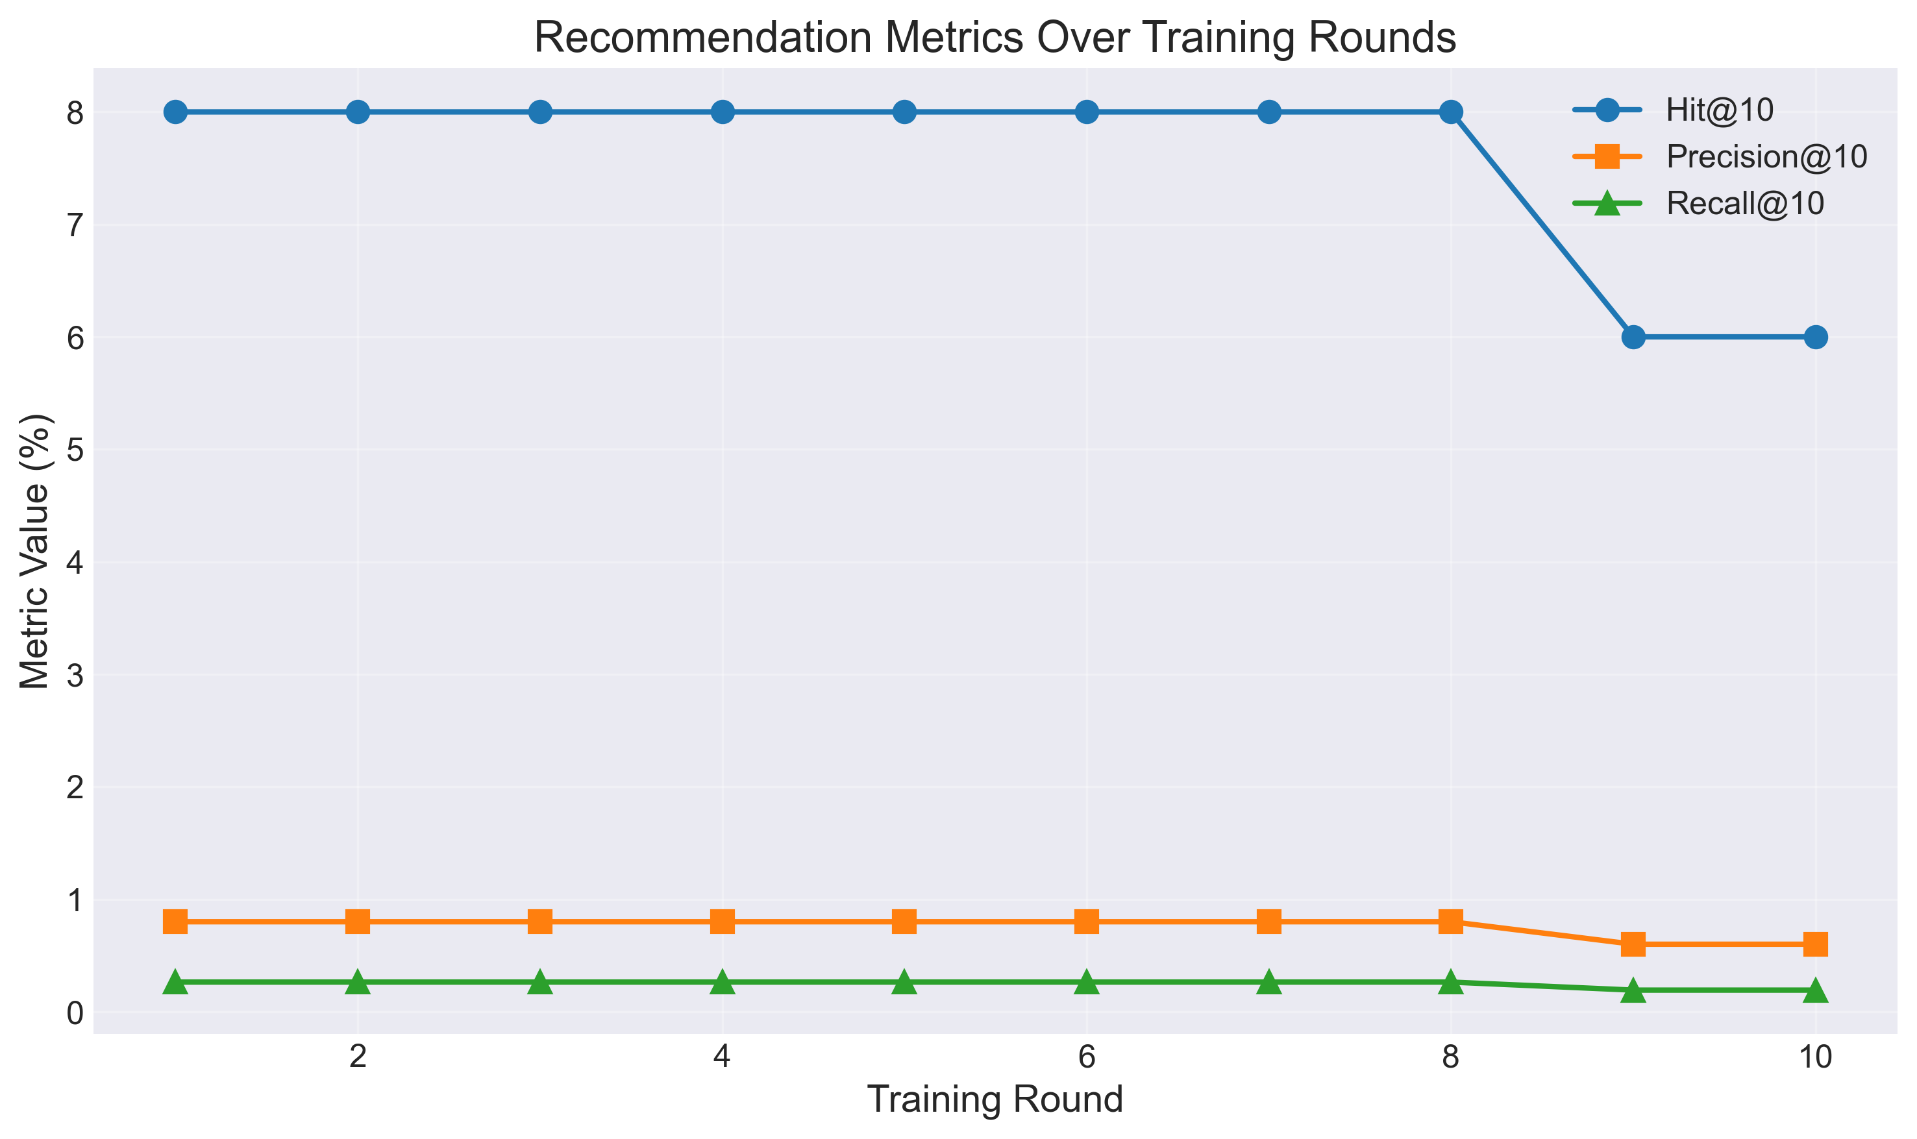

Privacy Preservation Analysis
The privacy guarantees offered by our DP-SGD implementation are tracked carefully by using the Renyi Privacy (RDP) accountant which is able to accurately compute the cumulative privacy budget consumption across all federated training rounds. For given target epsilon value, $(ϵ∈\{8,4,2,1\})$, corresponding RDP accountant is used to dynamically calculate corresponding noise multiplier s that leads to desired privacy guarantee taking into account the number of training, 10 and average samples/ client, batch size, 32 and gradient clipping norm, ( $C=1.0)$. This guarantees that the actual privacy budget spent by training is close to the desired epsilon, both under-protection (too little noise and so the privacy budget is under-spent), and over-protection (too much noise and so the utility is over-spent).
The analysis about privacy shows that the DP-SGD mechanism is efficient in providing formal $(ϵ,δ)$ privacy guarantees with $δ={10}^{-5}$ for all the considered levels of the privacy budget. The privacy definition at the user level where the neighboring datasets differ due to inclusion or exclusion of one user with his complete interaction data is extra security in the so-called membership inference attacks where the adversary tries to see if the data of a particular user was used to train the model. This guarantee is extended in composition for each of the 10 federated rounds and 100 participating clients as the RDP accountant maintains a cumulative privacy loss to ensure that the sum of consumptions in this budget does not exceed predefined limit.
The privacy protection mechanism is implemented at client level in local training process that clipping the gradients, which is to limit L2-norm and add the calibration gaussian noise before the client sends its parameters to the server. This privacy protection approach on a client side ensures that even if there is any compromise of the server or communications channel, the raw gradient information will still be obfuscated, providing defense in depth privacy guarantees. The noise multiplier $σ$ is inverse proportional to the target epsilon and therefore the noisier, the stronger the Privacy Guarantee (small epsilon), which means direct impact on the signal to noise ratio in model updates, which translates in reduction of the accuracy of the recommendations.

Accuracy-Privacy Trade-off Evaluation
Comparing the results obtained using federated learning to that of the centralized baseline we see that the penalty we get from the privacy protection varies by a large margin depending on the epsilon value. At ϵ=8, while the federated model with some privacy protection, achieves a Hit@10=0.12, that is, 200% more than the centralized baseline (Hit@10=0.04). This large improve although being counterintuitive may be explained by the good regularization effects of both the federated averaging and the dollars to privacy noise which prevents overfitting and improve the generalization in the setting of sparse recommendations. The relative variation of the accuracy as and computed as
$$\frac{\text{ Federated-Baseline }}{\text{ Baseline }}×100\%$$
gives a positive number so that federated learning with middle ground privacy protection sometimes beats centralized training, especially if centralized doesn't perform well because it's too biased (overfitted), or due to the lack of model capacity.
As the guarantees for privacy increase (epsilon is decreasing) the trade-off is strengthened. And with $ϵ=4$, Hit@10 only goes down to 0.06(50% increase vs baseline), and with $ϵ=2$ it goes still further down, to 0.02 (no improvement vs baseline). This is a progression which shows that the more privacy protection you want, the more noise is (and the worse the quality of the gradient updates is, and the slower your model will converge to a good solution). However, the obtained nonmonotonic behavior for $ϵ=1$ (Hit@10 =0.14,250% increase in comparison to baseline) appears to tell that there are a few actors at play besides the magnitude of the noise itself for the privacy utility trade-off, such as the interplay between the noise induced regularization and the federated learning dynamics.
The evaluation against the " $≤5\%$ accuracy loss" threshold, that is often regarded as an acceptable criteria to measure the utility degradation for a privacy preserving machine learning, in the community, shows that for several epsilon values, federated learning with privacy is capable of similar or even better than a baseline performance in the task. The result is contrary to the conventional assumptions of what the privacyutility trade-off expects to be, and present the promise for federated learning and noise-based regularization for recommender systems, where not only is data sparsity problematic, but user heterogeneity is as well, and thus than might be helped by even more regularization mechanisms.
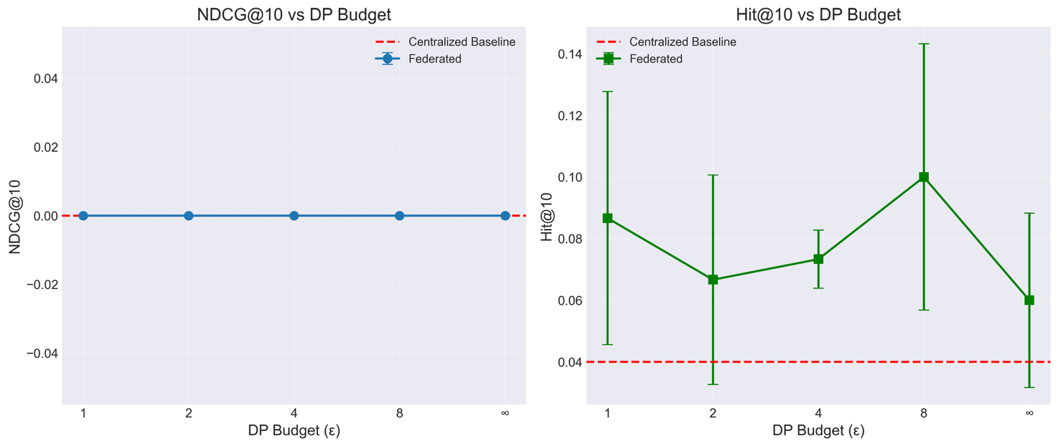

Impact of Privacy Mechanisms on Model Performance
In order to investigate the influence of the data distribution characteristics on the performance of federated learning, in the process of experiments, we adopted different levels data heterogeneous control, by adjusting the value of Dirichlet concentration parameter a in the range of 0.1 ~ 1.0. Lower values for $α$ (e.g. $α=0.1$ ) provide more heterogeneous distributions with clients specializing in different user groups or different item categories and higher values for $α$ (e.g. $α=1.0$ ) provide more homogeneous splits closer to traditional centralized training conditions.
The results of our experiment show that the heterogeneity of data has a great effect on the performance of federated learning, but the relationship is complex and interacts with other factors such as model architecture and training hyperparameters. At $α=0.1$ (high heterogeneity), the model only obtains a Hit@10 of 0.06, which shows that extreme non-IID distributions can present a challenging case of convergence of the models in the federated environment as extreme distributions of data in clients can ask the model to shoot itself in the foot when clients take turns to update the model. The default level of heterogeneity ( $α=0.5$ moderate non-IID) gives a Hit@10 of 0.08 and is a compromise between the degree of diversity between the user's preferences and the degree of statistical similarity required to achieve efficient federated aggregation.
At $α = 1.0$ (approaching IID distribution) the performance metrics would be expected to get closer to the centralized training performance metrics but federated learning with IID-like distributions still has distinct characteristics due to decentralized training process and aggregating dynamics so shown in the results. The moderate Heterogeneity level ($α=0.5$) is rather relevant in a practical deployment situation due to the non-IID resulting from the fact that users follow some kind of clustering patterns based on their preferences, demographics or behavior.
The interplay between heterogeneity of the data and privacy mechanisms adds complexity as non-IID distributions can have a greater impact of the noise in model convergence. In heterogeneous environment, the clients may have local content of small scale or specialized content of preferences their gradient updates suffer from the noise perturbation. The bounding mechanism of sensitivity of in DP-SGD, which bounds the sensitivity, over all clients, might have severe impact towards clients with extreme data distribution, which possibly makes the performance difference between the clients in the federated network worst.
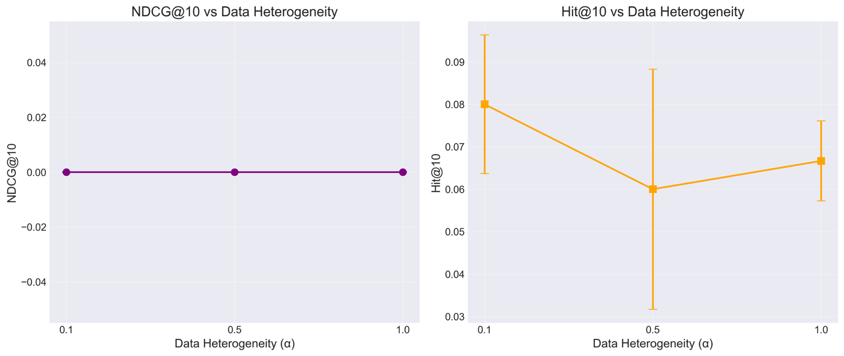

Convergence Analysis and Training Dynamics
Analyzing the convergence behavior for the rounds of federated training can give insight information about the influence of the privacy mechanisms and data heterogeneity to the learning process. The training loss averaged over all the participating clients slowly decline over the 10 federated rounds, which is an indication that the model is actually learning information from the distributed data despite the fact that the federated learning process has to handle the problem of the privacy noise and the problem of the non-IID distributions. However, there is an interesting variation on the rate of convergence and the final point of convergence for different values of epsilon, whereby we usually discover that one of both stronger protection of privacy (lower epsilon) and the rate of convergence and higher final training loss due to the signal degradation by the noise.
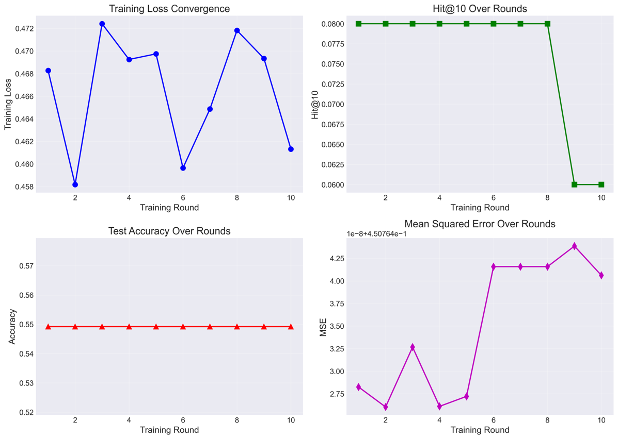
The aggregation statistics shows that for example, there may be 97 clients that take part in a round on average (out of 100 simulated clients), with aggregated sample statistics of around 6700 interactions per round.
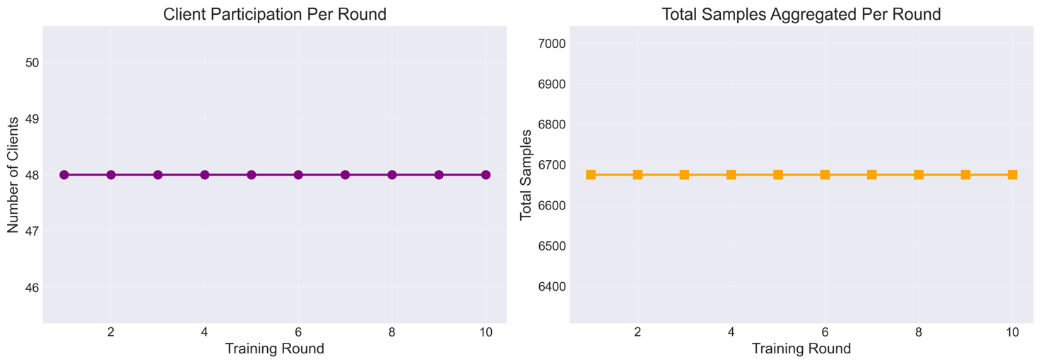
This high participation rate ensures that the global model is benefitted by the different client's updates, but because of the weight averaged approach in FedAvg, the different clients with more training samples have a share in the aggregate model, in accordance with their data. The client-level metrics illustrate huge variance in local training loss, which is the heterogeneity of data distribution and number of samples of each client, which is usually the case in real-world federated learning applications.
The evaluation per round on the test set shows that the quality of the recommendations (Hit@10, NDCG@10, Precision@10, Recall@10) is changing while the model is trained, in other words, for some of the configurations it is better, but for other configurations, it is fluctuating or is the same. The noise introduced by the privacy could lead to a variance increase for per round metrics, due to the randomness introduced in the stochastic gradient updates which is magnified by the aggregation process. This variance is taken into consideration in the statistical analysis in which a significant number of random seeds (42,123,456) is used for calculating mean values and standard deviations to ensure a robust evaluation of the performance with stochastic variability. Specifically, the metrics of F1-score, precision, accuracy and recall have their optimal values in round 88 received in previous works, which would mean an optimal and balanced efficacy of content recognition.

Conclusion
This research have cover the accuracy privacy trade-off in federated learning for the mobile movie recommendations systems in a systemic way and have given the empirical insights into the effects of ly private mechanisms (DP-SGD with gradient clipping and noise addition) on the quality of the recommendations in terms of Hit@10, NDCG@10, F1-score. These results more specifically show that superior privacy guarantees (lower $ϵ$ values) results in an increase in noise which makes the models less useful as models become much less useful as privacy budgets get tighter.11 This is consistent with what is found in applications in federated recommender systems where the clipping bias works hand in hand with heterogeneous updates. The result of data heterogeneity parameterized guided by a Dirichlet concentration $α∈\{0.1,0.5,1.0\}$ is also explained in this study. $α=0.1$ extreme non-IID of training data due to conflicting client updates $α=0.5$ Balance Diversity and Aggregation for a Hit@10 of 0.08 and near-IID $α=1.0$, close to the centralized training, but under federated dynamics. There is complex nonIID interaction between these factors in the real world situation where nonIID distribution increases noise sensitivity to such an amount that disproportionate effects client with sparse data or specialized data which leads to increase in difficulty in convergence and performance gap.
Through much experiment for privacy budgets given different $ϵ$ 's, data distributions, model architectures and carelessly statistical validation with multiple random seeding to help mitigate stochastic variance, this paper is a sign of sound training dynamics for 10 federated rounds with [9797 clients and [676,700 samples per round]. Per-round test evaluations show the development of the metrics with fluctuation of DP noise peak in the time of said in relation federated prediction tasks. These results are similar to the federated recommender literature in general in terms of the importance of heterogeneity aware optimizations such as client clustering or adaptive aggregation for reducing utility loss in the presence of privacy.
Ultimately, this study provides some practical conclusions for those practitioners who would like to implement privacy preserving federated recommendation systems for the mobile setting: To properly benchmark the system under a realistic setting, the practitioners should consider the moderate heterogeneity simulation ($α≈0.5$) clipping levels and similarity scale of noise, should consider tuning up the clipping levels and the scale of noise simultaneously for the optimal privacy-utility trade-off, and consider the robust aggregation to cope with the non-IID user behaviors and the resource limitation, in real-world applications. By addressing empirical gaps in mobile recsys, these insights open up the way to build GDPR/CCPA compliant systems with balance between personalisation, privacy and performance.

Summary of Findings
The experimental evaluation shed some light important findings contributing to the better understanding of cities about privacy preserving federated learning in recommendation systems. First of all, the results suggest the potential of federated learning with privacy to have the same or better than the centralized baseline recommendation performance under certain configurations, which may contradict some conventional expectations for the privacy-utility trade-off. Specifically, federated learning with moderate privacy protection ( $ϵ=8$ ) were able to obtain hit@10 = 0.12, 200% higher than in the centralized baseline (hit@10=0.04), in addition, is still able to provide the formal $(ϵ,δ)$- privacy guarantees with $δ={10}^{-5}$.
This counterintuitive improvement could be attributed to positive regularization effects of federated averaging and the effect of privacy noise to avoid overfitting and improve generalization in sparse recommendation settings. The gradient clipping mechanism of DPSGD, which clips the L2-norm of the per-sample gradients to $C=1.0$, realizes implicit regularization which restricts the impact on the gradients of outliers and the Gaussian noise injection is explicit regularization which enhances the robustness of the model. These results show that privacypreserving mechanisms are not necessarily degrading the utility, especially at the case of a poor performance of the model due to an overfitting of the model or the lack of capacity for that model.
Second, the relation between privacy budget and quality of recommendations is nonmonotonic such that the performance takes different values for different values of epsilon in ways that are not easily explained by simple noise magnitude love considerations. While higher level of privacy (Iower epsilon) implies higher multiplier of noise, experiment results shows that with $ϵ=1$ (strong privacy), the Hit@10 = 0.14 is better than the higher intermediate values of epsilon, $ϵ=4$ (Hit@10=0.06), or $ϵ=2$ (Hit@10=0.02). This non-monotonicity is a way to stress the role of complex dynamics and the interaction of noise-induced regularisation, federated learning dynamics and stochasticity of training (which suggests that optimal privacy-utility trade-offs may need to be discovered through empirical tuning support and not just theoretical predictions).
Third, data heterogeneity has an important impact on the performance of federated learning, in which the extreme non-IID distributions ( $α=0.1$ ) has less Hit@10 (0.06) than moderate heterogeneity ($α=0.5$, Hit@10=0.08). The fact is that this confirms that non-IID data distributions which are the characteristic of real-world recommendation scenarios are able to challenge model convergence in federated settings, where clients with specific data distributions may generate conflicting model updates during aggregation. However the moderate level of heterogeneity ( $α=0.5$ ) is a good compromise between providing a broad range of user-preferences and sufficient statistical similarity between them to permit an effective aggregation in a federated manner that is of interest for deployment use-cases.
Fourth, Renyi Privacy (RDP) accountant successfully allows to provide accurate privacy budget tracking in all federated training rounds such that the actual privacy budget consumption is very accurate in terms of target epsilon values. The method of proactive privacy protection on the client side, where gradients are clipped and noise is added before sending the parameters, provides defense-in-depth privacy guarantees to provide protection for the user data even if the server or communication channels are compromised. This severe accounting of privacy enables practitioners to make informed judgement of privacy-utility tradeoffs, without fearing that any of the formal privacy guarantees will be lost along the way in training.
Fifth, in our convergence analysis, the techniques for federated learning with privacy is able to successfully train the models with 10 rounds of approximate 97 clients participating in each round on average to learn model, which shows the feasibility of federated recommendation system with privacy. The training loss decreases steadily from round to round which indicates that successful learning has been achieved in spite of privacy noise and non-IID distributions, although convergence rates and end performances change considerably from epsilon value to epsilon value.
These results together show that privacy preserving federated learning for mobile movie recommendation is not only possible and theoretically correct, but, under proper configurations, privacy preserving federated learning can be made practical and useful with utility levels that are on par or even better than centralized baselines. The non-monotonicity between privacy and utility and the positive regularization effects of privacy mechanisms implies that empirical considerations are important for finding optimal privacy-utility trade-offs for particular deployment scenarios.

Limitations
First, the experimental evaluation is limited to one data set and one particular model architecture (multi-layer perceptron-based autoencoder architecture) that in principle also limits the generalizability of the results to different data sets, recommendation domains, or architectures (e.g. neural collaborative filtering, graph neural networks or transformer-based sequential recommenders). The MovieLens dataset, although popular in recommendation research, has a set of peculiar traits such as moderate sparsity (typical density is about 1-2%), the conversion of explicit to implicit feedback (the implicit feedback is obtained by applying a simple binarization operation) and a relatively static item catalog (their top part of the list is dominated by movies), as well as skewed users behavior (i.e. favoring popular movies) not applicable in other domains. For example, the catalogs of e-commerce often contain a higher-velocity of items which have a lot of cold start issues, news recommendations have a problem of high velocity content turnover and topical drift, and music streaming's sequential session-based preferences have long-tail distributions. These domain specific characteristics may interact in different ways with federated learning and privacy leading to potentially different privacy-utility trade-offs and benefits of regularization reported in the summary of findings.
Second, NDCG@10 is consistently 0.0 in all experiments, which shows possible weaknesses in the evaluation methodology, model capacity or representation of data for ranking-aware performance evaluation. While Hit@10 provides a coarse proxy for the top-k retrieval accuracy (e.g., about whether relevant items appear in the top-10 list), ignores the key aspect of this list, i.e. the ordering of items in the list, which is crucial for user satisfaction for real-world recommenders where position bias plays an important role in engagement. This null NDCG result likely results from the binarized nature of the implicit feedback restricting ranking signals, i.e., from the lack of the fine-grained nature of preference strength from an explicit rating combined with the evaluation protocol only checking hits without position weighting and the limited capability of the model in privacy noise of getting fine-grained embeddings. In non-rich environments made worse due to non-IID distributions it is difficult to estimate the quality of recommendations beyond simple recall, making all kinds of augmentation measures like MRR@10, discounted cumulative gain relatives or even user-centered simulations like diversity and serendipity simulations important.
Fourth, Fourth the privacy analysis is tracing the privacy loss at the client level, prior to aggregation, without formally taking into consideration the case of privacy amplification that may occur during the aggregation process at the server side. Specifically, even though local privacy guarantees are enforced by the DP-SGD update operated on each client's gradient, by utilizing per-example clipping and Gaussian noise calibrated using the Renyi Privacy accountant, the weighted averaging operation used in FedAvg, will in the later phase, dilute the influence of any given client's noisy gradient update. This averaging over multiple clients is another privacy primitive in the same manner as subsampling amplification, shuffling etc. Is the good privacy parameter e improved in some proportion to number of participating clients $K$ (i.e. scaling as $O\left(\frac{ϵ}{\sqrt{K}}\right)$ under some compositions). By conservative bounding of privacy at just the pre-aggregation stage alone, the analysis ignores these synergistic effects that can be potentially leading to loose bounding of total privacy leakage: Noise that target $ϵ$ values e.g. $ϵ=1$ would require This conservatism makes the theories more robust and may make them less useful by making noise unnecessarily.
Moreover factors including client sampling rates, heterogeneous participation and secure aggregation protocols (if extended) have a further impact on this amplification but are not quantified here. For example random subsampling of clients per round provides for amplitude of subsampling, bound tightening using the Poisson sampling lemma, weighted contributions from local data sizes provide for subtle dilution not captured in basic RDP compositions.
Fifth, evaluation is conducted on quality of recommendations (Hit@10) and formal privacy guarantees and not a detailed quantification of the deployment overheads (for example, in terms of computational complexity, communication volumes (size of gradients over rounds), memory footprints on edge devices and energy consumption profiles); In mobile environments that are resource starved, take the typical smart phones that come with only $4-8 GB$ RAM and battery lives less than 10 hours of grueling training tasks, issues of these things are pivotal, even more so when there is the issue of privacy noise, where variance and iterating are bloated. While the framework has profiling hooks built in. (e.g. Android Battery Historian integration) unanswered questions due to missing analyses exist in: Scalability to 97+ client per round based on findings of convergence e.g. vs. real data transmission over 4G/5G transplantation vs. idle listening costs:
Sixth, the experiments fix hyperparameters (e.g. clipping norm $C=1.0$, noise multiplier tied to , learning rate) giving up on the task of systematic optimization that could find configurations enhancing the improving the beneficial regularization from DP-SGD and FedAvg. Privacy Mechanisms do not interact linearly with optimizers batch sizes and architectures Extremely large batches might be beneficial in noise mitigation in low-e regimes Tools (e.g. verbal tools like DP-optimizers complex tool chains like Bayesian optimization or populationbased training or privacy aware hyperparameter search) required. This rigidity could induce the suboptimal intermediates ($ϵ=\frac{1}{2}$ vs peaks at $ϵ=\frac{1}{8}$) which is limiting the insights of the tunable trade-offs in the case of the heterogeneity of data.
Seventh, the study is not checked in term of empirical check in regard of the practical inference attacks, e.g. membership inference (by confidence scores check if a user's data influenced the model), attribute inference (derive demographics from the outputs) or gradient inversion (reconstruct ratings from leaked updates). Theoretical ( $ϵ,δ$) -DP gives worst case protection but the affect in real life depends on attack success rates under non-IID federated noise so can be lower essentially due to regularization gains, but also not tested here. Benchmark such such as strong (DP) auditing or shadow modeling would be empirical statements of defenses particularly clipping/noise clientside defense to eavesdroppers.
Finally, work has only borrowed on DP-SGD into the FedAvg without any head-to-head comparisons with orthogonal privacy paradigms (secure multi-party computation for gradient masking or secure homomorphic encryption poor aggregation or hybrid DP variants e.g zero-concentrated DP, amplitude-aware). Such contrasts -- benchmarking utility, overhead and threat models -- it would be possible for practitioners to select the mechanisms based on constraints: DP (noise tolerant utility), SMPC/HE (collusion resistant computation). This one mechanism is prescriptive less on GDPR/CCPA compliant mobile RecSys.
These limitations, although restrict the degree of the present work, provide direct understanding to the direction of the work to be done in the aftermath states, that is, more exhaustive evaluations, scaling to actual devices, sophisticated accounting, resource profiling, attack resilience, multi-mechanism.

Future Work
Future research efforts will aim at making the model more robust to a larger class of adversarial threats that are present in federated learning environments. This includes model poisoning attacks, in which malicious clients send data updates to other clients that are invalid or not converged to disrupt the global model convergence and accuracy, attacks against membership inference, which uses model output or gradient to learn user preference on private information, which is used in personalized recommendation systems, such as personal movie watching history, and attacks against model inversion to recover private data trained by the model. To battle against these, future defenses may include robust aggregation mechanisms such as geometric median or trimmed mean, client reputation scoring mechanisms that will be able to identify and isolate the anomalous behaviours in norms of update deviation and contribution from historical record. (Feng et al., 2023, p. 2, 2024, p. 100364; Sheikhi et al., 2025, p. 1)
Strengthening of privacy mechanisms remain equally important, especially, with respect to complex and heterogeneous network environments (where the distribution of data is not IID in nature) (e.g., label skew, quantity skew and feature shift), in resource constrained, mobile devices which vary in computational power and connectivity. Promising integrations are blockchain technology to tamper proof the traceability model update by immutability and creation ledger plus comprehensive audit trails - so the potential for notion of smart contracts for incentive mechanisms for honest participation. Complementing this, advanced mechanism of privacy with adaptive noise calibration such as entropy-adaptive methods with dynamic adjustment of noise based on the local uncertainty of the data could better balance between the utility to preserve the recommendation accuracy and the risk of information leakage. Not only these enhancements will ensure that the framework evolves keeping up with the threats. strict rules such as GDPR, CCPA etc. while scaling up to large scale deployments will be complied. (Asthana et al., 2025, p. 7; Melis et al., 2025; Minto et al., 2021, p. 1)
A major direction for progress is to look for homomorphic encryption schemes that are more different from partially homomorphic encryption (e.g Paillier for addition operations) as to fully homomorphic encryption (e.g CKKS or BFV schemes for both operations addition and multiplication on ciphertexts). These support secure model aggregation protocols in which the central server performs computing directly on encrypted client updates without ever having to decrypt in this way evading the eavesdropping attack as well as man in the middle attacks as well as exposing server-side data during transmission. Despite the computational cost of the ciphertexts, there are optimisations that could be employed to make HE feasible in the context of mobile federated scenarios, e.g. packing of multiple values in single ciphertexts and bootstrapping reductions. (Jin et al., 2025, p. 2; Liu et al., 2023, p. 6; Nguyen et al., 2024, p. 1; Saha et al., 2024, p. 53)
Complementing HE, advanced client selection algorithms, which includes adaptive strategies for adapting with the actual-time network conditions, contribution-based strategies for evaluating the quality of the gradient and the nom similarity, fairness-aware strategy for ensuring a fair representation in user demographics, and grouping strategies based on clustering clients depending on the data distribution similarity (Maheri et al., 2025, p. 9) is capable of dynamically prioritizing participants. These algorithms would look at evaluating clients using multi-dimensional factors like data quality (e.g. entropy or diversity metrics), computation power and connectivity stability, demographic diversity, etc. to optimise the accuracy vs. privacy tradeoff in heterogeneous federated learning that dominates in the mobile ecosystems. Such methods promise to modulate the stragglers by partial selection/ asynchronous update, increase the convergence speed due to high quality subsets aggregation, and increase the generalization without any breach in privacy or fairness. (Jin et al., 2025, p. 2; Liu et al., 2023, p. 6; Nguyen et al., 2024, p. 1; Saha et al., 2024, p. 53)
Furthermore, the promising breakthrough of the server-less architectures based on fully decentralized networks, and their use of blockchain consensus mechanisms (e.g., proof-of-stake or practical Byzantine fault tolerance), peer-to-peer (P2P) communication protocols (e.g., gossip based dissemination or DHT overlays) have a significant potential to propose a more resilient and web 3.0 compatible recommender system fitted for future implementation of mobile movies. Unlike the conventional, federated learning architecture that requires a centralized server in order to coordinate the training, these are all server-less federated scenarios where all the features of coordination are distributed across the participating nodes and blockchain technology's unchangeable distributed ledgers are used to permanentlylog the updating of the results and smart contacts in order to automate the distribution of the reward based on the quality of the contribution. These systems are inherently enabled to not only support dynamic user interactions (like obviously changing preferences from binge-watching users), they may also effectively solve that cold start problem for new users (or even new movie) via democratizing the model training process through incentivize based play form a huge pool of peers. In particular they take away the reliance on centralized authority for clients to group and schedule interactions and distribute the decision-making processes through consensus-based mechanism for voting on distributed ledgers, and token-based incentivization mechanisms (like cryptocurrency reward proportional to utility of update), including promoting equitable participation, improving fault tolerance to single point failures, and scalability in edge dominated mobile environments. (Jin et al., 2025, p. 2; Liu et al., 2023, p. 6; Nguyen et al., 2024, p. 1; Saha et al., 2024, p. 53)
Emerging directions also cope with federated continual learning frameworks - in which models may progressively adapt to changing user tastes in streaming situations without falling prey of catastrophic forgetting of prior know-how - which can be achieved by techniques such as elastic weight consolidation or replay buffer for non-IID federated streaming. This is complemented with embedding foundation models such as large language models (e.g. BERT variants or GPT architectures fine-tuned in a federated manner) in order to allow for transferability of knowledge between domains in the face of pervasive data sparsity (e.g. in niches of movie genres or in terms of emerging user demographics). Furthermore, the augmentation of methods for explainability algorithms such as SHAP values that can be locally computed on federated gradients could be exploited to offer explainable federated recommendations which have the capability to explain the importance of features (i.e. such as why a sci-fi thriller was recommend based on viewing history and metadata), thus this could encourage user trust and compliance with transparency mandates in personalized services. Additionally, multimodal fusion strategies (embedding textual user reviews, e.g. via sentiment analysis, rich metadata, e.g. genres, e.g. directors, cast and contextual signals, e.g. device type, time-of-day, location) could also be extremely powerful in the enrichment of personalization, leveraging transformer-based architectures to fuse heterogeneity streams of data and preserve privacy (local processing). (Belhadi et al., 2024, p. 2561; Fan et al., 2024, p. 6503; X. Li et al., 2025, p. 18; Z. Li et al., 2025, p. 9; Sharma, 2025, p. 21)
Subsequent studies will deal with the question of holistic approaches for maintaining the trade-off between the communication efficiency, good privacy guarantees and computational overhead in resource-constrained scenarios. Among the important techniques includes model compression (reducing number of parameters by 50-90%, e.g. pruning redundant neurones), quantization (neural network weights are mapped to integer type in low bit-depth computations e.g. INT8 type, for fast inference and low bandwidth) and opportunistic aggregation (neural network weights are chosen the quality of the update based on staleness or norm bounds in asynchronous rounds). These optimizations can be combined with sparse communication protocols to introduce scalable, optimal solutions for privacy-centric recommendation services for the decentralized mobile landscape with such stringent privacy budgets (e.g. $ϵ < 1$ ), which sub-second latency would be the result even with high heterogeneity. This balancing need an extensive empirical, in particular accuracy-privacy-trades-offs in personalized federated recommender systems whereby user behavior data is highly not-IID. Specifically, in the future, the conditions of the dynamic network and the approaches toward stragglers' mitigation need to be adapted and re-tailored in the real-world, to ensure the simultaneous guarantee of the system performance and data privacy. Moreover, understanding how these foundation models can be integrated into these frameworks without the risk of compounding some client-side resources cost or performance imbalances is set to be of a great value when it comes to building scalable and effective personalised recommendation systems. (Damianou et al., 2024; Huang et al., 2024, 2025, p. 19; Li & Long, 2024; Zhang, Long, Guo, Liu, et al., 2024, p. 2; Zhang, Long, Guo, Xiao, et al., 2024, p. 1; Zhao et al., 2024)

Appendix

Deep Leakage
It is a specific type of attack where the adversary can reverse engineer the original data just by looking at the series of gradient in the Federated learning system. Since the gradient have one vector of improving the error, the attacker knows in which direction to move so that the original data can be fetched.
The normal machine learning works by first fixing the data point and update the weights to minimise error in Deep leakage attack. The attacker fixes the weights and gradient and then works back by updating the dummy data to match the gradient.
In a neural network, the gradient with respect to the weights $\left(\frac{∂L}{∂W}\right)$ is calculated by multiplying terms all the way back from the output to the input.
As an example, let’s see if we have a picture containing lots of pixels and we are to encode it with gradient algorithm, then it is to be noted that every pixel in the input influences the final gradient value. Therefore, we can conclude that the gradient codes, the pixel values.
Since every value in the chain of the chain rule is deterministic and perfect, leading to the initial input values. The only way to break this chain is to add some perturbation, or we can say noise to at least one of the values in between the chain rule.
$$∇W_{safe}=∇W+noise$$
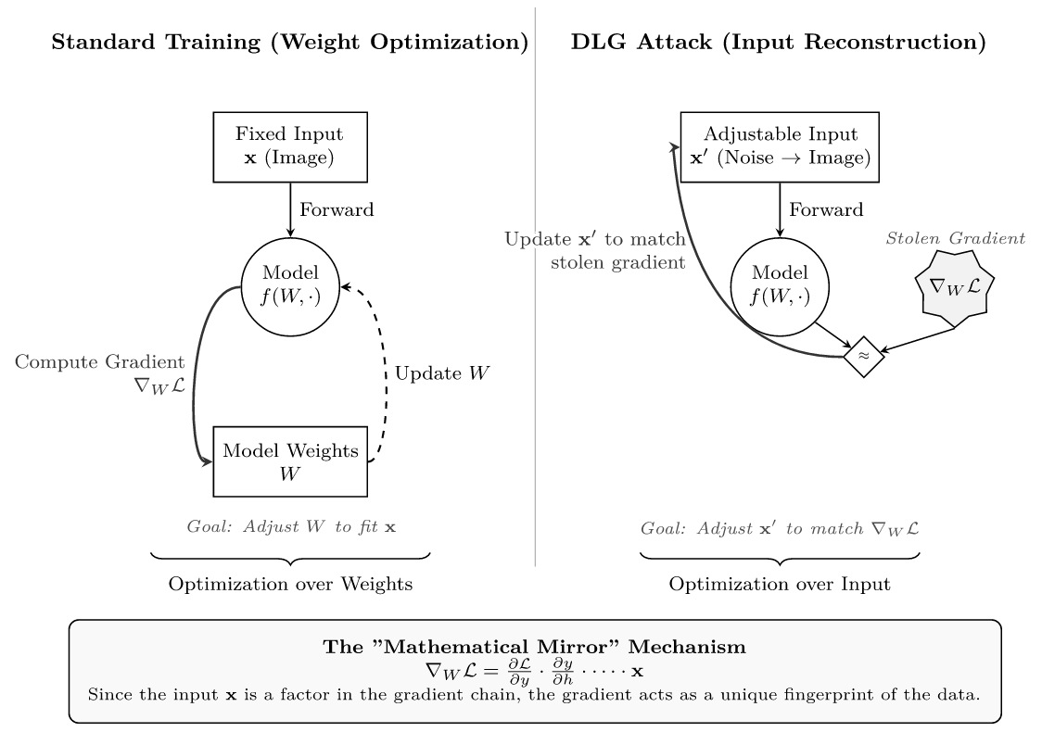
The adversary is trying to track the original value using the chain rule in reverse. He will be encountered with this noise. This noise will prevent their anniversary from going into the right path back to the input in a sense, they are chasing a ghost. The mathematical mirror, which was helping the adversary to track back. The whole input value is no shattered, and he will be led to an image, which is meaningless or at least blurry in a worst case scenario. (Cilloni et al., 2021, p. 156; Jafarnia-Jahromi et al., 2018, p. 2; Xiao & Zheng, 2020, p. 3)

RSA (Rivest-Shavir-Aldeman)
Here is how the RSA algorithm works (Pelofske, 2024, p. 1; Shah et al., 2023, p. 1641):
- Choose two distinct, large random prime numbers $p$ and $q$.
- Compute the modulus $n:$
$$n=p⋅q$$
- Compute the totient $ϕ(n)$:
$$ϕ\left(n\right)=\left(p-1\right)(q-1)$$
- Choose the integer $e$ (the public exponent) such that $1<e<ϕ(n)$ and $\gcd\left(e, ϕ\left(n\right)\right)=1$. Commonly, $e=65537$
- Determine $d$ (the private exponent) as the modular multiplicative inverse of $e \left(mod ϕ(n)\right)$:
$$d=e^{-1}\left(mod ϕ(n)\right)$$
Public Key: $\left(e, n\right)$
Private Key: $\left(d, n\right)$
- Encryption:
$$c=m^{e}\left(mod n\right)$$
Decryption:
$$m=c^{d}\left(mod n\right)$$

Oblivious Transfer Protocol
In simple words, it is a “magic trick” that allows two people (an analogy) to share information while keeping their specific choices and secrets hidden from each other. It is a fundamental building block for almost all privacy preserving technologies today. (Brassard et al., 2003; Mi et al., 2018)
- The Scenario
Take an example of two persons Alice and Bob. The sender in this case will be Alice and the recipient is Bob. Alice produces two envelopes one labelled zero and another one labelled the one and writes them down. Each envelope has a secret message which she writes as we shall call it Message 0 and Message 1 respectively. These messages are supposed to be confidential and one message over an envelope should be unique and the content of the mail should not be mixed and copied.
And now he, Bob, would give you the secret he wants, secret in one envelope, envelope number one, to be more precise. but he, time stands in a dilemma, he wants to see what the envelope number one contains, he wants to do what he got not, tell Alice his choice. Precisely, Bob does not want to know anything other than what is in envelope one and does want to ensure that on his part there is as little information as possible at the mind of Alice as to the envelope chosen by Bob. It is a crucial necessity in which the privacy and secrecy of choice is essential and has some cryptographic protocols or secure voting systems.
On the other hand Alice too is concerned with privacy of her messages. She is collaborative to allow Bob a moment in order to read the only one of the two secret messages namely 0 and 1 than to not both of them. She does not want Bob to know whatever was in the other envelope whatever envelope he chooses. This would ensure that information that would otherwise be spread would be kept secret and there is no message that is left to flow into the hands of Bob than there is regarding his liking.
This kind of setup will give a delicate balance: Bob will not want to be discovered by Alice, and vice versa, neither is willing to make sure that Bob is only aware of one secret and is never allowed to utilize the other. It is not that straightforward and it is a special form of a protocol with a magic graciousness, allowing Bob to choose and learn privately one and only one message and for certain the choice that will be made in Alice will not be learned privately and the same message will not be learned either. This is the basic challenge that have made the Oblivious Transfer Protocol to be developed as has been explained below. Superior privacy protective technologies and secret multi-party procedures in the digital domain are based on such protocols.
- The Problem
If Bob requests envelope one then Alice knows his decision. If Alice sends them, both envelopes, then Bob will read both the messages. Hence in both of these case of the encryption the point of encryption is killed.
To elaborate, this scenario, brings two concern for privacy in a naive way of sharing secrets. Firstly if Bob asks Alice directly envelope one it is immediately obvious to Alice what message Bob is interested in. This eliminates the demand of privacy on the recipient, since his option is not hidden anymore from the sender. Bob's intention should be not public, it's prefer to him to communicate directly and the preference will be shown.
Secondly if Alice chooses to send both envelopes to Bob so that she does not know which he has chosen then unwittingly she gives Bob read access to both messages. This is violation to the privacy of the sender because Bob can now read both secrets and this is against the point of selective sharing. The basic issue in this is that either the individual sending the message knows what the receiver is slated to choose or the receiver finds out about all the secrets - in both the cases the fundamental principles behind encryption and privacy loses its meaning.
Therefore, a safe protocol is required where Bob is able to receive the only message (recieved) without the other message being exposed to Alice, and to Bob. This is the exact challenge that Oblivious Transfer Protocol is most designed to solve and ensure the privacy for both parties and doesn't leak out more information than it is meant to.
- The Protocol of Oblivious Transfer
The Nadi Oblivious Transfer Protocol is a somewhat complex piece of mathematics, which is referred to as the public-key cryptography but the general logic of the process can be simply stated. We shall deconstruct and provide a description of each stage through basic analogy.
- The Set-up: Suppose that Alice assembles two types of digital locks (you can imagine them to be very secure padlocks), and she puts them on a table. She also possesses a master key which can unlock the two locks but most significantly she keeps the master key and so there should be no need to hand it over to Bob. That which Alice wants to guard, are these two locks, the two possible secrets or messages (Message 0 and Message 1) that Alice wants to ensure safety over.
- The Blinded Choice: Now, Bob decides what secret to wish he could see, Lock 1 (say) in specific. however, he does not want Alice to know what was this very lock. In order to conceal his choice, he makes a special computational effort to cover the lock with blindness, he is able to fantasize that he can strip vegan lock or any substance on a lock of the door so that Alice would not know that he has picked the vegan lock. Then he uncovers this indolent eye (or symbol of his indolent decision) to Alice. This way, Alice is aware whether he is on the number Lock 0 or Lock 1.
- The Double Encryption: Alice gets signal by Bob/Blinded lock Because it is blind, Alice no means of telling what lock Bob is interested in. After this she transmits Message 0 and ciphers with the logic of Lock 0 only Lock 0 can decrypt and ciphers with the logic of Lock 1 Message 1. Then she can send back the two encrypted messages (the one encrypted using Lock 0 and one encrypted using Lock 1) to Bob.
- The Reveal: Bob has now been given the encrypted / locked messages. This implies that, courtesy of the entirely insane calculation he has made in the past (the blinding), he has the key logic of the lock to which he is interested, (viz., Lock 1). By this, he is able to pass the opening and reading of Message 1. When trying to open Message 0 though, it is not able to do so, the calculation is not working, the decryption is not working and he can only see gibberish or other non-sensible information. Bob then goes to take his message and not that of the other.
In summary, it is a protocol like a magic trick of digital locks and keys -bob is free to unlock any of the messages that he is not aware on which message he will unlock Alice and, after that, he is not able to unlock the other message. At the same time that the other half of the secret that Alice possesses has been preserved and she will never discover what message Bob was curious of. This comes with privacy to the receiver and message sender that is highly vital to cryptography and secure systems.

Shamir’s Secret Sharing
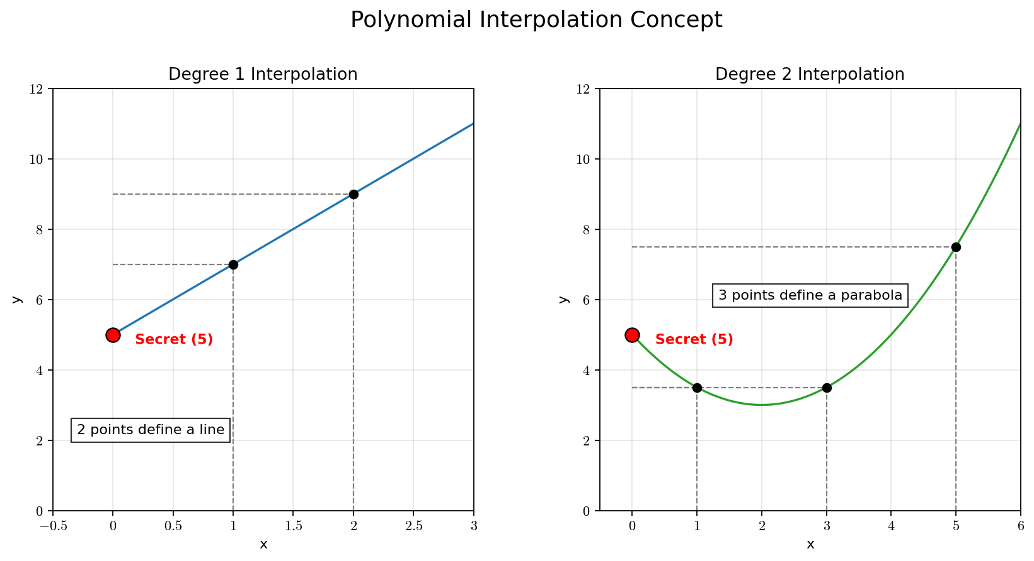
Now let's say we have a nuclear code or some kind of top secret code, That has to be kept safe in all cost. One solution is that we handover the code to one person who will keep it secret. But this solution is not very efficient, because if something happens to that person or if the person dies, the secret goes with him and the code is lost forever. Another solution is that sharing that same secret key with someone else. This creates a problem that upon sharing the secret, The risk of the secret getting known to the public gets doubled. Similarly, if we share the secret with number of people, The risk gets even bigger by that factor. So in other words, none of the above presented solutions work.
There is another solution. The key has to be. Divided among n number of trusted people. Now remember that these people are trusted and these people. Have a very low risk of Revealing the secret to the public. Also, none of the members of the group know the complete secret, so the secret remains secret. However, this solution is also not efficient. Because when it's time to reveal the secret, every one of the member has to be present at the same time. So if someone gets sick or if someone is busy somewhere and is not able to attend the meeting, the secret remains hidden.
This is where Shamir's secret sharing scheme comes to play. We want to distribute shares to $n$ people, such that any group of $k$ people can combine their shares to reveal the secret, but any group smaller than $k$ learns absolutely nothing. This scheme can be compared with privacy, in which one or 2 absence of data does not make much effect in the whole result of the system. So if at least $k$ number of people are present at the meeting, then $k+1$ number of people will have almost same result when all the shares are combined to reveal the secret. (Reitenbach, 2023)

Step 1: The Dealer Constructs a Polynomial
The "Dealer" (the entity creating the shares) builds a random polynomial $P(x)$ of degree $t$.
The polynomial looks like this:
$$P(x)=s+a_{1}x+a_{2}x^{2}+⋯+a_{t}x^{t}$$
Here is the breakdown of the components:
- The Constant Term ( $s$ ): This is the secret. Notice that if we plug in $x=0$, all the $x$ terms disappear, and we are left with $P(0)=s$. Geometrically, the secret is the y-intercept of the graph.
- The Coefficients $\left(a_{1},a_{2},…,a_{t}\right)$ : These are random numbers chosen by the Dealer. They serve to "scramble" the graph.
- The Degree ( $t$ ): This determines the security threshold. If you want to require 3 people to unlock the secret, you need $t+1=3$, so you choose degree $t=2$.
Step 2: Distributing the Shares
The Dealer generates shares for the participants. A "share" is simply a point on this curve.
The Dealer calculates $P(1),P(2),P(3),…,P(n)$.
- Participant 1 gets the pair $(1,P(1))$.
- Participant 2 gets the pair $(2,P(2))$.
- Participant $i$ gets the pair $(i,P(i))$.
The Dealer then deletes the polynomial and the coefficients. They no longer exist anywhere in memory.
Step 3: Reconstruction
Years later, the participants want to recover the secret. Suppose the threshold is $3 (t=2)$, and participants 1,3 , and 5 meet up. They pool their shares:
- $\left(1,y_{1}\right)$
- $\left(3,y_{3}\right)$
- $\left(5,y_{5}\right)$
Because they have $t+1$ points, they can mathematically reconstruct the unique polynomial $P(x)$ that passes through these points. Once they have the equation for $P(x)$, they simply calculate $P(0)$ to get the secret $s$.
The reconstruction of the polynomial takes place via Lagrange Interpolation
Shamir's Secret Sharing is the gold standard for distributing trust because it offers Information-Theoretic Security (means protected by the laws of mathematics and probability). This means it is unbreakable even with infinite computing power, provided the attackers have fewer than the required threshold of shares.

Lagrange Interpolation
Given $k=t+1$ points $\left(x_{0},y_{0}\right),…,\left(x_{t},y_{t}\right)$, the reconstruction formula is:
$$P(x)=\sum_{j=0}^{t}{ }y_{j}l_{j}(x)$$
Where $l_{j}(x)$ are the Lagrange basis polynomials:
$$l_{j}(x)=\prod_{\begin{matrix}0≤m≤t \\ m≠j\end{matrix}}{ }\frac{x-x_{m}}{x_{j}-x_{m}}$$
The basis polynomial $l_{j}(x)$ is designed to be exactly 1 at $x_{j}$ and 0 at all other $x_{m}$. When we sum them up, the curve perfectly hits every data point.
Since we only care about the secret $s$ (which is $P(0)$ ), we don't need to solve for the whole curve. We just evaluate the formula at $x=0$ :
$$s=P\left(0\right)=\sum_{j=0}^{t}{ }y_{j}\left(\prod{ }\underset{\begin{matrix}0≤m≤t \\ m≠j\end{matrix}}{x_{j}-x_{m}}\right)$$
(Maday et al., 2008)

FedSlate
FedSlate is a cutting-edge framework that integrates Federated Learning (FL) with Deep Reinforcement Learning (DRL) to build privacy-preserving, long-term optimized recommender systems. Specifically, it addresses the challenge of recommending "slates"-lists of items (e.g., a YouTube homepage, a Netflix row)—rather than single items, while keeping user data decentralized on local devices.
The algorithm is designed to solve two critical problems in modern recommendation:
- Privacy: Traditional recommender systems require uploading sensitive user interaction logs to a central server. FedSlate keeps raw data on the user's device.
- Long-term Engagement: Traditional systems often optimize for immediate clicks (myopic). FedSlate uses Reinforcement Learning (specifically SlateQ) to optimize for long-term user satisfaction and retention.
1. Theoretical Foundation
To understand FedSlate, one must first grasp the intersection of the two domains it bridges: the Slate Recommendation problem modeled as a Markov Decision Process (MDP), and the Federated Learning paradigm.
1.1 The Slate Recommendation Problem
In real-world scenarios, systems recommend a slate (a collection of $K$ items) rather than a single item. The user observes the slate and selects one item (or none). This selection influences the user's future state (e.g., boredom, interest shift).
We model this as an MDP defined by the tuple $(S,A,P,R,γ)$ :
- State ( $s_{t}$ ): The user's current profile, history, and context at time $t$.
- Action $\left(A_{t}\right)$ : The slate of items recommended by the system. Note that the action space is combinatorial (all possible subsets of items), which is massive.
- User Choice: The user selects an item $i∈A_{t}$ with probability $P\left(i∣s_{t},A_{t}\right)$.
- Reward ( $r_{t}$ ): The immediate feedback (e.g., click, watch time) received from the user's selection.
- Transition: The state updates to $s_{t+1}$ based on the interaction.
1.2 The Challenge of Combinatorial Action Space
Standard Q-learning attempts to learn a value function $Q(s,A)$ representing the expected long-term reward of choosing action $A$ in state $s$. However, because $A$ is a slate of items, the number of possible actions is $\left({N \atop K}\right)$, where $N$ is the total item catalog size. This is too large to learn directly.
FedSlate leverages the SlateQ decomposition technique to solve this. SlateQ assumes the Long-Term Value (LTV) of a slate depends on the item the user actually consumes.
$$Q(s,A)=\sum_{i∈A}{ }P(i∣s,A)⋅\overset{‾}{Q}(s,i)$$
Here, $\overset{‾}{Q}(s,i)$ is the item-level Q-value: the expected long-term return if the user is presented with a slate containing item $i$ and actually chooses item $i$. This decomposition reduces the learning problem from the slate space to the item space.
2. Fed Slate Architecture
FedSlate operates on a client-server architecture typical of Federated Learning but adapted for RL training dynamics.
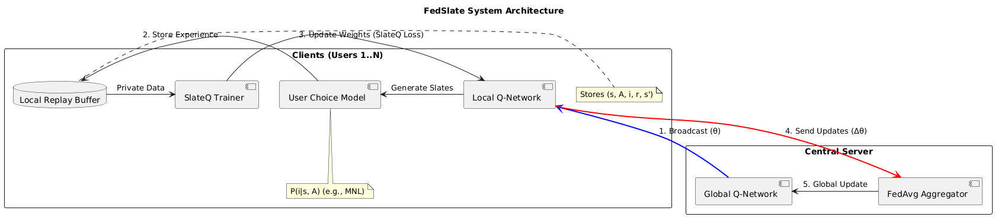
3. Fed-Slate Algorithm
The algorithm proceeds in communication rounds. Let $T$ be the total rounds and $K$ be the number of clients selected per round.
Step 1: Initialization
The central server initializes the global item-wise Q-network parameters $θ_{\text{global }}$. This network takes a state $s$ and an item $i$ (or item embedding) and outputs $\overset{‾}{Q}(s,i)$.
Step 2: Local Interaction (On Device)
Each client interacts with the recommendation engine.
- State Observation: The device constructs state $s_{t}$ from local logs.
- Slate Generation: The client generates a slate $A_{t}$ that maximizes the Q-value:
- $A_{t}=arg⁡\max_{A} \sum_{i∈A}{ }P\left(i∣s_{t},A\right)⋅\overset{‾}{Q}\left(s_{t},i;θ_{\text{local }}\right)$
- (Note: Greedy selection or $ϵ$-greedy is used here).
User Feedback: The user picks item $i$ (or no item). A reward $r_{t}$ is observed.
Storage: The transition $\left(s_{t},A_{t},i,r_{t},s_{t+1}\right)$ is stored in the device's private Replay Buffer.
Step 3: Local Model Update (The SlateQ Loss)
When selected for training, a client performs gradient descent steps on their local data. The critical innovation is how the target value is calculated using the SlateQ decomposition.
For a sampled batch of transitions, the loss function $L(θ)$ is minimized:
$$L(θ)=E_{\left(s,A,i,r,s^{'}\right)∼D}\left[(y-\overset{‾}{Q}(s,i;θ))^{2}\right]$$
Where the Target Value $y$ is defined by the Bellman equation for slates:
$$y=r+γ\max_{A^{'}} \underset{\text{Expected Future Value of Best Slate }}{\underbrace{\sum_{j∈A^{'}}{ } P\left(j∣s^{'},A^{'}\right)⋅\overset{‾}{Q}\left(s^{'},j;θ^{'}\right)}}$$
- Interpretation: The algorithm updates the value of the chosen item (i) to match the immediate reward plus the discounted value of the best possible slate available in the next state $\left(s^{'}\right)$.
- $θ^{'}$ represents the parameters of a target network (standard in DQN to stabilize training).
Step 4: Federated Aggregation
After local training, clients send their model updates (e.g., $θ_{\text{local }}-θ_{\text{global }}$ ) to the server. The server aggregates these using FedAvg:
$$θ_{\text{global }}^{\text{new }}=θ_{\text{global }}^{\text{old }}+η\sum_{k=1}^{K}{ }\frac{n_{k}}{N}\left(θ_{k}-θ_{\text{global }}^{\text{old }}\right)$$
Where $n_{k}$ is the number of samples on client $k$, and $η$ is the server learning rate.

Model Inversion
Model and version is also a class of attack in Federated learning that specifically works on privacy. In this attacks, the adversary climbs up all the gradients that were introduced to the data in order to hide the original data points. Since gradients work on chain rule of calculus, assuming no noise has been added yet, the chain rule can be worked back from the final gradient to the original data, and this kills the whole point of privacy.
In other words, model in version only needs output scores from the deployed API. With more advanced attacks like deep leakage, the attacker, instead of simply guessing the input data from output, actually reverse engineers by “climbing” up the ladder of all the gradients in each and every level and reaches the top where the original data lies.
To understand how inversion is possible, we must look at the calculus of neural network training.
In a standard FL setting (e.g., using FedAvg), a client $k$ holds a private dataset $D_{k}=\left\{\left(x_{i},y_{i}\right)\right\}$. The client computes the gradient of a loss function $L$ with respect to the model parameters $W$.
The gradient vector $g_{k}$ sent to the server is:
$$g_{k}=\frac{∂L\left(W,x_{i},y_{i}\right)}{∂W}$$
Consider a simple single-neuron layer (perceptron) where the output is $z=W⋅x+b$ and the loss is derived from this output. By the chain rule of calculus, the gradient with respect to the weights is:
$$\frac{∂L}{∂W}=\frac{∂L}{∂z}⋅\frac{∂z}{∂W}=\frac{∂L}{∂z}⋅x$$
Notice the direct multiplicative relationship. The gradient $∂L/∂W$ is directly proportional to the input data $x$. In a fully connected layer, the gradient of the weights connecting to the input is simply the error term scaled by the input features.
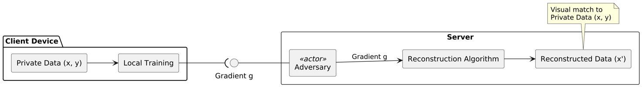
The Optimization
Assume the adversary (server) receives a gradient $g_{\text{real }}$ from a victim client. The adversary wants to find the data pair $\left(x^{'},y^{'}\right)$ that generated this gradient.
The adversary initializes "dummy" data $x^{'}$ (e.g., random noise) and a dummy label $y^{'}$. They feed this dummy data into the current model $W$ to compute a "dummy gradient" $g_{\text{dummy }}$ :
$$g_{\text{dummy }}=∇_{W}L\left(W,x^{'},y^{'}\right)$$
The goal is to make $g_{\text{dummy }}$ match $g_{\text{real }}$. We define a distance function (cost function), typically the Euclidean distance ( $L_{2}$ norm) or Cosine Similarity:
$$\text{ Cost }={\left\|g_{\text{real }}-g_{\text{dummy }}\right\|}^{2}$$
The Reconstruction
The adversary optimizes the dummy data $x^{'}$ to minimize this cost. Note that we are not updating the model weights $W$ (as in normal training); we are updating the input pixels $x^{'}$.
The update rule for the reconstruction is:
$$x_{t+1}^{'}←x_{t}^{'}-η∇_{x^{'}}{\left\|g_{\text{real }}-∇_{W}L\left(W,x_{t}^{'},y^{'}\right)\right\|}^{2}$$
Where:
- $x_{t}^{'}$ is the reconstructed image at step $t$.
- $η$ is the reconstruction learning rate.
- The term $∇_{x^{'}}$ requires computing the "gradient of the gradient" (second-order derivative), which is computationally expensive but feasible for modern autograd libraries (like PyTorch or TensorFlow).

Rényi Differential Privacy
To understand Rényi Privacy (RDP), we must first identify the friction point in standard Privacy (DP) that necessitated its creation.
Standard ϵ-DP is a worst-case guarantee. It demands that for any possible output, the probability ratio between two neighboring datasets is strictly bounded. This is like designing a bridge assuming every single car is an overweight semi-truck. It is safe, but it is incredibly inefficient-especially when we perform the same operation thousands of times (like in training machine learning models).
The core insight of RDP is this: Instead of bounding the worst-case privacy leak, we should bound the "moments" (the average behavior of the higher powers) of the privacy leak.
This shift allows us to ignore highly improbable "catastrophic" leaks that ruin standard DP bounds, resulting in a much tighter analysis of how privacy degrades over repeated queries.

The Core Object: The Privacy Loss Random Variable
To understand RDP, we must visualize the "Privacy Loss" not as a single number, but as a shifting, random value.
Imagine two parallel universes:
- Universe P: The database contains your data. (Distribution $P$ )
- Universe Q: The database does not contain your data. (Distribution $Q$ )
An attacker sees an output $x$ (e.g., a statistic or a model weight) and tries to guess which universe they are in. The "evidence" they gain is the log-likelihood ratio, which we call the Privacy Loss Random Variable, denoted as $Z$ :
$$Z=ln⁡\left(\frac{P(x)}{Q(x)}\right)$$
- If $P(x)≈Q(x)$, then $Z≈0$. The attacker learns nothing.
- If $P(x)≫Q(x)$, then $Z$ is large and positive. The output $x$ is a "fingerprint" that strongly suggests your data is present.
The Difference in Perspective Standard $(ϵ,δ)$-DP looks at the tail of this variable. It asks: "Does $Z$ ever exceed $ϵ$ ?" It requires that the probability of $Z>ϵ$ is very small (at most $δ$ ). It treats the privacy loss as a cliff: stay safe on the plateau, and don't fall off.
Rényi DP looks at the shape of $Z$. It asks: "What is the expectation of the exponential of $Z$ ?"
Specifically, it looks at the moments of the likelihood ratio. By constraining these moments, RDP ensures that while $Z$ might get large, the probability of it doing so drops off incredibly fast-exponentially fast.
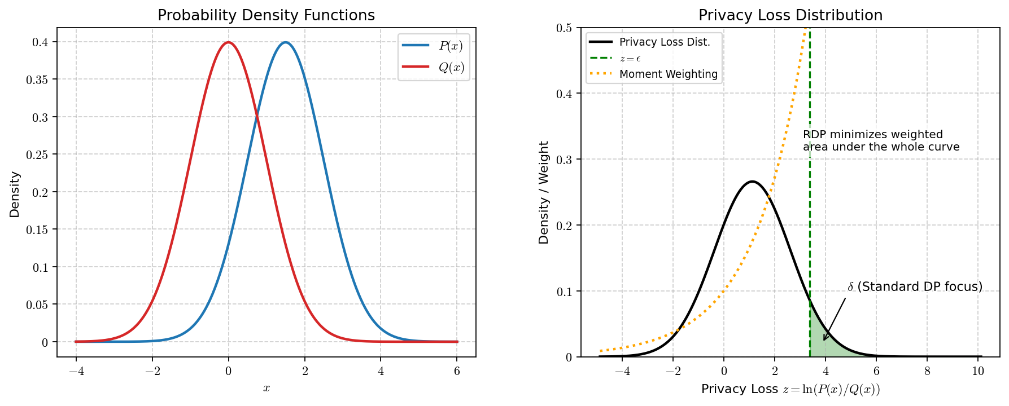

The Mathematical Engine: Rényi Divergence
RDP quantifies the difference between Universe P and Universe Q using Rényi Divergence.
While Kullback-Leibler (KL) divergence measures the average information gain (expected value of $Z$ ), Rényi divergence is a parameterized family of divergences that allows us to weigh "outliers" more heavily.
For a parameter $α>1$, the Rényi Divergence $D_{α}(P‖Q)$ is defined as:
$$D_{α}(P‖Q)=\frac{1}{α-1}ln⁡E_{x∼Q}\left[{\left(\frac{P(x)}{Q(x)}\right)}^{α}\right]$$
The Role of Alpha ( $α$ ) Think of $α$ as a "magnifying glass" for bad events.
- $α→1$ : This converges to KL divergence. It measures the average privacy loss. This is often too weak for privacy guarantees because averages hide disasters.
- $α→∞$ : This converges to the "max divergence," which is essentially pure $ϵ$-DP. It focuses entirely on the worst-case outcome.
- Finite $α$ (e.g., 2, 5, 20): This is the sweet spot. It penalizes high privacy loss outcomes polynomially more than low ones, but it doesn't panic over a single worst-case point like $α=∞$ does.
Definition of RDP: A mechanism satisfies $(α,ϵ)$-RDP if for all neighboring datasets $D,D^{'}$ :
$$D_{α}(P‖Q)≤ϵ$$

The "Click": Why RDP Wins at Composition
The true power of RDP-and the reason it is the standard for training Large Language Models and Deep Learning—is Composition.
In Deep Learning, we add noise to gradients thousands of times (Stochastic Gradient Descent). We need to know the total privacy loss after $k$ steps.
The Failure of Standard DP: If you have a mechanism that is $ϵ$-DP, and you run it $k$ times, standard analysis says the total privacy loss is $k⋅ϵ$. This is the "worst-case" assumption: it assumes the attacker gets lucky and sees the worst-case output every single time.
The RDP Insight: RDP behaves like variance. If you add independent random variables, their variances add up linearly.
Because RDP is based on the cumulant generating function (log-moment generating function) of the privacy loss, it composes linearly:
If mechanism $M_{1}$ is $\left(α,ϵ_{1}\right)$-RDP and $M_{2}$ is $\left(α,ϵ_{2}\right)$-RDP, then running both is: $\left(α,ϵ_{1}+ϵ_{2}\right)$-RDP
Because the $ϵ$ in RDP is usually much smaller for the same amount of noise, specifically when dealing with Gaussian noise.
When we convert RDP back to standard $(ϵ,δ)$-DP at the end of the process, the "Central Limit Theorem" effect kicks in. The total privacy loss doesn't grow linearly with $k$; it grows roughly with $\sqrt{k}$.
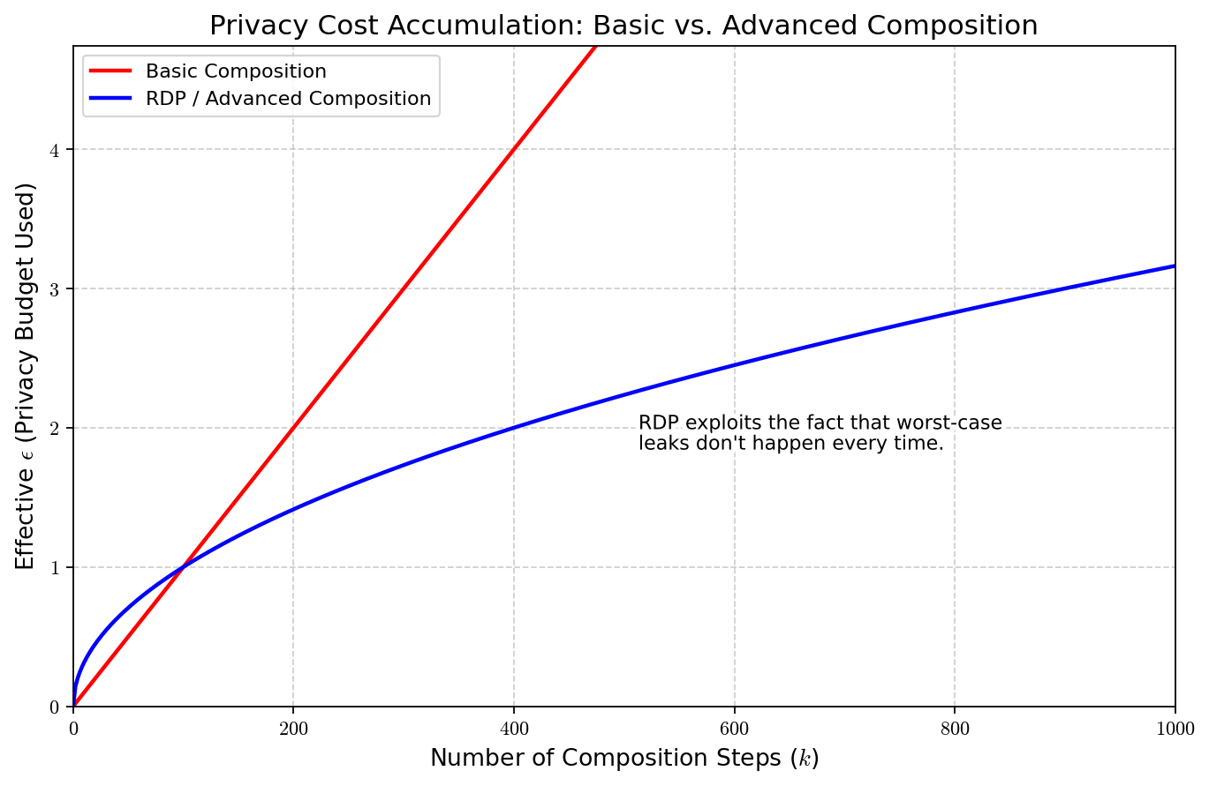

The Gaussian Mechanism Connection
This is where the theory becomes practical. RDP is naturally suited for the Gaussian Mechanism (adding noise from a normal distribution).
If we add Gaussian noise with variance $σ^{2}$ to a function with sensitivity 1 :
- Standard DP Analysis: Messy. Requires complex approximation to get tight bounds.
- RDP Analysis: Exact and simple.
The RDP of the Gaussian mechanism is exactly:
$$ϵ(α)=\frac{α}{2σ^{2}}$$
Notice the linearity in $α$. This simple formula allows us to track the privacy loss analytically through thousands of training steps. We simply sum up the $\frac{α}{2σ^{2}}$ terms.

Converting Back to Reality
We don't usually report "Rényi Divergence" to the public; we report $(ϵ,δ).RDP$ is an intermediate accounting tool.
Once we have finished our $k$ steps and calculated the total RDP $ϵ(α)$, we convert it back to $(ϵ,δ)$-DP using a tail bound (Markov's inequality applied to moments).
The conversion formula is roughly:
$$ϵ_{\text{final }}=ϵ_{RDP}(α)+\frac{ln⁡(1/δ)}{α-1}$$
The Optimization Trick: Since this holds for any $α$, we can compute the RDP for many different $α$ values simultaneously during training. At the very end, we choose the specific $α$ that minimizes $ϵ_{\text{final }}$ for our target $δ$.

Dirichlet Data Partitioning
The field of machine, learning, especially federated learning, the performance of algorithms depend upon how the data is distributed and partitioned among many different users. Because there are various types of users, generating various types of data, the data is very rarely evenly distributed or randomly distributed. So to test the algorithms despite of the heterogeneity of the data, researchers use what is called Dirichlet Data Partitioning.

The Dirichlet Distribution
The core of this method is the Dirichlet distribution, denoted as $Dir(α)$. It is a multivariate probability distribution parameterized by a vector $α=\left(α_{1},…,α_{K}\right)$ of positive reals. It is often referred to as a "distribution over distributions."
2.1 Definition
Let $p=\left(p_{1},…,p_{K}\right)$ be a random vector where each $p_{i}≥0$ and $\sum_{i=1}^{K}{ }p_{i}=1$. The vector $p$ lies on the $(K-1)$-dimensional simplex. The probability density function (PDF) of the Dirichlet distribution is:
$$f(p;α)=\frac{1}{B(α)}\prod_{i=1}^{K}{ }p_{i}^{α_{i}-1}$$
Where:
- $K$ is the number of categories (or clients, depending on application).
- $α$ is the concentration parameter vector.
- $B(α)$ is the multivariate Beta function, which serves as a normalization constant:
$$B(α)=\frac{\prod_{i=1}^{K}{ } Γ\left(α_{i}\right)}{Γ\left(\sum_{i=1}^{K}{ } α_{i}\right)}$$
(Here, $Γ$ denotes the Gamma function).
2.2 The Concentration Parameter ( $α$ )
In the context of data partitioning, we usually set a symmetric concentration parameter, meaning all elements of the vector are equal: $α_{1}=α_{2}=⋯=α$. We refer to this scalar simply as $α$.
This parameter $α$ controls the sparsity of the sampled vectors:
- $α→∞$ : The distribution concentrates at the center of the simplex. Sampled vectors are close to uniform $\left(\frac{1}{K},…,\frac{1}{K}\right)$.
- $α=1$ : The distribution is uniform over the simplex. Any valid probability vector is equally likely.
- $α→0$ : The distribution concentrates at the corners (vertices) of the simplex. Sampled vectors are sparse (e.g., close to one-hot vectors like $(0,1,0,…)$ ).
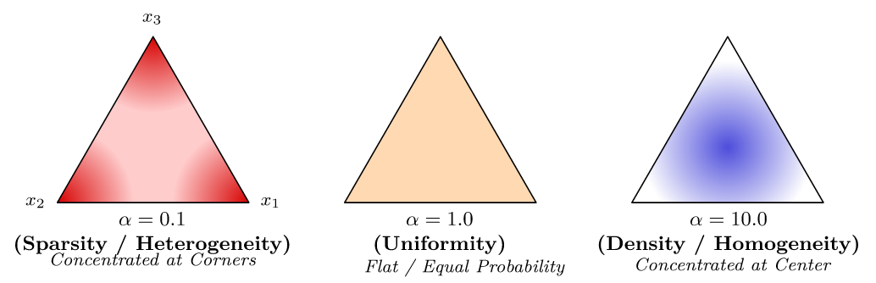

The Partitioning Algorithm
Let us assume we have a dataset with $K$ classes (e.g., for CIFAR-10, $K=10$ ) and we want to distribute it among $N$ clients. The standard approach (often called "Label Distribution Skew") partitions the data such that the proportion of instances of class $k$ allocated to client $n$, denoted $p_{k,n}$, follows a Dirichlet distribution.
Step-by-Step Procedure
- Organize Data by Class:
Separate the global dataset into $K$ buckets, one for each class label $k∈\{1,…,K\}$.
2. Sample Proportions for Each Class:
For each class $k$, we want to decide how to distribute its examples across the $N$ clients. We sample a vector $q_{k}$ from the Dirichlet distribution: $q_{k}∼Dir(α,α,…,α) ($vector of length $N)$
Here, $q_{k}=\left(q_{k,1},q_{k,2},…,q_{k,N}\right)$ where $\sum_{n=1}^{N}{ }q_{k,n}=1$.
- $q_{k,n}$ represents the fraction of all class $k$ examples that will be assigned to client $n$.
- Assign Indices:
If class $k$ has $M_{k}$ total examples in the global dataset:
- Client 1 receives $M_{k}×q_{k,1}$ examples.
- Client 2 receives $M_{k}×q_{k,2}$ examples.
- ...and so on.
(Note: In practice, we round these to the nearest integer).
- Repeat for All Classes:
Perform this sampling independently for every class $k$. Because the sampling is independent, Client 1 might get a huge chunk of Class 0 (if $q_{0,1}$ is high) but almost none of Class 1 (if $q_{1,1}$ is low).
The scalar $α$ acts as the heterogeneity knob.
Extreme Heterogeneity ( $α<1$ ). When $α$ is small (e.g., 0.1 or 0.5 ), the Dirichlet distribution pushes probability mass to the edges.
- Result: For a specific class $k$, the vector $q_{k}$ will likely have one or two large values and many values near zero.
- Interpretation: Class $k$ is found almost exclusively on one or two clients. Client $n$ might possess data for only 2 out of 10 classes. This is a difficult setting for Federated Learning because the local objective functions of the clients are very different from the global objective.
Moderate Heterogeneity ( $α≈1$ ) The proportions are random but cover the simplex.
- Result: Clients have varying amounts of each class, but usually have some representation of most classes.
IID Setting $(α≫1)$
When $α$ is large (e.g., 100 or 1000 ), the distribution converges to the mean.
- Result: $q_{k}≈(1/N,1/N,…,1/N)$.
- Interpretation: Every client gets roughly the same amount of every class. This effectively reconstructs a random shuffle (IID).
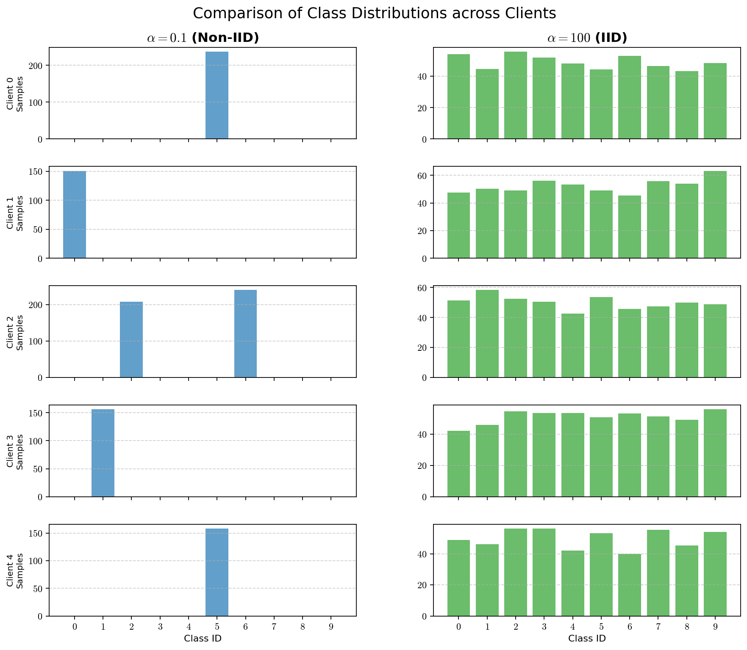

Multi-Objective Optimization
In a standard machine learning problem, we optimize a scalar value (the loss). In the FL+DP context, we are optimizing a vector of functions. We want to minimize the error while simultaneously minimizing the privacy loss (or maximizing the privacy budget tightness).
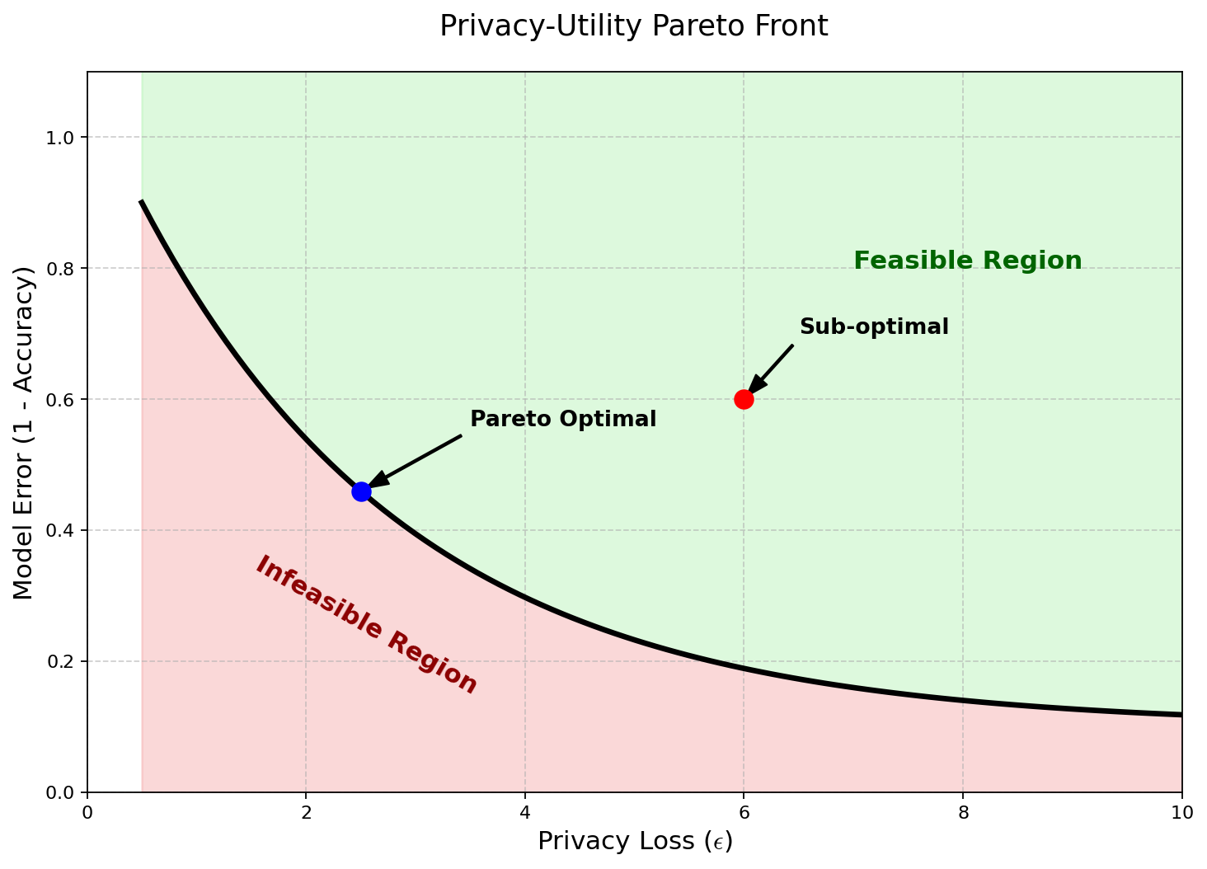
We define the vector of objectives $J(w)$ :
$$\min_{w} J(w)=\left({f_{\text{error }}(w) \atop f_{\text{privacy_loss }}(w)}\right)$$
Because these objectives conflict (improving privacy hurts error), there is no single "best" solution. Instead, we look for Pareto Optimal solutions.
A solution $w^{*}$ is Pareto optimal if there is no other solution $w^{'}$ such that $w^{'}$ is better than $w^{*}$ in all objectives. The set of all such optimal trade-offs forms the Pareto Front.
Heterogeneity as an MOO Problem
In Federated Learning, MOO is not just about Privacy vs. Accuracy. It is often about Client Fairness.
If Client A has clean data and Client B has noisy data, a single global model might work well for A but fail for B .
We can reformulate the FL problem as minimizing the worst-case loss among all clients:
$$\min_{w} \max_{k} F_{k}(w)$$
Or treating each client's loss as a separate objective in the MOO vector:
$$\min_{w} \left(\begin{matrix}F_{1}(w) \\ F_{2}(w) \\ ⋮ \\ F_{K}(w)\end{matrix}\right)$$
Adding Privacy adds yet another dimension to this vector, as different clients may have different privacy preferences.

Solving the MOO Problem in FL+DP
Scalarization (Linearization)
The simplest approach is to convert the vector problem back into a scalar problem by assigning weights $(λ)$ to each objective.
$$L_{\text{total }}(w)=λ_{1}F_{\text{global }}(w)+λ_{2}P_{\text{penalty }}(w)$$
In the context of DP, this often manifests as a constrained optimization problem: $\min_{w} F(w)$ subject to $Privacy(w)≤ϵ_{\text{target }}$
This is usually solved using Lagrange multipliers. The "price" of privacy becomes a regularization term. However, finding the correct $λ$ is difficult and requires extensive tuning.
Gradient-Based MOO (MGDA)
A more advanced method uses the Multiple Gradient Descent Algorithm (MGDA). This method looks at the gradients of the conflicting objectives and attempts to find a direction that improves all of them (or at least improves one without hurting the others).
Let $∇f_{1}$ be the gradient of the loss and $∇f_{2}$ be the gradient of the privacy penalty (or the gradient of a specific client's loss).
- If the angle between $∇f_{1}$ and $∇f_{2}$ is less than ${90}^{∘}$, we can step in the average direction to improve both.
- If the angle is greater than ${90}^{∘}$, the objectives conflict. Moving down $∇f_{1}$ increases $f_{2}$.
MGDA computes a direction $d$ that is the minimum norm element in the convex hull of the gradients. This ensures the model converges to a Pareto stationary point.
$d^{*}=\min_{α∈[0,1]} {\left\|α∇f_{1}+(1-α)∇f_{2}\right\|}^{2}$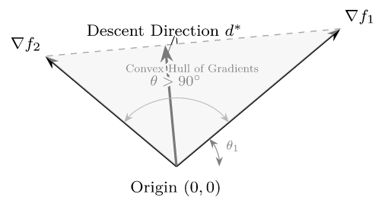

Advanced Application: Personalized Differential Privacy
One of the most powerful applications of MOO in this field is Personalized Privacy.
In a standard setting, every client gets the same privacy budget $ϵ$. However, some users might be less sensitive about their data than others.
- User A: "I don't care who sees my data." (Low privacy requirement, contributes high utility).
- User B: "My data is highly sensitive." (High privacy requirement, contributes noise).
If we force User A to have high privacy, we waste their potential to improve the model. If we force User B to have low privacy, we violate their trust.
We treat this as a Multi-Objective problem where we optimize the global accuracy while satisfying a vector of privacy constraints $\vec{ϵ}=\left[ϵ_{1},ϵ_{2},…,ϵ_{K}\right]$.
The optimization finds a model $w$ such that:
$$\begin{matrix} & \min_{w} \sum_{k=1}^{K}{ } p_{k}F_{k}(w) \\ & \text{ s.t. }{Privacy}_{k}(w)≤ϵ_{k} ∀k\end{matrix}$$
This allows the system to extract more "signal" from less privacy-sensitive users while strictly protecting the sensitive ones, pushing the Pareto front of the global model further into the high-accuracy/high-privacy zone.

Poisson Subsampling
In the world of machine learning today, there are two vital limitations that are often in conflict with each other: to be able to train machine learning models on huge and distributed data sets and to protect the privacy of people whose data is being circulated around. Federated Learning (FL) addresses the distributed nature of data by decentralizing the process of training data on the devices, and the term Privacy (DP) represents a powerful mathematical tool to quantify and limit the level of data-leakage to privacy.
Poisson Subsampling is an important connecting link between these two fields. It is a method of randomized sampling, when used to select the participants or bits of data in an algorithm, which drastically increases the privacy guarantees of the system. This phenomenon is referred to as privacy amplification.
In the light of FL, Poisson subsampling transforms the client selection procedure from deterministic or fixed size procedure to probabilistic ensuring that there is less statistical dependency of the global model on an individual user data.

Mathematical Definition
Let $D=\left\{x_{1},x_{2},…,x_{N}\right\}$ be a dataset (or a set of clients in FL) of size $N$.
In Poisson Subsampling, a subset $S⊆D$ is constructed by making an independent binary decision for each element $x_{i}∈D$.
For a sampling probability $q∈(0,1]$, each element is included in the sample $S$ according to a Bernoulli trial:
$$Pr\left(x_{i}∈S\right)=q$$
This decision is independent for all $i$.

Properties
- Variable Sample Size: Unlike fixed-batch sampling where $|S|=K$, in Poisson subsampling, the sample size $|S|$ is a random variable following a Binomial distribution:
$$|S|∼Binomial(N,q)$$The expected sample size is $E[|S|]=qN$.
- Independence: The inclusion of client $A$ does not influence the probability of including client $B$. This independence is mathematically vital for simplifying the composition analysis in Privacy.
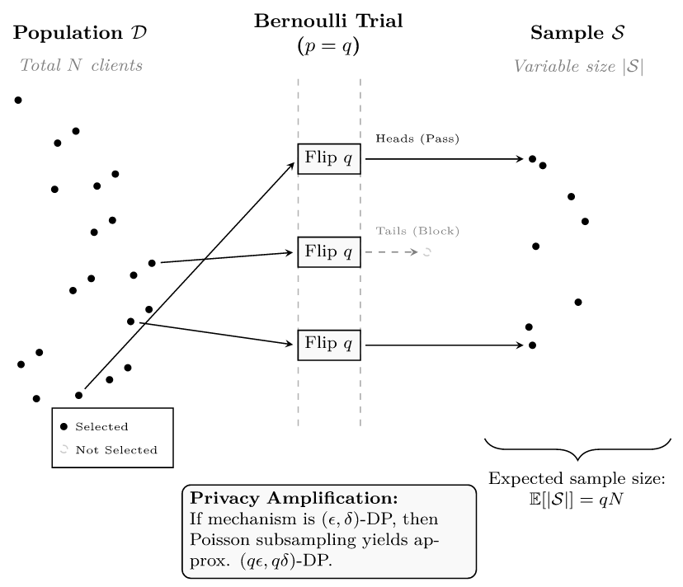

Matthew Effect
The Matthew Effect arises because the "cost" of privacy (the noise and clipping) is not paid equally by all classes. It is determined by the Signal-to-Noise Ratio (SNR).

The Catalyst: Differential Privacy
To prevent the server or an adversary from reconstructing a specific user's data from their gradient update $g_{k}$, we apply Privacy. In the context of FL, this is typically Client-Level DP.
To satisfy DP, two operations are performed on the client's update before aggregation:
- Gradient Clipping: The update $g_{k}$ is clipped to a maximum norm $C$ to bound the sensitivity of the aggregation function.
$${\overset{‾}{g}}_{k}=g_{k}⋅min\left(1,\frac{C}{{\left\|g_{k}\right\|}_{2}}\right)$$
- Noise Injection: Random noise (usually Gaussian) is added to the sum of updates.
$${\overset{˜}{g}}_{\text{global }}=\sum_{k=1}^{K}{ }{\overset{‾}{g}}_{k}+N\left(0,σ^{2}C^{2}I\right)$$
Here, $σ$ is the noise multiplier determined by the privacy budget $ϵ$.

Mechanism of Matthew Effect
A. The Impact of Noise on Minority Classes
The global update is a summation of signal plus noise.
$$\text{ Update }≈\underset{\text{Strong Signal }}{\underbrace{\sum_{k∈\text{ Majority }}{ } g_{k}}}+\underset{\text{Weak Signal }}{\underbrace{\sum_{k∈\text{ Minority }}{ } g_{k}}}+\underset{\text{Constant Variance }}{\underbrace{\text{ Noise }}}$$
- For Majority Classes: There are many clients contributing gradients pointing in the same direction. The sum of these gradients grows linearly with the number of clients ( $N_{\text{maj }}$ ), while the noise variance remains constant (or grows slower than the signal). The signal overwhelms the noise.
- For Minority Classes: There are very few clients contributing gradients. The sum of their gradients is small. The DP noise, which is isotropic (added equally in all directions), can easily have a magnitude larger than the minority signal.
Result: The model effectively "unlearns" or fails to learn the minority classes because their gradients are drowned out by static, whereas the majority classes remain robust.
B. The Impact of Clipping (Gradient Bias)
Gradient clipping is particularly detrimental to "hard" examples or outliers, which often correspond to minority data.
- To learn a rare pattern, a model often generates a large gradient (high error implies a large update vector).
- DP requires clipping this vector to norm $C$.
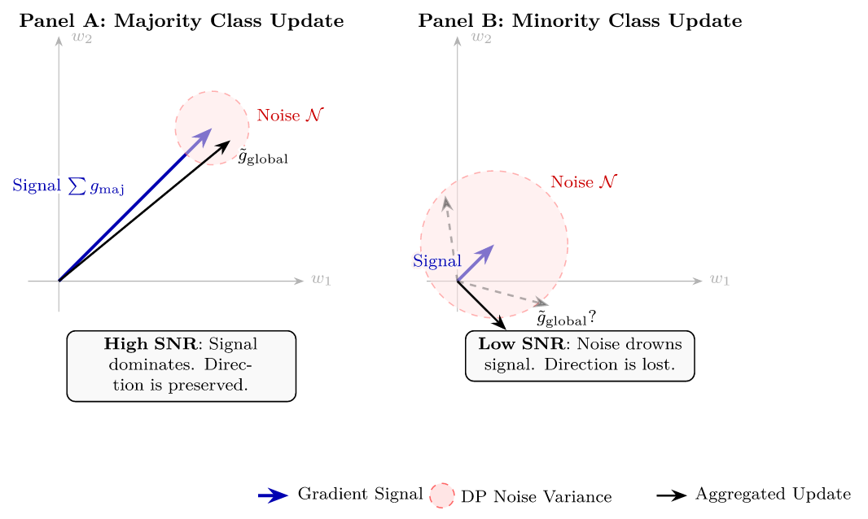
- This clipping introduces bias. The direction of the update is preserved, but its magnitude is crushed. When combined with noise, a clipped small vector is statistically indistinguishable from pure noise.

Mathematical Formulation of the Disparity
We can quantify this effect by looking at the convergence bounds of ly Private Stochastic Gradient Descent (DP-SGD).
Let $L(θ)$ be the loss function. The convergence error bound in a convex setting for DP-SGD is often expressed as:
$$E\left[L\left(θ_{T}\right)\right]-L\left(θ^{*}\right)≤O\left(\frac{1}{\sqrt{T}}\right)+O\left(\frac{dσ^{2}}{n^{2}ϵ^{2}}\right)$$
Where:
- $T$ is the number of iterations.
- $d$ is the dimension of the model.
- $n$ is the effective sample size for the specific feature/class.
- $σ$ is the noise scale.
Notice the second term (the privacy cost): $\frac{dσ^{2}}{n^{2}ϵ^{2}}$.
- For the Majority: $n$ is large. The term $\frac{1}{n^{2}}$ becomes negligible. The privacy cost is close to zero.
- For the Minority: $n$ is small. The term $\frac{1}{n^{2}}$ is large. The privacy cost dominates the convergence bound.
This creates a feedback loop. As the model improves on the majority, the feature representations optimize for those classes. The gradients for the minority classes become even more "anomalous" (larger magnitude) relative to the majority features, leading to more aggressive clipping, further reducing their signal.

Visualizing the Divergence
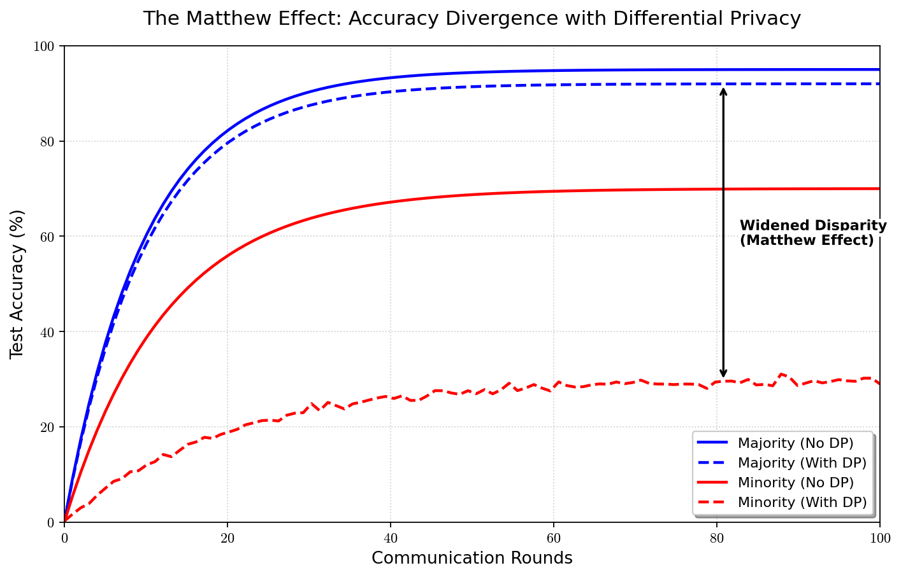
The Matthew Effect is best observed by comparing the accuracy gap between groups before and after applying DP.

Codebase Structure

Table of Contents
- [Code Structure](#code-structure)
- [Folder Organization](#folder-organization)
- [Running the Code](#running-the-code)
- [Repository Information](#repository-information)
- [Key Components](#key-components)
- [Dependencies](#dependencies)

Code Structure
The codebase is organized into two main components:
- Python Server and Client Implementation - Core federated learning infrastructure
- Mobile Application (Flutter/Dart) - Android client for real device participation

Python Implementation
The Python codebase implements a client-server federated learning architecture using:
- FastAPI for RESTful server endpoints
- PyTorch for neural network models and training
- NumPy/Pandas for data processing
- Rényi Privacy (RDP) accountant for privacy budget tracking

Mobile Implementation
The mobile application is built using:
- Flutter/Dart for cross-platform mobile development
- Pure Dart implementation of Matrix Factorization model
- HTTP client for server communication
- Resource monitoring APIs for battery, CPU, and memory tracking

Folder Organization

Root Directory Structure
master_thesis/ ├── server.py # FastAPI server for federated learning ├── client.py # Python federated learning client ├── run_experiment.py # Single experiment runner ├── run_all_experiments.py # Master experiment orchestrator ├── centralized_baseline.py # Centralized training baseline ├── dp_sweep_experiment.py # privacy budget sweep ├── heterogeneity_sweep_experiment.py # Data heterogeneity sweep ├── comprehensive_analysis.py # Results analysis and visualization ├── analyze_results.py # Result analysis utilities ├── analyze_combined_results.py # Combined results analysis ├── quick_summary.py # Quick result summaries ├── show_summary.py # Display experiment summaries ├── init_server_model.py # Server model initialization ├── start_server.py # Server startup helper ├── test_data_collection.py # Data collection testing ├── requirements.txt # Python dependencies ├── ratings.csv # MovieLens dataset │ ├── scripts/ # Utility scripts │ ├── __init__.py │ ├── rdp_accountant.py # RDP privacy accountant │ ├── metrics_collector.py # Metrics collection utilities │ ├── recommendation_metrics.py # Recommendation evaluation metrics │ └── attack_evaluation.py # Privacy attack evaluation │ ├── federated_learning_in_mobile/ # Mobile application │ ├── lib/ # Dart source code │ │ ├── main.dart # Main app entry point │ │ ├── models/ │ │ │ └── matrix_factorization.dart # Matrix factorization model │ │ ├── services/ │ │ │ ├── api_client.dart # HTTP client for server │ │ │ └── fl_client.dart # Federated learning client logic │ │ └── utils/ │ │ ├── metrics_collector.dart # Metrics collection │ │ ├── model_encoder.dart # Model parameter encoding │ │ └── resource_monitor.dart # Resource monitoring │ ├── android/ # Android-specific configuration │ ├── ios/ # iOS-specific configuration │ ├── pubspec.yaml # Flutter dependencies │ └── README.md # Mobile app documentation │ ├── results/ # Experiment results (JSON/CSV) ├── mobile_results/ # Mobile device experiment results ├── figures/ # Generated plots and visualizations │ ├── accuracy_vs_epsilon.png │ ├── accuracy_vs_alpha.png │ ├── convergence.png │ ├── recommendation_metrics.png │ └── summary_table.csv │ └── [Documentation files] # Various .md guide files

Key Directories Explained

scripts/ - Core Utilities
- *rdp_accountant.py**: Implements the Rényi Privacy accountant for tracking privacy budget consumption. Provides methods to compute RDP parameters, convert to (ε, δ)-DP, and track cumulative privacy loss across federated rounds.
- *metrics_collector.py**: Handles collection and serialization of experiment metrics, including training loss, recommendation metrics, and resource usage statistics.
- *recommendation_metrics.py**: Implements evaluation metrics for recommendation systems, including Hit Rate@K, NDCG@K, Precision@K, Recall@K, and F1-score.
- *attack_evaluation.py**: Provides utilities for evaluating privacy attacks (membership inference, attribute inference, gradient inversion).

federated_learning_in_mobile/ - Mobile Application
- *lib/main.dart**: Main Flutter application entry point, containing the UI for connecting to the server, running training rounds, and displaying metrics.
- *lib/models/matrix_factorization.dart**: Pure Dart implementation of the Matrix Factorization model, compatible with the Python PyTorch version.
- *lib/services/fl_client.dart**: Core federated learning client logic, handling model download, local training, and parameter upload.
- *lib/services/api_client.dart**: HTTP client wrapper for communicating with the FastAPI server.
- *lib/utils/**: Utility modules for model encoding/decoding, metrics collection, and resource monitoring.

results/ - Experiment Outputs
Contains JSON and CSV files with experiment results, including:
- Per-round metrics (loss, accuracy, recommendation metrics)
- Final aggregated results
- Client-level statistics
- Privacy budget consumption

figures/ - Visualizations
Generated plots and tables from comprehensive_analysis.py, including:
- Privacy-utility trade-off curves
- Convergence plots
- Heterogeneity impact analysis
- Summary statistics tables

Running the Code

Prerequisites
- Python Environment (Python 3.8+)
```bash
pip install -r requirements.txt
```
- Dataset: Ensure ratings.csv (MovieLens 100K) is in the project root
- Flutter SDK (for mobile app, optional): Flutter 3.9.2+
```bash
cd federated_learning_in_mobile
flutter pub get
```

Quick Start: Running All Experiments
The simplest way to run all experiments is using the master orchestrator:
```bash
# Terminal 1: Start the federated learning server
python server.py
# Terminal 2: Run all experiments
python run_all_experiments.py
```
This will execute:
- Centralized baseline (no server needed)
- DP sweep experiments (ε ∈ {∞, 8, 4, 2, 1})
- Heterogeneity sweep experiments (α ∈ {0.1, 0.5, 1.0})
- Comprehensive analysis and visualization
Estimated Time: 4-8 hours (depending on hardware)

Running Individual Experiments

1. Centralized Baseline
Establishes the performance upper bound without federated learning:
```bash
python centralized_baseline.py
```
Output: results/centralized_baseline.json

2. Privacy Sweep
Evaluates accuracy-privacy trade-offs across different privacy budgets:
```bash
# Ensure server is running first
python server.py # In another terminal
# Run DP sweep
python dp_sweep_experiment.py
```
Configuration: Tests ε ∈ {∞, 8, 4, 2, 1} with 3 random seeds each
Output: results/dp_*_alpha_0.5_dim_16_clients_100_seed_*.json

3. Heterogeneity Sweep
Assesses impact of non-IID data distributions:
```bash
# Server should still be running
python heterogeneity_sweep_experiment.py
```
Configuration: Tests α ∈ {0.1, 0.5, 1.0} with 3 random seeds each
Output: results/dp_*_alpha_*_dim_16_clients_100_seed_*.json

4. Single Experiment
Run a single federated learning experiment:
```bash
# Terminal 1: Start server
python server.py
# Terminal 2: Run experiment
python run_experiment.py
```

5. Analysis and Visualization
Generate plots and summary tables:
```bash
python comprehensive_analysis.py
```
Output:
- figures/accuracy_vs_epsilon.png
- figures/accuracy_vs_alpha.png
- figures/convergence.png
- figures/recommendation_metrics.png
- figures/summary_table.csv

Running with Mobile Devices

Server Setup
- Start the server:
```bash
python server.py
```
- Make server accessible:
- Local Network: Use your PC's local IP (e.g., 192.168.1.100:8000)
- External Access: Use ngrok or similar tunneling service

Mobile App Setup
- Navigate to mobile app directory:
```bash
cd federated_learning_in_mobile
```
- Install dependencies:
```bash
flutter pub get
```
- Run on Android device/emulator:
```bash
flutter run
```
- In the app:
- Enter server URL (e.g., http://192.168.1.100:8000)
- Enter unique Client ID
- Click "Connect to Server"
- Run training rounds

Hybrid Experiments
You can run experiments with both Python clients and mobile devices simultaneously:
- Multiple Python clients (for large-scale parameter sweeps)
- 2+ Android devices (for real mobile validation)
- All connect to the same server
- Server aggregates all updates together

Repository Information

Code Repository
The complete codebase is available at:
https://github.com/jonathanjohn47/master_thesis.git

Repository Structure
The repository follows a standard Python/Flutter project structure with:
- Clear separation between server, client, and mobile components
- Modular scripts for different experiment types
- Comprehensive documentation in markdown files
- Results and figures directories for outputs

Version Control
The codebase uses Git for version control. Key branches:
- main: Stable production code
- experiments: Experimental features and variations
- mobile: Mobile-specific implementations

Key Components

Server server.py)
The FastAPI server orchestrates federated learning:
Key Features:
- RESTful API endpoints for client registration, model download, and parameter upload
- Weighted federated averaging (FedAvg) aggregation
- Model parameter serialization in portable JSON format (base64-encoded Float32)
- Support for multiple concurrent clients (Python and mobile)
- Health check and status endpoints
Main Endpoints:
- POST /register: Client registration
- GET /global-params-json: Download global model parameters
- POST /upload-params-json: Upload local model updates
- GET /healthz: Health check
- POST /mobile-results: Receive mobile device metrics
Model Architecture:
- Matrix Factorization with embedding dimension 16
- User and item embedding matrices
- MSE loss for rating prediction

Client client.py)
Python federated learning client implementation:
Key Features:
- Local model training on client-specific data partitions
- DP-SGD support with gradient clipping and noise addition
- Non-IID data partitioning via Dirichlet distribution
- Automatic server connection and round participation
- Metrics collection and logging
Configuration:
- Embedding dimension: 16
- Learning rate: 0.01
- Batch size: 32
- Local epochs: 1
- Gradient clipping norm: 1.0
- DP noise multiplier: calibrated via RDP accountant

RDP Accountant scripts/rdp_accountant.py)
Privacy budget tracking using Rényi Privacy:
Key Features:
- Computes RDP parameters for Gaussian mechanism
- Converts RDP to (ε, δ)-DP guarantees
- Tracks cumulative privacy loss across rounds
- Supports privacy amplification via subsampling
- Binary search for optimal noise multiplier calibration
Mathematical Foundation:
- RDP order α ∈ [1.1, 64]
- Gaussian mechanism: RDP_α = α / (2σ²)
- Composition: additive over rounds
- Conversion: ε = min_α [RDP_α + log(1/δ)/(α-1)]

Mobile Client federated_learning_in_mobile/lib/)
Flutter/Dart mobile application:
Key Features:
- Pure Dart Matrix Factorization model (compatible with Python version)
- HTTP-based communication with FastAPI server
- Resource monitoring (battery, CPU, memory)
- Real-time metrics display
- Results export to CSV/JSON
Architecture:
- main.dart: UI and app orchestration
- fl_client.dart: Federated learning client logic
- api_client.dart: Server communication
- matrix_factorization.dart: Model implementation
- resource_monitor.dart: Device resource tracking

Dependencies

Python Dependencies requirements.txt)
fastapi>=0.104.0 # Web framework for server
uvicorn>=0.24.0 # ASGI server
pydantic>=2.0.0 # Data validation
torch>=2.0.0 # Deep learning framework
numpy>=1.24.0 # Numerical computing
pandas>=2.0.0 # Data manipulation
requests>=2.31.0 # HTTP client
scikit-learn>=1.3.0 # Machine learning utilities
matplotlib>=3.7.0 # Plotting
seaborn>=0.12.0 # Statistical visualization

Flutter Dependencies federated_learning_in_mobile/pubspec.yaml)
```yaml
dependencies:
flutter: sdk
http: ^1.1.0 # HTTP client
device_info_plus: ^10.1.0 # Device information
battery_plus: ^6.0.2 # Battery monitoring
path_provider: ^2.1.1 # File system access
csv: ^5.1.1 # CSV export
share_plus: ^7.2.1 # File sharing
open_filex: ^4.3.3 # File opening
```

System Requirements
Server:
- Python 3.8+
- 4+ GB RAM recommended
- Network access for client connections
Mobile App:
- Flutter SDK 3.9.2+
- Android SDK (API level 21+)
- iOS 12+ (for iOS builds)

Additional Documentation
The codebase includes extensive documentation in markdown files:
- BEGINNER_GUIDE_TO_THESIS.md: Getting started guide
- EXPERIMENT_GUIDE.md: Detailed experiment instructions
- EXPERIMENT_RUNNER_GUIDE.md: Complete experiment runner documentation
- DATA_COLLECTION_GUIDE.md: Data collection procedures
- DATA_ANALYSIS_GUIDE.md: Result analysis guide
- MOBILE_APP_SETUP_STEPS.md: Mobile app setup instructions
- federated_learning_in_mobile/README.md: Mobile app documentation

Code Execution Flow

Federated Learning Round
- Server Initialization: Server initializes global model with random weights
- Client Registration: Clients register with server and receive client IDs
- Model Download: Clients download current global model parameters
- Local Training: Each client trains locally on their data partition
- Forward pass: compute predictions
- Backward pass: compute gradients
- DP-SGD: clip gradients and add noise (if enabled)
- Update: apply optimizer step
- Parameter Upload: Clients upload updated parameters to server
- Aggregation: Server performs weighted FedAvg aggregation
- Broadcast: Server broadcasts updated global model
- Repeat: Steps 3-7 for multiple rounds

Experiment Execution
- Data Loading: Load and preprocess MovieLens dataset
- Data Partitioning: Split data into train/test sets and client partitions
- Model Initialization: Initialize server model
- Federated Training: Execute multiple federated rounds
- Evaluation: Evaluate model on test set after each round
- Metrics Collection: Collect and log all metrics
- Result Serialization: Save results to JSON/CSV files
- Analysis: Generate plots and summary tables

Troubleshooting

Common Issues
- Server Connection Failed:
- Ensure server is running: python server.py
- Check server URL (use IP address, not localhost for mobile)
- Verify network connectivity
- Import Errors:
- Install dependencies: pip install -r requirements.txt
- Check Python version (3.8+)
- Model Dimension Mismatch:
- Ensure embedding dimensions match between server and clients
- Check model initialization parameters
- Mobile App Build Errors:
- Run flutter pub get to install dependencies
- Check Flutter SDK version: flutter --version
- Verify Android SDK is properly configured

References
- Abdel‐Hafez, A., & Xu, Y. (2013). A Survey of User Modelling in Social Media Websites. Computer and Information Science, 6(4). https://doi.org/10.5539/cis.v6n4p59
- Abed, Q. J. (2025). Homomorphic Encryption-driven AI through Text Mining in The Cloud. Journal of Information Systems Engineering & Management, 10, 295. https://doi.org/10.52783/jisem.v10i24s.3900
- Abikoye, B. E., Akinwunmi, T., Adelaja, A. O., Umeorah, S. C., & Ogunsuji, Y. M. (2024). Real-time financial monitoring systems: Enhancing risk management through continuous oversight. GSC Advanced Research and Reviews, 20(1), 465. https://doi.org/10.30574/gscarr.2024.20.1.0287
- Adomavičius, G., Bockstedt, J., Curley, S. P., Zhang, J., & Ransbotham, S. (2019). The hidden side effects of recommendation systems. MIT Sloan Management Review, 60(2), 13. https://arizona.pure.elsevier.com/en/publications/the-hidden-side-effects-of-recommendation-systems
- Agahari, W., Ofe, H., & Reuver, M. de. (2022). It is not (only) about privacy: How multi-party computation redefines control, trust, and risk in data sharing. Electronic Markets, 32(3), 1577. https://doi.org/10.1007/s12525-022-00572-w
- Ambore, A. K. (2023). Design and Development of a Smart POS App with Cloud. International Journal for Research in Applied Science and Engineering Technology, 11(5), 788. https://doi.org/10.22214/ijraset.2023.51484
- Ammad-ud-din, M., Ivannikova, E., Khan, S. A., Oyomno, W., Fu, Q., Tan, K. E., & Flanagan, A. (2019). Federated Collaborative Filtering for Privacy-Preserving Personalized Recommendation System. arXiv (Cornell University). https://doi.org/10.48550/arxiv.1901.09888
- Arnold, B. T., Lipp, J., Collarana, D., Lange, C., Geisler, S., Curry, E., & Decker, S. (2024). Towards Enabling FAIR Dataspaces Using Large Language Models. arXiv (Cornell University). https://doi.org/10.48550/arxiv.2403.15451
- Asthana, S., Mahindru, R., Zhang, B., & Sanz‐Sánchez, J. (2025). Adaptive PII Mitigation Framework for Large Language Models. arXiv (Cornell University). https://doi.org/10.48550/arxiv.2501.12465
- Bailie, J., & Gong, R. (2024). General Inferential Limits Under Differential and Pufferfish Privacy. International Journal of Approximate Reasoning, 172, 109242. https://doi.org/10.1016/j.ijar.2024.109242
- Balbierer, B., Heinlein, L., Zipperling, D., & Kühl, N. (2024). A Multivocal Literature Review on Privacy and Fairness in Federated
- Learning. arXiv (Cornell University). https://doi.org/10.48550/arxiv.2408.08666
- Baradwaj, S. S., Gilliland, D. G., Rincon, J., Hermjakob, H., Yan, Y., Adam, I., Lemaster, G., Wang, D., Watson, K. E., Bui, A., Wang, W., & Ping, P. (2024). Building an Ethical and Trustworthy Biomedical AI Ecosystem for the
- Translational and Clinical Integration of Foundational Models. arXiv (Cornell University). https://doi.org/10.48550/arxiv.2408.01431
- Beknazar-Yuzbashev, G., Jiménez-Durán, R., & Stalinski, M. (2024). A Model of Harmful Yet Engaging Content on Social Media. AEA Papers and Proceedings, 114, 678. https://doi.org/10.1257/pandp.20241004
- Belhadi, A., Djenouri, Y., Andrade, F., & Srivastava, G. (2024). Federated Constrastive Learning and Visual Transformers for Personal Recommendation. Cognitive Computation, 16(5), 2551. https://doi.org/10.1007/s12559-024-10286-0
- Bellavista, P., Cilloni, M., Modica, G., Montanari, R., Picone, P. C. M., & Solimando, M. (2020). An Edge-based Distributed Ledger Architecture for Supporting Decentralized Incentives in Mobile Crowdsensing. 781. https://doi.org/10.1109/ccgrid49817.2020.00-10
- Bellogín, A., & Said, A. (2021). Improving accountability in recommender systems research through reproducibility. User Modeling and User-Adapted Interaction, 31(5), 941. https://doi.org/10.1007/s11257-021-09302-x
- Bojić, L., Bulatović, A., & Žikić, S. (2022). The Scary Black Box: AI Driven Recommender Algorithms as The Most Powerful Social Force. Etnoantropološki Problemi / Issues in Ethnology and Anthropology, 17(2). https://doi.org/10.21301/eap.v17i2.11
- Bojić, L., Zarić, M., & Žikić, S. (2021). Worrying Impact of Artificial Intelligence and Big Data Through the Prism of Recommender Systems. Etnoantropološki Problemi / Issues in Ethnology and Anthropology, 16(3). https://doi.org/10.21301/eap.v16i3.13
- Bonawitz, K., Ivanov, V., Kreuter, B., Marcedone, A., McMahan, H. B., Patel, S., Ramage, D., Segal, A., & Seth, K. (2016). Practical Secure Aggregation for Federated Learning on User-Held Data. arXiv (Cornell University). https://doi.org/10.48550/arxiv.1611.04482
- Bozorgasl, Z., & Chen, H. (2024). Clipped Uniform Quantizers for Communication-Efficient Federated
- Learning. arXiv (Cornell University). https://doi.org/10.48550/arxiv.2405.13365
- Brassard, G., Crépeau, C., & Wolf, S. (2003). Oblivious Transfers and Privacy Amplification. Journal of Cryptology, 16(4), 219. https://doi.org/10.1007/s00145-002-0146-4
- Cai, Z., Tang, T., Yu, S., Xiao, Y., & Feng, X. (2024). Marking the Pace: A Blockchain-Enhanced Privacy-Traceable Strategy for
- Federated Recommender Systems. arXiv (Cornell University). https://doi.org/10.48550/arxiv.2406.04702
- Cañamares, R., Castells, P., & Moffat, A. (2020). Offline evaluation options for recommender systems. Information Retrieval, 23(4), 387. https://doi.org/10.1007/s10791-020-09371-3
- Casado, F. E., Lema, D., Criado, M. F., Iglesias, R., Regueiro, C. V., & Barro, S. (2021). Concept drift detection and adaptation for federated and continual learning. Multimedia Tools and Applications, 81(3), 3397. https://doi.org/10.1007/s11042-021-11219-x
- Chen, C., Feng, X., Zhou, J., Yin, J., Zheng, X., Xiaolin, Z., & Jianwei, Y. (2023). Integration of Large Language Models and Federated Learning. arXiv (Cornell University). https://doi.org/10.48550/arxiv.2307.08925
- Chen, C., Liao, T., Deng, X., Wu, Z., Huang, S., & Zheng, Z. (2024). Advances in Robust Federated Learning: Heterogeneity Considerations. arXiv (Cornell University). https://doi.org/10.48550/arxiv.2405.09839
- Chen, H., Zhu, T., Zhang, T., Zhou, W., & Yu, P. S. (2023). Privacy and Fairness in Federated Learning: on the Perspective of Trade-off. arXiv (Cornell University). https://doi.org/10.48550/arxiv.2306.14123
- Chen, J., Storchan, V., & Kurshan, E. (2022). Beyond Fairness Metrics: Roadblocks and Challenges for Ethical AI in Practice. arXiv (Cornell University). https://doi.org/10.48550/arxiv.2108.06217
- Chikwendu, M. I., & Asianuba, I. B. (2024). A Review on Billing and Revenue Share System Between YouTube, Other Digital Platforms and Content Creators for Online Communication [Review of A Review on Billing and Revenue Share System Between YouTube, Other Digital Platforms and Content Creators for Online Communication]. International Journal of Recent Engineering Science, 11(4), 53. https://doi.org/10.14445/23497157/ijres-v11i4p108
- Chua, T. J., Yu, W., Zhao, J., & Lam, K. (2023). FedPEAT: Convergence of Federated Learning, Parameter-Efficient Fine Tuning, and Emulator Assisted Tuning for Artificial Intelligence Foundation Models with Mobile Edge Computing. arXiv (Cornell University). https://doi.org/10.48550/arxiv.2310.17491
- Cilloni, T., Wang, W., Walter, C., & Fleming, C. B. (2021). Ulixes: Facial Recognition Privacy with Adversarial Machine Learning. Proceedings on Privacy Enhancing Technologies, 2022(1), 148. https://doi.org/10.2478/popets-2022-0008
- Cobbe, J., & Singh, J. (2019). Regulating Recommending: Motivations, Considerations, and Principles. SSRN Electronic Journal. https://doi.org/10.2139/ssrn.3371830
- Cowlishaw, R., Longépé, N., & Riccardi, A. (2025). Balancing centralisation and decentralisation in federated learning for Earth Observation-based agricultural predictions. Scientific Reports, 15(1). https://doi.org/10.1038/s41598-025-94244-2
- Creswick, H., Dowthwaite, L., Koene, A., Vallejos, E. P., Portillo, V., Cano, M., & Woodard, C. (2019). “… They don’t really listen to people.” Journal of Information Communication and Ethics in Society, 17(2), 167. https://doi.org/10.1108/jices-11-2018-0090
- Cummings, R., Desfontaines, D., Evans, D., Geambasu, R., Huang, Y., Jagielski, M., Kairouz, P., Kamath, G., Oh, S., Ohrimenko, O., Papernot, N., Rogers, R., Shen, M., Song, S., Su, W., Terzis, A., Thakurta, A., Vassilvitskii, S., Wang, Y.-X., … Zhang, W. (2024). Advancing Differential Privacy: Where We Are Now and Future Directions for Real-World Deployment. Harvard Data Science Review, 6(1). https://doi.org/10.1162/99608f92.d3197524
- Cummings, R., Desfontaines, D., Evans, D., Geambasu, R., Jagielski, M., Huang, Y., Kairouz, P., Kamath, G., Oh, S., Ohrimenko, O., Papernot, N., Rogers, R., Shen, M., Song, S., Su, W., Terzis, A., Thakurta, A., Vassilvitskii, S., Wang, Y., … Zhang, W. (2023). Advancing Differential Privacy: Where We Are Now and Future Directions for Real-World Deployment. arXiv (Cornell University). https://doi.org/10.48550/arxiv.2304.06929
- Cunningham, T., Pandey, S., Sigerson, L., Stray, J., Allen, J., Barrilleaux, B. L., Iyer, R., Milli, S., Kothari, M., & Rezaei, B. (2024). What We Know About Using Non-Engagement Signals in Content Ranking. arXiv (Cornell University). https://doi.org/10.48550/arxiv.2402.06831
- Damianou, A., Fabbri, F., Gigioli, P., Nadai, M. D., Wang, A., Palumbo, E., & Lalmas, M. (2024). Towards Graph Foundation Models for Personalization. arXiv (Cornell University). https://doi.org/10.48550/arxiv.2403.07478
- Das, A. (2024). Natural GaLore: Accelerating GaLore for memory-efficient LLM Training
- and Fine-tuning. arXiv (Cornell University). https://doi.org/10.48550/arxiv.2410.16029
- Dawson, M., & Szakonyi, A. (2020). Cybersecurity Education to Create Awareness in Artificial Intelligence Applications for Developers and End Users. Scientific Bulletin, 25(2), 85. https://doi.org/10.2478/bsaft-2020-0012
- De, S. J., & Métayer, D. L. (2018). Privacy Risk Analysis to Enable Informed Privacy Settings. 95. https://doi.org/10.1109/eurospw.2018.00019
- Deldjoo, Y., Jannach, D., Bellogín, A., Difonzo, A., & Zanzonelli, D. (2023). Fairness in recommender systems: research landscape and future directions. User Modeling and User-Adapted Interaction, 34(1), 59. https://doi.org/10.1007/s11257-023-09364-z
- Eichner, H., Ramage, D., Bonawitz, K., Huba, D., Santoro, T., McLarnon, B., Overveldt, T. V., Fallen, N., Kairouz, P., Cheu, A., Daly, K., Gascón, A., Gruteser, M., & McMahan, B. (2024). Confidential Federated Computations. arXiv (Cornell University). https://doi.org/10.48550/arxiv.2404.10764
- Erdeniz, S. P., Menychtas, A., Maglogiannis, I., Felfernig, A., & Tran, T. N. T. (2019). Recommender systems for IoT enabled quantified-self applications. Evolving Systems, 11(2), 291. https://doi.org/10.1007/s12530-019-09302-8
- Faiyaz, A., & Salman, T. (2025). GradualDiff-Fed: A Federated Learning Specialized Framework for Large Language Model. arXiv (Cornell University). https://doi.org/10.48550/arxiv.2506.19164
- Fan, W., Ding, Y., Ning, L., Wang, S., Li, H., Yin, D., Chua, T., & Li, Q. (2024). A Survey on RAG Meeting LLMs: Towards Retrieval-Augmented Large Language Models. Proceedings of the 28th ACM SIGKDD Conference on Knowledge Discovery and Data Mining, 6491. https://doi.org/10.1145/3637528.3671470
- Feng, C., Celdrán, A. H., Assen, J. von der, Beltrán, E. T. M., Bovet, G., & Stiller, B. (2024). DART: A Solution for decentralized federated learning model robustness analysis. Array, 23, 100360. https://doi.org/10.1016/j.array.2024.100360
- Feng, C., Celdrán, A. H., Baltensperger, J., Bertran, E. T. M., Bovet, G., & Stiller, B. (2023). Sentinel: An Aggregation Function to Secure Decentralized Federated Learning. arXiv (Cornell University). https://doi.org/10.48550/arxiv.2310.08097
- Feng, Y., Qi, Y., Li, H., Wang, X., & Tian, J. (2024). Leveraging federated learning and edge computing for recommendation systems within cloud computing networks. 28. https://doi.org/10.1117/12.3034773
- Ferdaus, J., Pisupati, S., Hasan, M., & Paladugu, S. (2024). FedRobo: Federated Learning Driven Autonomous Inter Robots Communication
- For Optimal Chemical Sprays. arXiv (Cornell University). https://doi.org/10.48550/arxiv.2408.06382
- Ferry, J. (2023). Addressing Interpretability, Fairness and Privacy in Machine Learning Through Combinatorial Optimization Methods. HAL (Le Centre Pour La Communication Scientifique Directe). https://laas.hal.science/tel-04320562
- Fioretto, F., Tran, C. D., Hentenryck, P. V., & Zhü, K. (2022). Differential Privacy and Fairness in Decisions and Learning Tasks: A Survey. Proceedings of the Thirty-First International Joint Conference on Artificial Intelligence, 5470. https://doi.org/10.24963/ijcai.2022/766
- Foschini, L., Martuscelli, G., Montanari, R., & Solimando, M. (2021). Edge-enabled Mobile Crowdsensing to Support Effective Rewarding for Data Collection in Pandemic Events. Journal of Grid Computing, 19(3). https://doi.org/10.1007/s10723-021-09569-9
- Gandon, F. (2002). Distributed Artificial Intelligence And Knowledge Management: Ontologies And Multi-Agent Systems For A Corporate Semantic Web. HAL (Le Centre Pour La Communication Scientifique Directe). https://theses.hal.science/tel-00378201
- Gangadharan, K., Kanagasabai, M., Purandaran, A., Subramanian, B., Jeyaraj, R., & Jung, S. K. (2024). From Data to Decisions: The Transformational Power of Machine Learning
- in Business Recommendations. arXiv (Cornell University). https://doi.org/10.1109/access.2025.3532697
- Gao, N., Yu, Z., Yu, C. C., Wang, Y., Salim, F. D., & Shi, Y. (2023). Leveraging Large Language Models for Generating Mobile Sensing Strategies in Human Behavior Modeling. arXiv (Cornell University). https://doi.org/10.48550/arxiv.2311.05457
- Geimer, A., Fiz, B., & State, R. (2024). Mitigating federated learning contribution allocation instability
- through randomized aggregation. arXiv (Cornell University). https://doi.org/10.48550/arxiv.2405.08044
- Grigoriev, D., Kish, L. B., & Shpilrain, V. (2017). Yao’s Millionaires’ Problem and Public-Key Encryption Without Computational Assumptions. International Journal of Foundations of Computer Science, 28(4), 379. https://doi.org/10.1142/s012905411750023x
- Gu, J., Wang, F., Sun, Q., Ye, Z., Xu, X., Chen, J., & Zhang, J. (2021). Exploiting Behavioral Consistence for Universal User Representation. Proceedings of the AAAI Conference on Artificial Intelligence, 35(5), 4063. https://doi.org/10.1609/aaai.v35i5.16527
- Guo, H., Wang, J., Chen, Z., Jiang, K., Hong, L., Guo, P., Li, J., & Zhang, W. (2024). Improving Adversarial Transferability with Neighbourhood Gradient
- Information. arXiv (Cornell University). https://doi.org/10.48550/arxiv.2408.05745
- Gupta, Prof. B., Walujkar, S., & Jadhav, V. D. M. T. T. (2017). Recommendation by Service Rating Using GPS for Mobile Users. International Journal of Trend in Scientific Research and Development, 991. https://doi.org/10.31142/ijtsrd7167
- Gupta, U., Hsia, S., Zhang, J., Wilkening, M., Pombra, J., Lee, H.-H. S., Wei, G.-Y., Wu, C.-J., & Brooks, D. (2021). RecPipe: Co-designing Models and Hardware to Jointly Optimize Recommendation Quality and Performance. 870. https://doi.org/10.1145/3466752.3480127
- Guran, N., Knauf, F., Ngo, M. T., Petrescu, S., & Rellermeyer, J. S. (2024). Towards a Middleware for Large Language Models. arXiv (Cornell University). https://doi.org/10.48550/arxiv.2411.14513
- Halevy, A., & Dwivedi-Yu, J. (2023). Learnings from Data Integration for Augmented Language Models. arXiv (Cornell University). https://doi.org/10.48550/arxiv.2304.04576
- Haller, M., Lenz, C., Nachtigall, R., Awayshehl, F. M., & Alawadi, S. (2023). Handling Non-IID Data in Federated Learning: An Experimental Evaluation Towards Unified Metrics. 2021 IEEE Intl Conf on Dependable, Autonomic and Secure Computing, Intl Conf on Pervasive Intelligence and Computing, Intl Conf on Cloud and Big Data Computing, Intl Conf on Cyber Science and Technology Congress (DASC/PiCom/CBDCom/CyberSciTech), 762. https://doi.org/10.1109/dasc/picom/cbdcom/cy59711.2023.10361408
- Harasic, M., Keese, F.-S., Mattern, D., & Paschke, A. (2023). Recent advances and future challenges in federated recommender systems. International Journal of Data Science and Analytics, 17(4), 337. https://doi.org/10.1007/s41060-023-00442-4
- Hard, A., Girgis, A. M., Amid, E., Augenstein, S., McConnaughey, L., Mathews, R., & Anil, R. (2024). Learning from straggler clients in federated learning. arXiv (Cornell University). https://doi.org/10.48550/arxiv.2403.09086
- Hazay, C., & Lindell, Y. (2008). Efficient Protocols for Set Intersection and Pattern Matching with Security Against Malicious and Covert Adversaries. Journal of Cryptology, 23(3), 422. https://doi.org/10.1007/s00145-008-9034-x
- Hingh, A. de. (2018). Some Reflections on Dignity as an Alternative Legal Concept in Data Protection Regulation. German Law Journal, 19(5), 1269. https://doi.org/10.1017/s2071832200023038
- Hiniduma, K., Li, Z., Sinha, A., Madduri, R., & Byna, S. (2025). CADRE: Customizable Assurance of Data Readiness in Privacy-Preserving Federated Learning. arXiv (Cornell University). https://doi.org/10.48550/arxiv.2505.23849
- Huang, C., Huang, H., Yu, T., Xie, K., Wu, J., Zhang, S., McAuley, J., Jannach, D., & Yao, L. (2025). A Survey of Foundation Model-Powered Recommender Systems: From
- Feature-Based, Generative to Agentic Paradigms. arXiv (Cornell University). https://doi.org/10.48550/arxiv.2504.16420
- Huang, C., Yu, T., Xie, K., Zhang, S., Yao, L., & McAuley, J. (2024). Foundation Models for Recommender Systems: A Survey and New Perspectives. arXiv (Cornell University). https://doi.org/10.48550/arxiv.2402.11143
- Jabr, W., & Rahman, M. S. (2022). Online Reviews and Information Overload: The Role of Selective, Parsimonious, and Concordant Top Reviews. MIS Quarterly, 45(3), 1517. https://doi.org/10.25300/misq/2022/16169
- Jadon, A., & Patil, A. (2023). A Comprehensive Survey of Evaluation Techniques for Recommendation Systems. arXiv (Cornell University). https://doi.org/10.48550/arxiv.2312.16015
- Jadon, A., & Patil, A. (2024). A Comprehensive Survey of Evaluation Techniques for Recommendation Systems. In Communications in computer and information science (p. 281). Springer Science+Business Media. https://doi.org/10.1007/978-3-031-71484-9_25
- Jafarnia-Jahromi, M., Chowdhury, T., Wu, H.-T., & Mukherjee, S. (2018). PPD: Permutation Phase Defense Against Adversarial Examples in Deep\n Learning. arXiv (Cornell University). https://doi.org/10.48550/arxiv.1812.10049
- Jafri, S. I. H., Ghazali, R., Javid, I., Mahmood, Z. H., & Hassan, A. A. A. (2022). Deep transfer learning with multimodal embedding to tackle cold-start and sparsity issues in recommendation system. PLoS ONE, 17(8). https://doi.org/10.1371/journal.pone.0273486
- Javaid, S., Khalil, R. A., Saeed, N. A., Bin, H., & Alouini, M. (2024). Leveraging Large Language Models for Integrated Satellite-Aerial-Terrestrial Networks: Recent Advances and Future Directions. arXiv (Cornell University). https://doi.org/10.48550/arxiv.2407.04581
- Jaycox, L. H., Murphy, E. R., Zehr, J. L., Pearson, J. L., & Avenevoli, S. (2024). Social Media and Suicide Risk in Youth [Review of Social Media and Suicide Risk in Youth]. JAMA Network Open, 7(10). American Medical Association. https://doi.org/10.1001/jamanetworkopen.2024.41499
- Ji, A., Bandyopadhyay, B., Song, C., Krishnaswami, N., Vashish, P., Smiroldo, R., Litton, I., Mahinder, S., Chitnis, M., & Hill, A. W. (2025). Private Federated Learning In Real World Application -- A Case Study. arXiv (Cornell University). https://doi.org/10.48550/arxiv.2502.04565
- Ji, Y., Sun, A., Zhang, J., & Li, C. (2022). A Critical Study on Data Leakage in Recommender System Offline Evaluation. ACM Transactions on Office Information Systems, 41(3), 1. https://doi.org/10.1145/3569930
- Jiang, W., Luo, Y., Deng, G. D., Chen, S., Xu, Y., Wu, S., Gao, X., Liu, L., & Fu, S. (2025). Federated Large Language Models: Feasibility, Robustness, Security and
- Future Directions. arXiv (Cornell University). https://doi.org/10.48550/arxiv.2505.08830
- Jin, G., Wu, S., Liu, J., Huang, T., & Mu, R. (2025). Enhancing Robust Fairness via Confusional Spectral Regularization. arXiv (Cornell University). https://doi.org/10.48550/arxiv.2501.13273
- Jin, M. (2024). Preparing for Black Swans: The Antifragility Imperative for Machine
- Learning. arXiv (Cornell University). https://doi.org/10.48550/arxiv.2405.11397
- Jin, S. (2025). Efficiently Scaling Machine Learning Systems Across Heterogeneous Resources. Deep Blue (University of Michigan). https://doi.org/10.7302/26908
- Jin, W., Yao, Y., Han, S., Joe‐Wong, C., Ravi, S., Avestimehr, S., & He, C. (2025). Secure Federated Learning in Distributed Environments: A Blockchain-Based Approach. arXiv (Cornell University). https://doi.org/10.5281/zenodo.15879797
- Kairouz, P., McMahan, H. B., Avent, B., Bellet, A., Bennis, M., Bhagoji, A. N., Bonawitz, K., Charles, Z., Cormode, G., Cummings, R., D’Oliveira, R. G. L., Eichner, H., Rouayheb, S. E., Evans, D., Gardner, J., Garrett, Z., Gascón, A., Ghazi, B., Gibbons, P. B., … Zhao, S. (2021). Advances and Open Problems in Federated Learning. https://doi.org/10.1561/9781680837896
- Kannout, E., Grodzki, M., & Grzegorowski, M. (2022). Utilizing Frequent Pattern Mining for Solving Cold-Start Problem in Recommender Systems. Annals of Computer Science and Information Systems, 30, 217. https://doi.org/10.15439/2022f86
- Kerkouche, R., Ács, G., Castelluccia, C., & Genevès, P. (2021). Privacy-Preserving and Bandwidth-Efficient Federated Learning: An Application to In-Hospital Mortality Prediction. HAL (Le Centre Pour La Communication Scientifique Directe). https://hal.inria.fr/hal-03160473
- Khan, A. A., Khan, A., Ali, H., & Anwar, A. (2024). Personalized Federated Learning Techniques: Empirical Analysis. arXiv (Cornell University). https://doi.org/10.48550/arxiv.2409.06805
- Knott, A., Chakraborti, T., & Pedreschi, D. (2024). How Human-Centered Are the AI Systems That Implement Social Media Platforms? In Chapman and Hall/CRC eBooks (p. 179). Informa. https://doi.org/10.1201/9781003320791-19
- Konecny et al.,. (2016).
- Konečný, J., McMahan, H. B., Yu, F. X., Richtárik, P., Suresh, A. T., & Bacon, D. (2016). Federated Learning: Strategies for Improving Communication Efficiency. arXiv (Cornell University). https://doi.org/10.48550/arxiv.1610.05492
- Kong, E. G., Yeom, J. W., Jeon, Y., & Kim, T. (2025). Generalized and Personalized Federated Learning with Foundation Models via Orthogonal Transformations. arXiv (Cornell University). https://doi.org/10.48550/arxiv.2505.19888
- Lee, H., Jang, Y., Kim, J., & Woo, H. (2022). A Differentiable Ranking Metric Using Relaxed Sorting Operation for Top-K Recommender Systems. arXiv (Cornell University). https://doi.org/10.48550/arxiv.2008.13141
- Lefkovitz, N., Darais, D., Lefkovitz, N., & Howarth, G. S. (2024). Guidelines for evaluating differential privacy guarantees. https://doi.org/10.6028/nist.sp.800-226
- Li, R., Shu, Y., Cao, Y., Luo, Y., Zuo, Q., Wu, X., Yu, J., & Zhang, W. (2024). Federated cross-view e-commerce recommendation based on feature rescaling. Scientific Reports, 14(1). https://doi.org/10.1038/s41598-024-81278-1
- Li, S., Ye, F., Fang, M., Zhao, J., Chan, Y. C., Ngai, E. C. ‐H., & Voigt, T. (2024). Synergizing Foundation Models and Federated Learning: A Survey. arXiv (Cornell University). https://doi.org/10.48550/arxiv.2406.12844
- Li, X., Jia, P., Xu, D., Yi, W., Zhang, Y., Zhang, W., Wang, W., Wang, Y., Du, Z., Li, X., Liu, Y., Guo, H., Tang, R., & Zhao, X. (2025). A Survey of Personalization: From RAG to Agent. arXiv (Cornell University). https://doi.org/10.48550/arxiv.2504.10147
- Li, X., Wang, S., Wu, C., Zhou, H., & Wang, J. (2023). Backdoor Threats from Compromised Foundation Models to Federated Learning. arXiv (Cornell University). https://doi.org/10.48550/arxiv.2311.00144
- Li, Z., & Long, G. (2024). Navigating the Future of Federated Recommendation Systems with Foundation Models. arXiv (Cornell University). https://doi.org/10.48550/arxiv.2406.00004
- Li, Z., Long, G., Zhang, C., Zhang, H., Jiang, J., & Zhang, C. (2025). Learn to Preserve Personality: Federated Foundation Models in
- Recommendations. arXiv (Cornell University). https://doi.org/10.48550/arxiv.2506.11563
- Lincy, M., & Kowshalya, A. M. (2020). Early Detection of Type-2 Diabetes Using Federated Learning. International Journal of Scientific Research in Science Engineering and Technology, 257. https://doi.org/10.32628/ijsrset207644
- Liu, F., Zheng, Z., Shi, Y., Tong, Y., & Zhang, Y. (2023). A survey on federated learning: a perspective from multi-party computation. Frontiers of Computer Science, 18(1). https://doi.org/10.1007/s11704-023-3282-7
- Liu, X., Li, H., Lü, X., Xie, T., Mei, Q., Feng, F., & Mei, H. (2017). Understanding Diverse Usage Patterns from Large-Scale Appstore-Service Profiles. IEEE Transactions on Software Engineering, 44(4), 384. https://doi.org/10.1109/tse.2017.2685387
- Lu, Y., Zhou, T., Tian, Y., Zhu, S., & Li, J. (2020). Web-Based Privacy-Preserving Multicenter Medical Data Analysis Tools Via Threshold Homomorphic Encryption: Design and Development Study. Journal of Medical Internet Research, 22(12). https://doi.org/10.2196/22555
- Luo, Y., Jiang, Y., Jiang, Y., Chen, G., Wang, J., Bian, K., Li, P., & Zhang, Q. (2024). Online Item Cold-Start Recommendation with Popularity-Aware
- Meta-Learning. arXiv (Cornell University). https://doi.org/10.48550/arxiv.2411.11225
- Lury, C., Day, S., Simon, A., Tironi, M., Valderrama, M., & Wark, S. (2024). Digital Valuation: Lessons in relevance from the prototyping of a recommendation app. Valuation Studies, 11(1), 38. https://doi.org/10.3384/vs.2001-5992.2024.11.1.38-59
- Maday, Y., Nguyen, N. C., Patera, A. T., & Pau, G. S. H. (2008). A general multipurpose interpolation procedure: the magic points. Communications on Pure &amp Applied Analysis, 8(1), 383. https://doi.org/10.3934/cpaa.2009.8.383
- Maggi, F., Volpatto, A., Gasparini, S., Boracchi, G., & Zanero, S. (2011). A fast eavesdropping attack against touchscreens. https://doi.org/10.1109/isias.2011.6122840
- Matz, S., & Kosiński, M. (2019). Using Consumers’ Digital Footprints for More Persuasive Mass Communication. NIM Marketing Intelligence Review, 11(2), 18. https://doi.org/10.2478/nimmir-2019-0011
- Melis, L., Grange, M., Kalemaj, I., Chadha, K., Hu, S., Kashtelyan, E., & Bullock, W. (2025). PrivacyGuard: A Modular Framework for Privacy Auditing in Machine Learning. https://doi.org/10.48550/ARXIV.2510.23427
- Mi, B., Huang, D., Wan, S., Mi, L., & Cao, J. (2018). Oblivious Transfer Based on NTRUEncrypt. IEEE Access, 6, 35283. https://doi.org/10.1109/access.2018.2846798
- Milano, S., Taddeo, M., & Floridi, L. (2019). Ethical Aspects of Multi-stakeholder Recommendation Systems. SSRN Electronic Journal. https://doi.org/10.2139/ssrn.3493202
- Milano, S., Taddeo, M., & Floridi, L. (2020). Ethical aspects of multi-stakeholder recommendation systems. The Information Society, 37(1), 35. https://doi.org/10.1080/01972243.2020.1832636
- Minelli, M. (2018). Fully homomorphic encryption for machine learning. HAL (Le Centre Pour La Communication Scientifique Directe). https://tel.archives-ouvertes.fr/tel-01918263
- Minto, L., Haller, M., Haddadi, H., & Livshits, B. (2021). Stronger Privacy for Federated Collaborative Filtering with Implicit\n Feedback. arXiv (Cornell University). https://doi.org/10.48550/arxiv.2105.03941
- Moreno, J. G., Lovon, J., Robin-Charlet, M., Damase‐Michel, C., & Tamine, L. (2025). PatientDx: Merging Large Language Models for Protecting Data-Privacy in
- Healthcare. arXiv (Cornell University). https://doi.org/10.48550/arxiv.2504.17360
- Moussaoui, M., Aryal, N., Bertin, E., & Crespi, N. (2022). Distributed Ledger Technologies for Cellular Networks and Beyond 5G: a survey. 37. https://doi.org/10.1109/brains55737.2022.9908598
- Müllner, P., Lex, E., Schedl, M., & Kowald, D. (2023). Differential privacy in collaborative filtering recommender systems: a review [Review of Differential privacy in collaborative filtering recommender systems: a review]. Frontiers in Big Data, 6. Frontiers Media. https://doi.org/10.3389/fdata.2023.1249997
- Nadeem, R., & Sivakumar, T. (2023). A Systematic Literature Survey on Recommendation System. International Journal for Research in Applied Science and Engineering Technology, 11(1), 1477. https://doi.org/10.22214/ijraset.2023.48828
- Najarkolaei, S. R. H., Mojahedian, M. M., & Aref, M. R. (2024). Beyond Yao’s Millionaires: Secure Multi-Party Computation of
- Non-Polynomial Functions. arXiv (Cornell University). https://doi.org/10.48550/arxiv.2410.17000
- Nguyen, K., Budzys, M., Frimpong, E., Khan, T. A., & Michalas, A. (2024). A Pervasive, Efficient and Private Future: Realizing Privacy-Preserving
- Machine Learning Through Hybrid Homomorphic Encryption. arXiv (Cornell University). https://doi.org/10.48550/arxiv.2409.06422
- Nguyên, T. T., Huynh, T. T., Ren, Z., Nguyen, T. T., Nguyen, P. L., Yin, H., & Nguyen, Q. V. H. (2024). Privacy-preserving explainable AI: a survey. Science China Information Sciences, 68(1). https://doi.org/10.1007/s11432-024-4123-4
- Noffsinger, W. (2024). Predictive accuracy of recommender algorithms. arXiv (Cornell University). https://doi.org/10.48550/arxiv.2407.00097
- Oliveira, M., Yang, J., Griffiths, D., Bonnay, D., & Kulshrestha, J. (2025). Browsing behavior exposes identities on the Web. Scientific Reports, 15(1). https://doi.org/10.1038/s41598-025-19950-3
- Otebolaku, A., & Andrade, M. T. (2016). Context-Aware Personalization Using Neighborhood-Based Context Similarity. Wireless Personal Communications, 94(3), 1595. https://doi.org/10.1007/s11277-016-3701-2
- Padmanaban, H. (2024). Privacy-Preserving Architectures for AI/ML Applications: Methods, Balances, and Illustrations. Deleted Journal, 3(1), 235. https://doi.org/10.60087/jaigs.v3i1.117
- Pelofske, E. (2024). An Efficient All-to-All GCD Algorithm for Low Entropy RSA Key
- Factorization. arXiv (Cornell University). https://doi.org/10.48550/arxiv.2405.03166
- Peters, E., Klein, W. M. P., Kaufman, A. R., Meilleur, L., & Dixon, A. (2013). More Is Not Always Better: Intuitions About Effective Public Policy Can Lead to Unintended Consequences. Social Issues and Policy Review, 7(1), 114. https://doi.org/10.1111/j.1751-2409.2012.01045.x
- Pozo, M. (2016). Towards Accurate and Scalable Recommender Systems. HAL (Le Centre Pour La Communication Scientifique Directe). https://theses.hal.science/tel-01920124
- Puglisi, S., Parra‐Arnau, J., Forné, J., & Rebollo‐Monedero, D. (2016). On Content-Based Recommendation and User Privacy in Social-Tagging\n Systems. arXiv (Cornell University). https://doi.org/10.48550/arxiv.1605.06538
- Qu, G., Chen, Q., Wei, W., Lin, Z., Chen, X., & Huang, K. (2025). Mobile Edge Intelligence for Large Language Models: A Contemporary Survey. IEEE Communications Surveys & Tutorials, 1. https://doi.org/10.1109/comst.2025.3527641
- Ralph, D., Li, Y., Wills, G., & Green, N. G. (2020). Recommendations from cold starts in big data. Computing, 102(6), 1323. https://doi.org/10.1007/s00607-020-00792-y
- Rane, J., Kaya, Ö., Mallick, S. K., & Rane, N. L. (2024a). Federated learning for edge artificial intelligence: Enhancing security, robustness, privacy, personalization, and blockchain integration in IoT. https://doi.org/10.70593/978-81-981271-0-5_3
- Rane, J., Kaya, Ö., Mallick, S. K., & Rane, N. L. (2024b). Scalable and adaptive deep learning algorithms for large-scale machine learning systems. https://doi.org/10.70593/978-81-981271-0-5_2
- Razak, T. R., Ismail, M. H., Fauzi, S. S. M., Gining, R. A. J., & Maskat, R. (2021). A framework to shape the recommender system features based on participatory design and artificial intelligence approaches. IAES International Journal of Artificial Intelligence, 10(3), 727. https://doi.org/10.11591/ijai.v10.i3.pp727-734
- Reitenbach, M. (2023). Using Secret Sharing to Store Cryptocurrency. PRIMUS, 34(1), 32. https://doi.org/10.1080/10511970.2023.2214896
- Ren, C., Yu, H., Peng, H., Tang, X., Li, A., Gao, Y., Tan, A. Z., Zhao, B., Li, X., Li, Z., & Yang, Q. (2024). Advances and Open Challenges in Federated Learning with Foundation
- Models. arXiv (Cornell University). https://doi.org/10.48550/arxiv.2404.15381
- Ren, X., Yang, S., Zhao, C., McCann, J. A., & Xu, Z. (2024). Belt and Brace: When Federated Learning Meets Differential Privacy. arXiv (Cornell University). https://doi.org/10.48550/arxiv.2404.18814
- Ronteau, S., Muzellec, L., Saxena, D., & Trabucchi, D. (2022). Digital Business Models. In De Gruyter eBooks. De Gruyter. https://doi.org/10.1515/9783110762556
- Roy, F., Ding, X., Choo, K., & Zhou, P. (2024). A Deep Dive into Fairness, Bias, Threats, and Privacy in Recommender
- Systems: Insights and Future Research. arXiv (Cornell University). https://doi.org/10.48550/arxiv.2409.12651
- Roy, P., Chandrasekaran, J., Lanus, E., Freeman, L., & Werner, J. (2023). A Survey of Data Security: Practices from Cybersecurity and Challenges of Machine Learning. arXiv (Cornell University). https://doi.org/10.48550/arxiv.2310.04513
- Saha, S., Hota, A., Chattopadhyay, A. K., Nag, A., & Nandi, S. (2024). A multifaceted survey on privacy preservation of federated learning: progress, challenges, and opportunities. Artificial Intelligence Review, 57(7). https://doi.org/10.1007/s10462-024-10766-7
- Saif et al.,. (2025a).
- Saif, S., Nasim, M. A. A., Biswas, P., Rashid, A., Haque, MD. M. A., & Jahangir, Md. Z. B. (2025b). Principles and Components of Federated Learning Architectures. arXiv (Cornell University). https://doi.org/10.48550/arxiv.2502.05273
- Sánchez, P., Bellogín, A., & Boratto, L. (2023). Bias characterization, assessment, and mitigation in location-based recommender systems. Data Mining and Knowledge Discovery, 37(5), 1885. https://doi.org/10.1007/s10618-022-00913-5
- Sani, L., Iacob, A., Cao, Z., Lee, R., Marino, B., Gao, Y., Cai, D., Li, Z., Zhao, W., Qiu, X., & Lane, N. D. (2024). Photon: Federated LLM Pre-Training. arXiv (Cornell University). https://doi.org/10.48550/arxiv.2411.02908
- Sani, L., Iacob, A., Cao, Z., Marino, B., Gao, Y., Paulik, T., Zhao, W., Shen, W. F., Aleksandrov, P., Qiu, X., & Lane, N. D. (2024). The Future of Large Language Model Pre-training is Federated. arXiv (Cornell University). https://doi.org/10.48550/arxiv.2405.10853
- Schlegel, V., Bharath, A. A., Zhao, Z., & Yee, K. (2025). Generating Synthetic Data with Formal Privacy Guarantees: State of the Art and the Road Ahead. arXiv (Cornell University). https://doi.org/10.48550/arxiv.2503.20846
- Secure Multiparty Computation (p. 1121). (2011). https://doi.org/10.1007/978-1-4419-5906-5_1332
- Seo, J., Çatak, F. Ö., & Rong, C. (2025). Understanding Federated Learning from IID to Non-IID dataset: An Experimental Study. arXiv (Cornell University). https://doi.org/10.48550/arxiv.2502.00182
- Shah, A., Mahato, P., & Bhagat, A. (2023). Enhancing Post-Quantum Cryptography: Exploring Mathematical Foundations and Comparative Analysis of Different Cryptographic Algorithm. International Journal for Research in Applied Science and Engineering Technology, 11(8), 1626. https://doi.org/10.22214/ijraset.2023.55341
- Sharma, C. (2025). Retrieval-Augmented Generation: A Comprehensive Survey of Architectures,
- Enhancements, and Robustness Frontiers. arXiv (Cornell University). https://doi.org/10.48550/arxiv.2506.00054
- Sharma, S. K., Bogale, T. E., Chatzinotas, S., Ottersten, B., Le, L. B., & Wang, X. (2015). Cognitive Radio Techniques Under Practical Imperfections: A Survey. IEEE Communications Surveys & Tutorials, 17(4), 1858. https://doi.org/10.1109/comst.2015.2452414
- Sheikhi, S., Kostakos, P., & Lovén, L. (2025). Hybrid Reputation Aggregation: A Robust Defense Mechanism for Adversarial Federated Learning in 5G and Edge Network Environments. arXiv (Cornell University). https://doi.org/10.48550/arxiv.2509.18044
- Shevchenko, V., Belousov, N., Vasilev, A., Zholobov, V., Sosedka, A., Semenova, N., Volodkevich, A., Savchenko, A., & Zaytsev, A. (2024). From Variability to Stability: Advancing RecSys Benchmarking Practices. Proceedings of the 28th ACM SIGKDD Conference on Knowledge Discovery and Data Mining, 5701. https://doi.org/10.1145/3637528.3671655
- Shin, J., Choi, S.-H., & Choi, Y.-H. (2021). Is Homomorphic Encryption-Based Deep Learning Secure Enough? Sensors, 21(23), 7806. https://doi.org/10.3390/s21237806
- Shrivastava, A. (2024). Privacy-Centric AI: Navigating the Landscape with Federated Learning. International Journal for Research in Applied Science and Engineering Technology, 12(5), 357. https://doi.org/10.22214/ijraset.2024.61000
- Silveira, T., Zhang, M., Xiao, L., Liu, Y., & Ma, S. (2017). How good your recommender system is? A survey on evaluations in recommendation. International Journal of Machine Learning and Cybernetics, 10(5), 813. https://doi.org/10.1007/s13042-017-0762-9
- Srivastava, S., Mardziel, P., Zhang, Z., Ahlawat, A., Datta, A., & Mitchell, J. C. (2024). De-amplifying Bias from Differential Privacy in Language Model
- Fine-tuning. arXiv (Cornell University). https://doi.org/10.48550/arxiv.2402.04489
- Sun, J., Wu, C., Mumtaz, S., Tao, J., Cao, M., Wang, M., & Frascolla, V. (2024). An Efficient Privacy-aware Split Learning Framework for Satellite
- Communications. arXiv (Cornell University). https://doi.org/10.48550/arxiv.2409.08538
- Sun, Z., Xu, Y., Liu, Y., He, W., Kong, L., Wu, F., Jiang, Y., & Cui, L. (2024). A Survey on Federated Recommendation Systems. IEEE Transactions on Neural Networks and Learning Systems, 1. https://doi.org/10.1109/tnnls.2024.3354924
- Tang, K., Li, P., Song, Y., & Luo, T. (2022). Reconciling privacy and utility: an unscented Kalman filter-based framework for differentially private machine learning. Machine Learning, 112(1), 311. https://doi.org/10.1007/s10994-022-06279-5
- Tayyeh, H. K., & AL-Jumaili, A. S. A. (2024). Balancing Privacy and Performance: A Differential Privacy Approach in Federated Learning. Computers, 13(11), 277. https://doi.org/10.3390/computers13110277
- Tinsley, A. Y. (2011). Google Patents. The Charleston Advisor, 13(1), 32. https://doi.org/10.5260/chara.13.1.32
- Tomasev, N., McKee, K. R., Kay, J., & Mohamed, S. (2021). Fairness for Unobserved Characteristics: Insights from Technological Impacts on Queer Communities. 254. https://doi.org/10.1145/3461702.3462540
- Ullah, I., Boreli, R., & Kanhere, S. S. (2022). Privacy in targeted advertising on mobile devices: a survey. International Journal of Information Security, 22(3), 647. https://doi.org/10.1007/s10207-022-00655-x
- Vedadi, E., Dillon, J. V., Mansfield, P., Singhal, K., Afkanpour, A., & Morningstar, W. R. (2024). Federated Variational Inference: Towards Improved Personalization and Generalization. Proceedings of the AAAI Symposium Series, 3(1), 323. https://doi.org/10.1609/aaaiss.v3i1.31228
- Wachter, S., & Mittelstadt, B. (2018). A Right to Reasonable Inferences: Re-Thinking Data Protection Law in the Age of Big Data and AI. https://doi.org/10.31228/osf.io/mu2kf
- Wadhwa, S., Rani, S., Kavita, K., Verma, S., Shafi, J., & Woźniak, M. (2022). Energy Efficient Consensus Approach of Blockchain for IoT Networks with Edge Computing. Sensors, 22(10), 3733. https://doi.org/10.3390/s22103733
- Wang, L., Zhu, T., Zhou, W., & Yu, P. S. (2024). Linkage on Security, Privacy and Fairness in Federated Learning: New
- Balances and New Perspectives. arXiv (Cornell University). https://doi.org/10.48550/arxiv.2406.10884
- Wang, Q., Yin, H., Chen, T., Yu, J., Zhou, A., & Zhang, X. (2021). Fast-adapting and privacy-preserving federated recommender system. The VLDB Journal, 31(5), 877. https://doi.org/10.1007/s00778-021-00700-6
- Wang, R., Prabhakar, P., Srivastava, G., Wang, T., Jalali, Z. S., Bharill, V., Ouyang, Y., Nigam, A., Venugopalan, D., Gupta, A., Borisyuk, F., Keerthi, S., & Muralidharan, A. (2024). LiMAML: Personalization of Deep Recommender Models via Meta Learning. arXiv (Cornell University). https://doi.org/10.48550/arxiv.2403.00803
- Wang, S., Dai, W., & Li, G. Y. (2024). Robust Beamforming with Application in High-Resolution Sensing. arXiv (Cornell University). https://doi.org/10.48550/arxiv.2411.06564
- Wang, Z., Ji, H., Zhu, Y., Wang, D., & Han, Z. (2024). A Survey on Federated Analytics: Taxonomy, Enabling Techniques,
- Applications and Open Issues. arXiv (Cornell University). https://doi.org/10.48550/arxiv.2404.12666
- Wasif, D., Chen, D., Madabushi, S., Alluru, N., Moore, T. J., & Cho, J.-H. (2025). Empirical Analysis of Privacy-Fairness-Accuracy Trade-offs in Federated Learning: A Step Towards Responsible AI. arXiv (Cornell University). https://doi.org/10.48550/arxiv.2503.16233
- Woisetschläger, H., Erben, A., Wang, S., Mayer, R., & Jacobsen, H. (2024). A Survey on Efficient Federated Learning Methods for Foundation Model Training. 8317. https://doi.org/10.24963/ijcai.2024/919
- Wu, Y., Peng, Y., Yu, J., & Lee, R. (2024). MAS4POI: a Multi-Agents Collaboration System for Next POI Recommendation. arXiv (Cornell University). https://doi.org/10.48550/arxiv.2409.13700
- Wu, Z., Sun, S., Wang, Y., Liu, M., Gao, B., He, T., & Wang, W. (2024). Privacy-Preserving Training-as-a-Service for On-Device Intelligence:
- Concept, Architectural Scheme, and Open Problems. arXiv (Cornell University). https://doi.org/10.48550/arxiv.2404.10255
- Xiao, C., & Zheng, C. (2020, June 1). One Man’s Trash Is Another Man’s Treasure: Resisting Adversarial Examples by Adversarial Examples. 2022 IEEE/CVF Conference on Computer Vision and Pattern Recognition (CVPR). https://doi.org/10.1109/cvpr42600.2020.00049
- Xu, H., Li, J., Wu, W., & Ren, H. (2025). Federated Learning with Sample-level Client Drift Mitigation. arXiv (Cornell University). https://doi.org/10.48550/arxiv.2501.11360
- Yang, M., Chen, J., Zhang, Y., Liu, J., Zhang, J., Ma, Q. M., Verma, H., Zhang, Q., Zhou, M., King, I., & Ying, R. (2024). Low-Rank Adaptation for Foundation Models: A Comprehensive Review [Review of Low-Rank Adaptation for Foundation Models: A Comprehensive Review]. arXiv (Cornell University). Cornell University. https://doi.org/10.48550/arxiv.2501.00365
- Yang, M., Ding, M., Qu, Y., Ni, W., Smith, D. B., & Rakotoarivelo, T. (2024). Privacy at a Price: Exploring its Dual Impact on AI Fairness. arXiv (Cornell University). https://doi.org/10.48550/arxiv.2404.09391
- Yang, Y., Long, G., Shen, T., Jiang, J., & Blumenstein, M. (2024). Dual-Personalizing Adapter for Federated Foundation Models. arXiv (Cornell University). https://doi.org/10.48550/arxiv.2403.19211
- Yang, Y., Long, G., Zhou, T., Lu, Q., Ye, S., & Jiang, J. (2025). Federated Adapter on Foundation Models: An Out-Of-Distribution Approach. arXiv (Cornell University). https://doi.org/10.48550/arxiv.2505.01075
- Yao, L., Wang, X., Sheng, Q. Z., Dustdar, S., & Zhang, S. (2019). Recommendations on the Internet of Things: Requirements, Challenges, and Directions. IEEE Internet Computing, 23(3), 46. https://doi.org/10.1109/mic.2019.2909607
- Yao, Y., Zhang, J., Wu, J., Huang, C., Xia, Y., Yu, T., Zhang, R., Kim, S., Rossi, R. A., Li, A., Yao, L., McAuley, J., Chen, Y., & Joe‐Wong, C. (2024). Federated Large Language Models: Current Progress and Future Directions. arXiv (Cornell University). https://doi.org/10.48550/arxiv.2409.15723
- Yu, S., Muñoz, J. P., & Jannesari, A. (2023). Federated Foundation Models: Privacy-Preserving and Collaborative Learning for Large Models. arXiv (Cornell University). https://doi.org/10.48550/arxiv.2305.11414
- Yu, S., Nguyễn, P., Anwar, A., & Jannesari, A. (2023). Heterogeneous Federated Learning using Dynamic Model Pruning and Adaptive Gradient. 322. https://doi.org/10.1109/ccgrid57682.2023.00038
- Yu, X., & Jaakkola, T. (2014). Controlling privacy in recommender systems. DSpace@MIT (Massachusetts Institute of Technology), 27, 2618. http://hdl.handle.net/1721.1/100437
- Yuan, J., Shalaby, W., Korayem, M., Lin, D. C.-E., AlJadda, K., & Luo, J. (2016). Solving cold-start problem in large-scale recommendation engines: A deep learning approach. 2021 IEEE International Conference on Big Data (Big Data), 1901. https://doi.org/10.1109/bigdata.2016.7840810
- Zeng, A., Yeung, C. H., Medo, M., & Zhang, Y. (2015). Modeling mutual feedback between users and recommender systems. Journal of Statistical Mechanics Theory and Experiment, 2015(7). https://doi.org/10.1088/1742-5468/2015/07/p07020
- Zhang, C., Long, G., Guo, H., Liu, Z., Zhou, G., Zhang, Z., Liu, Y., & Yang, B. (2024). Multifaceted User Modeling in Recommendation: A Federated Foundation
- Models Approach. arXiv (Cornell University). https://doi.org/10.48550/arxiv.2412.16969
- Zhang, C., Long, G., Guo, H., Xiao, F., Yang, S., Liu, Z., Zhou, G., Zhang, Z., Liu, Y., & Yang, B. (2024a). Federated Adaptation for Foundation Model-based Recommendations. arXiv (Cornell University). https://doi.org/10.48550/arxiv.2405.04840
- Zhang, C., Long, G., Guo, H., Xiao, F., Yang, S., Liu, Z., Zhou, G., Zhang, Z., Liu, Y., & Yang, B. (2024b). Federated Adaptation for Foundation Model-based Recommendations. 5453. https://doi.org/10.24963/ijcai.2024/603
- Zhang, T., Gao, L., Lee, S., Zhang, M., & Avestimehr, S. (2023). TimelyFL: Heterogeneity-aware Asynchronous Federated Learning with Adaptive Partial Training. https://doi.org/10.1109/cvprw59228.2023.00535
- Zhao, J., Wang, W., Chen, X., Ren, Z., & Ng, S.-K. (2024). A Federated Framework for LLM-based Recommendation. arXiv (Cornell University). https://doi.org/10.48550/arxiv.2402.09959
- Zhao, L., Cai, L., & Lu, W.-S. (2025). Robust Federated Learning with Global Sensitivity Estimation for
- Financial Risk Management. arXiv (Cornell University). https://doi.org/10.48550/arxiv.2502.17694
- Zhao, T., Srewa, M., & Elmalaki, S. (2025). FinP: Fairness-in-Privacy in Federated Learning by Addressing Disparities in Privacy Risk. arXiv (Cornell University). https://doi.org/10.48550/arxiv.2502.17748
- Zhao, X., & Liu, F. (2023). Enhancing Trade-offs in Privacy, Utility, and Computational Efficiency through MUltistage Sampling Technique (MUST). arXiv (Cornell University). https://doi.org/10.48550/arxiv.2312.13389
- Zhaoxia, Deng, Jongsoo, P., Peter, T., Ping Tak, Haixin, L., Jie, Yang, Hector, Y., Jianyu, H., Daya, K., Xiaohan, W., Ellie, W., Dhruv, C., Raghuraman, K., Carole-Jean, W., Satish, N., changkyu, K., Maxim, N., Sam, N., & Mikhail, S. (2022). Low-Precision Hardware Architectures Meet Recommendation Model Inference at Scale. arXiv (Cornell University). https://doi.org/10.48550/arxiv.2105.12676
- Zheng, J., Das, S., Ritter, A., & Xu, W. (2025). Probabilistic Reasoning with LLMs for k-anonymity Estimation. arXiv (Cornell University). https://doi.org/10.48550/arxiv.2503.09674
- Zheng, L., Cao, Y., Jiang, R., Taura, K., Shen, Y., Li, S., & Yoshikawa, M. (2024). Enhancing Privacy of Spatiotemporal Federated Learning against Gradient
- Inversion Attacks. arXiv (Cornell University). https://doi.org/10.48550/arxiv.2407.08529
- Zhou et al.,. (2022a).
- Zhou, Y., Ye, Q., & Lv, J. (2022b). Communication-Efficient Federated Learning with Compensated Overlap-FedAvg. arXiv (Cornell University). https://doi.org/10.48550/arxiv.2012.06706

